# Dedications

***To my dearest parents,***

*I want to dedicate this achievement to both of you. Your love, support, and sacrifices have been the driving force behind my success. You have always been there for me, providing guidance, encouragement, and a shoulder to lean on. Your belief in my abilities has given me the confidence to overcome challenges and pursue my dreams. I am truly grateful for everything you have done for me. This accomplishment is a testament to the values and lessons you have instilled in me. Thank you for being my constant inspiration and for always cheering me on. I love you both deeply.*

***To my lovely Brother Amir ,***

*I want to dedicate this milestone to you. Your presence in my life has been a blessing beyond measure. You have been my companions, confidants, and biggest supporters. Thank you for standing by my side through thick and thin. This achievement is not only mine but also a reflection of the love and bond we share. I am grateful to have such amazing brother by my side.*

***To my beloved ones ,***

*for their moral support and companionship, encouragement. Your friendship has been a beacon of light during the most challenging times, providing laughter , when I needed it most. The countless hours we spent together, whether studying, brainstorming, or simply sharing moments of joy, have left an indelible mark on my heart. Thank you for believing in me, for lifting me up when I was down, and for being my steadfast companions on this journey.*

***To my internship supervisor Mr Moataz Dakhlaoui ,***

*For being a friend more than a supervisor and for their exceptional guidance, encouragement, and constructive feedback during my time at SHAMASH IT . Your leadership and support have significantly contributed to my professional development and the successful completion of this project.*

***To my teammates ,***

*for their collaboration and dedication, making this journey a shared and rewarding experience.*

***To myself,***

*I dedicate this accomplishment to myself. It is a testament to my hard work determination, and perseverance. I am proud of the effort and commitment I have put into reaching this goal. I celebrate this milestone as a reflection of my personal growth and resilience. And finally, to everyone who has contributed in any way to the realization of this project, I express my deepest gratitude.*

***Nermine mouhajri***

***To my dearest family,***

*Would like to express my deep gratitude to my family, whose unconditional support and constant encouragement have allowed me to persevere and succeed. You have always believed in me, and that has made all the difference.*

***To my partner,***

*I dedicate this work to her, who has been an unwavering support throughout this project. Together, we have overcome many challenges and learned immensely.*

***To my friends****,*

*To my friends Sirine, Manar and Eya, thank you for your friendship and support. Your presence and encouragement have been an invaluable source of motivation and comfort. You have made this academic journey much more enjoyable and memorable.*

***To my internship supervisor, Mr. Moataz Dakhlaoui,***

*I am deeply grateful for our friendship and exceptional guidance throughout my time at SHAMASH IT. Your encouragement and constructive feedback have played a crucial role in my professional growth and the successful completion of this project. Your leadership and support have been truly invaluable.*

***To my team work,***

*Thank you for your collaboration and dedication. Your teamwork made this journey both shared and rewarding.*

*Thank you all for your precious help and unwavering support.*

***Nour Lahbibi***

# Acknowledgment

*We would like to express our sincere gratitude to our supervisor, Mr. Moataz Dakhlaoui at Shamash-IT, for his invaluable guidance and support throughout the course of this project.*

*His expertise in software development was instrumental in shaping the direction of our work and providing us with the necessary tools to achieve our goals. We particularly appreciate his guidance, his willingness to answer questions and provide feedback, even outside of regular meetings.*

*Mr. Dakhlaoui’s positive attitude, belief in our abilities, willingness to go the extra mile, created a supportive and enriching learning environment that allowed us to grow both professionally and personally. We are truly grateful for the opportunity to have worked under his supervision and for the invaluable experience we gained.*

*We extend our heartfelt gratitude to Mr Saber shimi , our esteemed supervisor from the Higher Institute of Technological Studies of Kelibia, for her invaluable guidance and support throughout this project.*

*Her insightful feedback, patience, and dedication was instrumental in shaping our work and propelling us towards success. We particularly appreciate her clear direction and positive attitude.*

*Mr.shimi's mentorship fostered a supportive and enriching learning environment that allowed us to grow both professionally and personally. We are truly grateful for the opportunity to have worked under her supervision and for the invaluable experience we gained.*

*We sincerely appreciate the time, expertise, and contribution of the esteemed jury members to our project evaluation.*

*Additionally, we would like to express our gratitude to all the professors at ISET Kelibia, as this achievement is also a testament to their contributions and efforts.*

# Table Of Contents

Dedications I

Acknowledgment IV

Table Of Contents V

List of Figures XI

List of Tables XIV

General introduction 1

Chapter 1: General Context 3

1.1 Introduction 3

1.2 Host Organization 3

1.2.1 Company Presentation 3

1.2.2 Shamash IT services 3

1.2.3 Shamash IT Solutions 4

1.2.4 company organization chart 5

1.3 Study of the existing 5

1.3.1 “Fundbox” Platform 6

1.3.2 “BlueVine” Platform 6

1.3.3 Kabbage Platform 7

1.4 Criticism of the existing 8

1.5 Our Solution 8

1.7.1 Why SCRUM 11

1.7.2 Scrum Presentation 11

1.6.3 SCRUM Team 12

1.6.4Gantt Chart 12

1.8 Conclusion 13

Chapter 2: Planification and architecture 14

2.1 Introduction 14

2.2 Analysis of Needs 14

2.2.1 Actor identification 14

2.2.2 Requirements identification 16

2.3.1 Product Backlog 18

2.3.2 Global Use Case Diagram 21

2.3.3 Sprints Plan 22

2.4 Working Environment 22

2.4.1 Material environment 22

2.4.2 Development environment 23

2.5 Architecture of The Application 26

2.5.1 Back-end architecture 28

2.5.2 Front-end architecture 29

2.6 Conclusion 31

Chapter 3: Sprint 1 Study and realization 32

Individual Module 32

3.1 Introduction 32

3.2 Sprint Backlog 32

3.3 Functional Specifications 33

3.3.1 Use Case Diagram 34

3.3.2 Add Moral individual scenario description 35

3.3.3 Add physical individual scenario description 37

3.3.4 Consult individuals List scenario description 39

3.4 Modeling 40

3.4.1 Sequence diagram 41

3.4.2 Class Diagram 43

3.5 Realization 43

3.5.1 Add moral individual interface 44

3.6 Tests 44

3.6.1 Individual creation 45

3.6.2 Get individual By Id 45

3.6.3 Get All individuals 46

3.7 Sprint 1 Retrospective 47

3.8 Conclusion 47

Chapter 4: Sprint 2 Study and realization 48

4.1 Introduction 48

4.2 Sprint Backlog 48

4.3 Functional Specifications 49

4.3.1 Use case diagram 49

4.3.2 Use case description 50

4.3.3 Add Contract scenario description 53

4.3.4 Update Contract scenario description 54

4.3.5 Consult Contract scenario description 56

4.4 Modeling 57

4.4.1 Sequence diagram 57

4.4.1.1 Add Contract Sequence diagram 57

4.4.1.2 Update Contract Sequence diagram 58

4.4.1.3 Consult Contract Sequence diagram 59

4.4.2 Contract Class diagram 60

4.5 Realization 61

4.5.1 Add Contract Interface 61

4.5.2 List Contract’s Interface 62

4.6 Tests 62

4.6.1 Contract creation 63

4.6.2 Get contract By Id 63

4.7 Sprint 2 Retrospective 64

4.8 Conclusion 64

Chapter 5: Sprint 3 Study and realization 65

5.1 Introduction 65

5.2 Sprint Backlog 65

5.3 Functional Specifications 66

5.3.1 General Use Case Diagram 66

5.3.2 Manage Financing scenario description 66

5.3.3 Manage Limits scenario description 69

5.4 Modeling 71

5.4.1 Sequence diagram 71

5.4.2 Class Diagram 74

5.5 Realization 74

5.5.1 "Add Financing" Interface 75

5.5.2 "View Financing Details" Interface 75

5.5.3 Create Limit Interface 76

5.5.4 Validate Limit Interface 76

5.6 Tests 77

5.6.1 Test Consultation of Financing by Contract Reference 77

5.6.2 Test Validate Financing 78

5.6.3 Test Consult Inactive Limits List 79

5.7 PlannetPress connect module 79

5.7.1 PlannetPress in Xpert factor 80

5.8 Sprint 4 Retrospective 81

5.9 Conclusion 81

Chapter 6: Sprint 4 Study and Realization 82

Impayé module 82

6.1 Introduction 82

6.2 Sprint Backlog 82

6.3 functional specification 83

6.3.1 Use case diagram 83

6.3.2 Add unpaid scenario description 83

6.3.2.1 Use case description 83

6.3.3 Consult unpaid 84

6.3.3.1 Detailed use case 84

6.3.3.2 Use case description 84

6.4 Modeling 84

6.4.1 Sequence diagram 85

6.4.1.1 Add unpaid sequence diagram 85

6.4.1.2 Consult unpaid sequence diagram 85

6.4.2 Class diagram 87

6.5 Realization 87

6.5.1 Add unpaid interface 87

6.5.2 Consult unpaid interface 88

6.5.3 resolution unpaid interface 88

6.6 Tests 88

6.6.1 Impayé (Unpaid) creation 89

6.6.2 Impayé (unpaid) resolution 89

6.6.3 Get List Of Impayé (unpaid) 90

6.6.4 Get List Of Historical Impayé(unpaid) 90

Bordereaux module 91

6.7 Introduction 91

6.8 Sprint Backlog 91

6.9 Functional Specifications 92

6.9.1 Use Case Diagram 92

6.9.2 Add Bordereaux scenario description 93

6.9.3 Validate Bordereaux scenario description 94

6.10 Modeling 95

6.10.1 Sequence diagram 96

6.10.2 Class Diagram 97

6.11 Realization 98

6.11.1 Add Bordereaux interface 98

6.11.2 Validate Bordereaux interface 99

6.12 Tests 100

6.12.1 Bordereaux creation 100

6.12.2 Get All Bordereaux 100

6.12.4 Get Details Bordereaux By Ref_Ctr 101

6.12.5 Delete Bordereaux 102

6.12.7 Validate Bordereaux 102

6.13 Sprint 4 Retrospective 103

6.14 Conclusion 103

Chapter 7: sprint 5 study and realization 104

7.1 Introduction 104

7.2 Sprint bakclog 104

7.3 Use case diagram 104

7.3.1 Use case description 104

7.4 Modeling 105

7.4.1 Sequence diagram 105

7.5 Realization 106

7.5.1 Login interface 107

Manage User, Roles, Permissions module 107

7.6 Use case diagram 108

7.6.1 Manage user scenario description 108

7.6.1.1 Detailed use case 108

7.6.2 Manage roles scenario description 109

7.6.2.1 Detailed use case 109

7.7 Manage permissions 110

7.7.1 Detailed use case 110

7.7.2 Manage permissions scenario description 110

BI Module 112

Power BI Dashboard Analysis Module 113

7.7.2 ‘Buyer Dashboard’ 113

7.7.3 ‘Rapport mensuel tous les adherents’ dashboard 115

Deployment module 116

General conclusion and perspectives 120

Webography 121

Summary 122

## List of Figures

Figure 1.1– Company logo 3

Figure 1.2– Shamash IT Solutions 4

Figure 1.3 – Company organization chart 5

Figure 1.4– Fundbox interface 6

Figure 1.5– BlueVine interface 7

Figure 1.6– Kabbage interface 7

Figure 1.7– Comparative table of existing solutions 8

Figure 1.8 – Factoring schema 10

Figure 1.9– SCRUM cycle 11

Figure 1.10 - Gantt chart 13

Figure 2.1 – Global Use Case Diagram 21

Figure 2.2 – Sprint Planning 22

Figure 2.3 – Next JS logo 23

Figure 2.4 – .Net logo 23

Figure 2.5 – SQL Server logo 24

Figure 2.6 – Swagger UI logo 24

Figure 2.7 – Visual Studio Code logo 25

Figure 2.8 – Visual paradigm logo 25

Figure 2.9 – JetBrains Rider logo 25

Figure 2.10 – Docker logo 26

Figure 2.11 – Power BI logo 26

Figure 2.12 -Physic architecture 27

Figure 2.13- clean architecture schema 29

Figure 2.14 - Schema Component-Based Architecture 30

Figure 3.1– Individual Use Case 34

Figure 3.2– Add moral individual Use Case 35

Figure 3.3– Add physical individual Use Case 37

Figure 3.4– Consult individuals list Use Case 39

Figure 3.5– Add moral individual sequence diagram 41

Figure 3.6– Consult individual List sequence diagram 42

Figure 3.7– Sprint 1 class diagram 43

Figure 3.8 – add individual interface 44

Figure 3.9 – add individual rest interface 44

Figure 3.10– Test case individual creation 45

Figure 3.11– Test case of getting individual by id 46

Figure 3.12– Test case of getting all individuals 47

Figure 4.1– Contract Use Case 50

Figure 4.2– Create Contract Use Case 53

Figure 4.3– Update contracts use case 54

Figure 4.4– Consult Contract use case 56

Figure 4.5– Add Contract sequence diagram 58

Figure 4.6– Update Contract sequence diagram 59

Figure 4.7– Add Contract sequence diagram 59

Figure 4.8– Sprint 2 class diagram 61

Figure 4.9–Step 1 of Creation Contract 61

Figure 4.12– List Contract Interface 62

Figure 4.13– Test case of getting all individuals 63

Figure 4.14– Test case of getting Contracts by ID 64

Figure 5.1 – Use Case Diagram "Manage Financing and Manage Limits" 66

Figure 5.2 – Detailed Use Case Diagram "Manage Financing" 67

Figure 5.4 - Detailed Sequence Diagram "Add Financing" 71

Figure 5.5 - Detailed Sequence Diagram "View Financing Details" 72

Figure 5.6 - Detailed Sequence Diagram "Create Limit" 73

Figure 5.7 - Detailed Sequence Diagram "Validate Limit" 73

Figure 5.8 - Class Diagram of sprint 3 74

Figure 5.9 – "Add Financing" Interface 75

Figure 5.10 – "View Financing Details" Interface 75

Figure 5.11 – "Create Limit" Interface 76

Figure 5.12 – "Validate Limit" Interface 77

Figure 5.13 – "Consultation of Financing by Contract Reference" Test 78

Figure 5.14 – "Validate Financing" Test 78

Figure 5.15 – "Consult Inactive Limits List" Test 79

Figure 5.16 - exemple of PlanetPress work 80

Figure 5.17 – Qr code 80

Figure 6.1 – Unpaid global use case 83

Figure 6.2 – Add unpaid use case 83

Figure 6.3 - Consult unpaid use case 84

Figure 6.4 – add unpaid sequence diagram 85

Figure 6.5 – consult unpaid sequnce diagram 86

Figure 6.6 –Class diagram unpaid 87

Figure 6.7 – add unpaid interface 87

Figure 6.8 – Consult unpaid interface 88

Figure 6.9 – resolution unpaid interface 88

Figure 6.10 - Impayé (Unpaid) creation 89

Figure 6.11 - Impayé (unpaid) resolution 89

Figure 6.12 - Get List Of Impayé (unpaid) 90

Figure 6.13 - Get List Of Historical Impayé(unpaid) 90

Figure 6.14–Bordereaux Use Case 92

Figure 6.15– Add Bordereaux Use Case 93

Figure 6.16– Validate Bordereaux Use Case 94

Figure 6.17– Add Bordereau Sequence diagram 96

Figure 6.18– Validate Bordereaux Sequence diagram 97

Figure 6.19–Bordereaux Class diagram 98

Figure 6.20– Add Bordereaux interface 99

Figure 6.21– Validate Bordereaux interface 99

Figure 6.22– Test case create New Bordereaux 100

Figure 6.23– Test case Get All Bordereaux 101

Figure 6.24– Test case Get Details Bordereaux By Ref_Ctr 101

Figure 6.25– Test case Delete Bordereaux 102

Figure 6.26– Test case Validate Bordereaux 103

Figure 7.1 - Log in use case 104

Figure 7.2 - login sequence diagram 106

Figure 7.3 - Login interface 107

Figure 7.4 – login session 107

Figure 7.5 – Use case manage roles , permissions , users 108

Figure 7.6– Manage roles use case 109

Figure 7.7 – Manage permissions use case 110

Figure 7.8– Conception BI Cycle 112

Figure 7.9 - Buyer Dashboard 113

Figure 7. 10- Rapport mensuel tous les adherents dashboard 115

Figure 7.11– CI/CD pipeline schema 117

Figure 7.12-deployment 117

Figure 7.13– deployment schema 119

# List of Tables

Table 2.1 – Project management with scrum 18

Table 2.2 – Product Backlog 20

Table 2.3 – Nour’s Material environment 22

Table 2.4 – Nermine’s Material environment 23

Table 3.1 – Sprint 1 Backlog 33

Table 3.2 – Add Moral individual scenario description 36

Table 3.3 – Add Contact for Moral Individual scenario description 37

Table 3.4 – Add physical individual scenario description 38

Table 3.5 – Add Contact for physical Individual scenario description 39

Table 3.6 – Consult individuals list scenario description 40

Table 4.1 – Sprint 2 Backlog 49

Table 4.2 – Create a contract scenario description 51

Table 4.3 – Consult Contracts list scenario description 52

Table 4.4 – Consult Contracts list scenario description 52

Table 4.5 – Add contract scenario description 54

Table 4.6– Update contract scenario description 55

Table 4.7 – Consult contract scenario description 57

Table 5.1 – Sprint 3 Backlog 65

Table 5.2 – Description of the Use Case "Add Financing" 68

Table 5.3 – Description of the Use Case " Consult Trade Registry " 68

Table 5.4 – Description of the Use Case " Manage Limits" 70

Table 5.5 – Description of the Use Case " Validate Limits" 70

Table 6.1 – Sprint 4 Backlog (Unpaid) 82

Table 6.2 – use case description Add unpaid 84

Table 6.3 - Consult unpaid description 84

Table 6.6 – Sprint Backlog (Bordereaux) 92

Table 6.7 – Add Bordereaux scenario description 94

Table 6.8 – Validate Bordereaux scenario description 95

Table 7.1 – sprint backlog 104

Table 7.2 – use case description 105

# General introduction

Factoring, a crucial tool for unlocking cash flow potential, often remains inaccessible to many businesses. Our goal is to change that with a new web app designed to simplify and democratize the factoring process, helping businesses thrive in today's dynamic financial landscape.

Our end-of-studies project at Shamash-IT, part of our pursuit of a national license diploma in Information Technology from the Higher Institute of Technological Studies, addresses several shortcomings in existing solutions. This application will offer key functionalities such as user management, application settings management, secure and convenient file management, bordereaux management, credit and debit management, customizable reports, and financing management.

This comprehensive solution aims to improve efficiency and user experience, making the factoring process more accessible and effective for businesses. This report details the various phases of our project, providing an overview of the framework, describing its subject, and presenting the methods, tools, technologies used, and the results obtained. The figure below illustrates our proposed solution.

In this report, we will delve into the various chapters that outline the progression and achievements of our project.

Our first chapter general context provides an overview of the project's background and significance. We will discuss the current state of factoring processes, the challenges businesses face, and the necessity for an automated solution. This context sets the stage for understanding the importance and impact of our project.

The second one Planning and Architecture, we will detail the planning and architectural design of our application. We will explain the methodologies used for project management, including the timeline, milestones, and resource allocation. Additionally, we will describe the system architecture, highlighting the components and their interactions to ensure a robust and scalable solution.

And from chapter 3 to 7 these chapters are dedicated to the study and realizations achieved during our sprints. Each chapter will cover a specific sprint, detailing the goals, tasks, challenges, and outcomes. We will present the iterative development process, including the implementation of key features such as user management, application settings, file management, bordereaux management, credit and debit management, customizable reports, and financing management. Each sprint's results will demonstrate the progress and refinement of our application, leading to a comprehensive and effective solution for automating the factoring process.

This structured approach ensures a thorough examination of our project's development, showcasing the methods, tools, and technologies used, as well as the tangible results obtained through our systematic and iterative work.

# Chapter 1: General Context

## 1.1 Introduction

The project study phase is a captivating stage that enables us to delve into the company's environment and articulate the primary objectives of our project. We will start by providing a comprehensive overview of the host organization, followed by elaborating the project itself, including identifying the problem to be addressed and conducting an analysis of the existing situation. Subsequently, we will present our proposed solution. Lastly, we will elucidate the Framework employed in our work to actualize the project.

## 1.2 Host Organization

### 1.2.1 Company Presentation

Shamash Information Technology [Web 1] is a Tunisian IT services and consulting company specializing in the provision of IT resources (IT outsourcing) and nearshoring for international partners, mainly European, on the one hand, and the integration of ERP and business solutions for Africa on the other hand.



Figure 1.1– Company logo

### 1.2.2 Shamash IT services

"Shamash IT" has a diversity of services:

* + **Solution Integration:** They help businesses automate their communications by integrating solutions like ERP, CRM, and more.
  + **Outsourcing-IT:** Application development, infrastructure and software support and maintenance, and data center management
  + **Development:** Implement a content management system that will give your company a competitive edge.

### 1.2.3 Shamash IT Solutions

Figure 1.2– Shamash IT Solutions

* + **Divalto :**

Divalto is a French software company that specializes in ERP (Enterprise Resource Planning) & CRM Management Software for SMEs and Mid-sized Companies .

* + **PlanetPress Connect :**

PlanetPress Connect is a software solution developed by Objectif Lune for managing personalized customer communications across multiple channels.

* + **CannyForce:**

CannyForce provides streamlined CRM and SFA solutions for businesses.

### 1.2.4 company organization chart

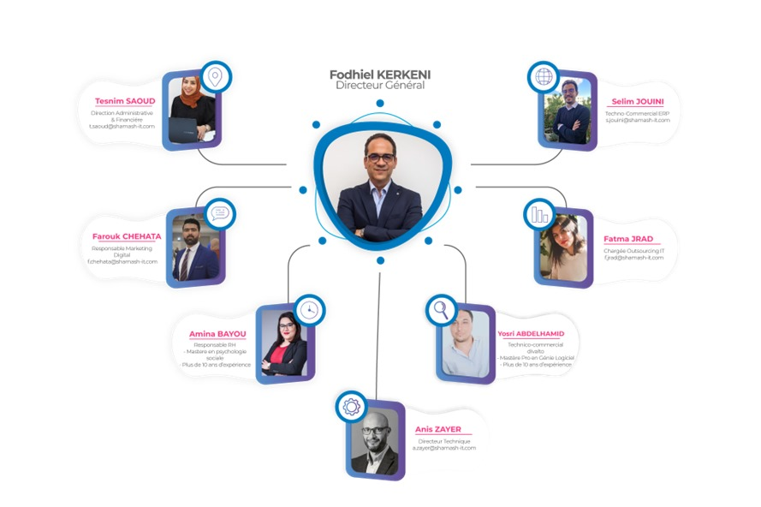Figure 1.3 – Company organization chart

## 1.3 Study of the existing

Before starting any sort of project, it is necessary to do an existing research phase. In fact, it enables a deeper knowledge of the consumers demands as well as the discovery of gaps in existing applications, which might lead to the development of a dependable and effective solution. In this part, we will begin by analyzing and describing current apps, highlighting their merits and drawbacks. Then we will go on to the critique stage. Finally, we will declare our solution.

In the same context as our application, we provide a list of existing applications, namely: Fundbox , BlueVine and Kabbage.

### 1.3.1 “Fundbox” Platform

**Fundbox** [Web 2] is a platform that offers credit and payment solutions as a service for small businesses. This platform provides online invoice factoring services to help small businesses quickly obtain financing based on their unpaid invoices.

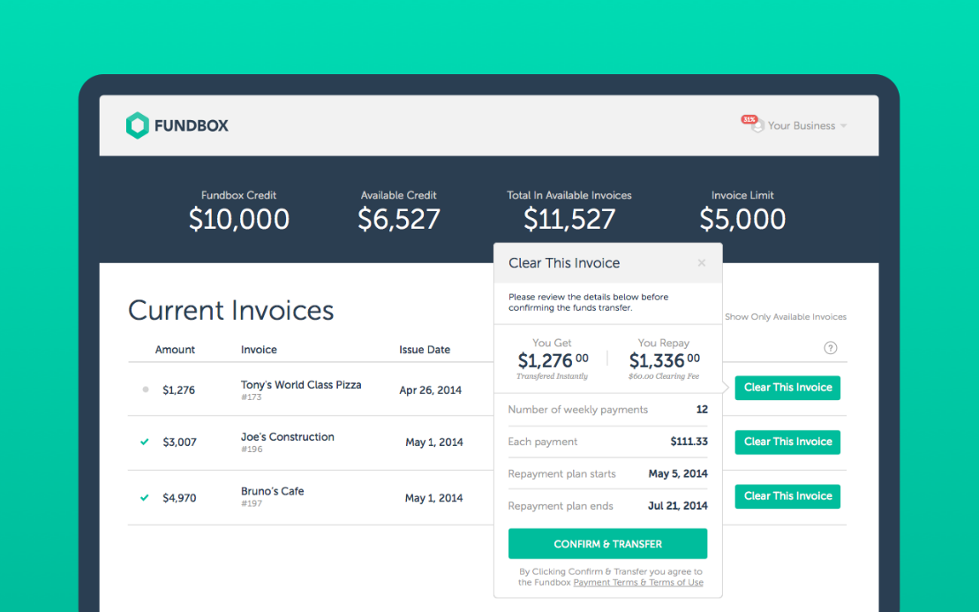

Figure 1.4– Fundbox interface

### 1.3.2 “BlueVine” Platform

**BlueVine** [Web 3] is a financial technology platform that provides financing solutions to small businesses. Specializing in online invoice factoring, BlueVine allows business to convert their unpaid invoices into immediate cash. This approach helps small businesses maintain their cash flow and meet their financing needs quickly and efficiently.

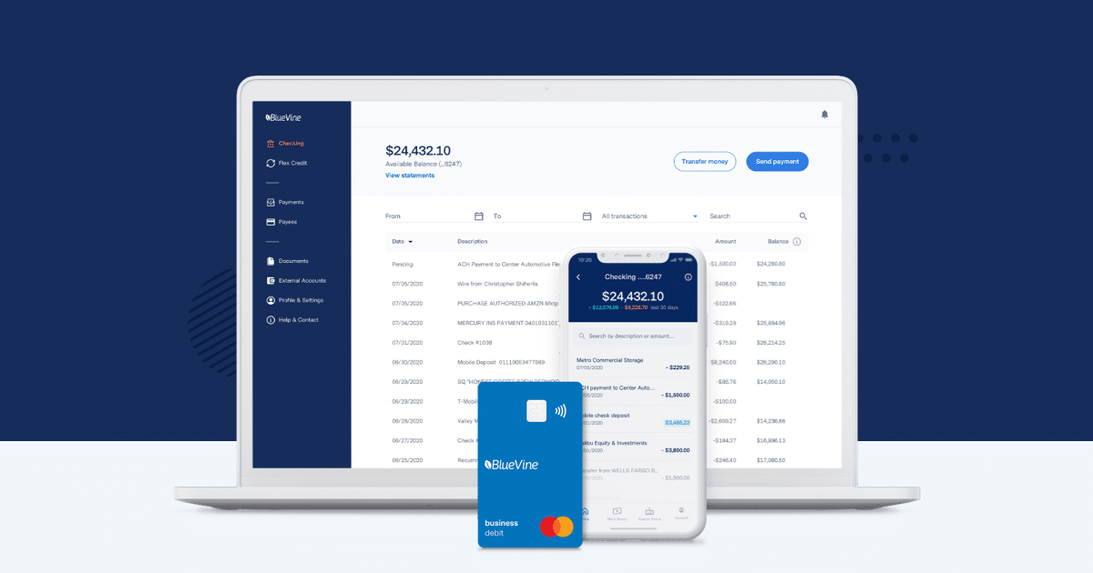

Figure 1.5– BlueVine interface

### 1.3.3 Kabbage Platform

**Kabbage** [Web 4] is a financial technology platform that provides financing solutions to small businesses and consumers. Headquartered in Atlanta, Georgia, Kabbage offers online invoice factoring services that allow businesses to quickly access funds based on their customer invoices. The platform utilizes an automated approach to streamline the loan application and processing process, providing businesses with easy and fast access to cash to meet their financial needs.

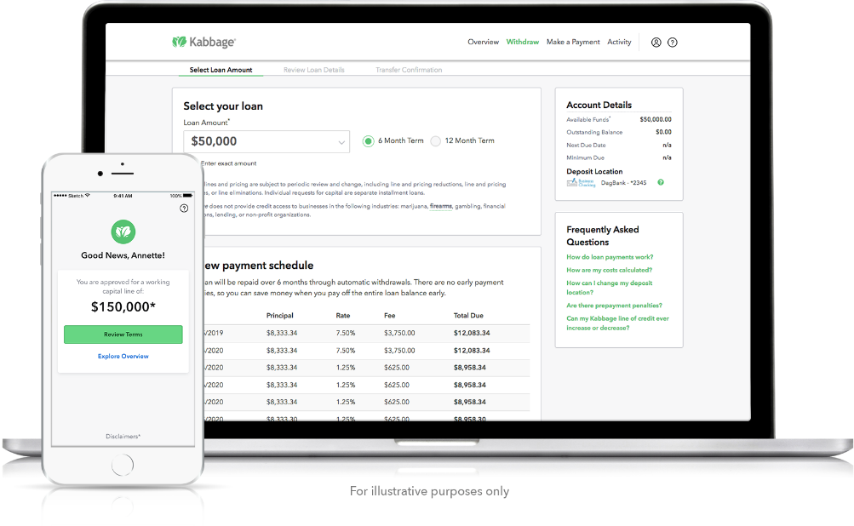

Figure 1.6– Kabbage interface

## 1.4 Criticism of the existing

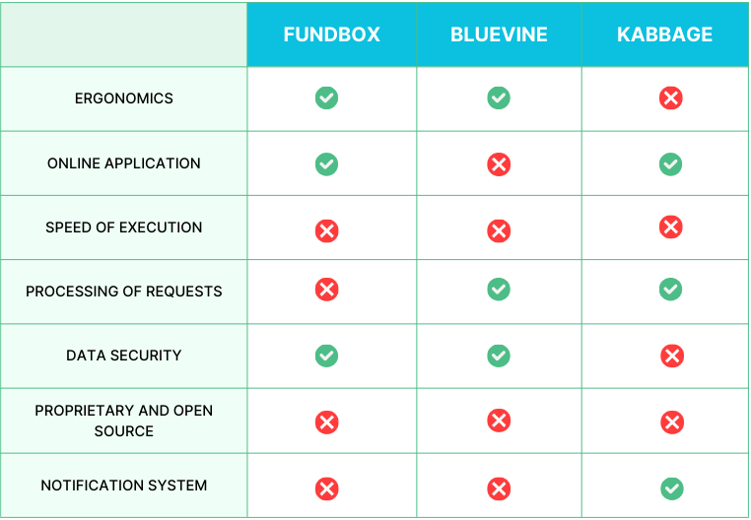

Figure 1.7– Comparative table of existing solutions

## 1.5 Our Solution

Our analysis of existing solutions has revealed several short comings. Therefore, it is crucial to propose a new and simple solution that automates the factoring process. ThusAs a result , we have identified the main functionalities that our application should offer. The figure below presents a graphical illustration of our solution.

**Application Features**

* + User Management.
  + Application Settings Management.
  + Secure and Convenient File Management.
  + Bordereaux Management.
  + Credit and Debit Management.
  + Customizable Reports.
  + Financing Management.

1. **Factoring**

Factoring is a credit transaction consisting of a company to be transferred certain commercial claims held on its clients to a specialised body (company factoring) also known as “Factoring”, or “Factor”, which is responsible, with a certain remuneration and temporary deductions (interest and costs) to operate the recovery and which guarantees its correct end, even in the event of a momentary failure or debtor’s permanent.The factoring operation is therefore a contract between the seller and the factoring company in under which the seller undertakes to assign his claims to the "Factor" in exchange for which he benefits an advance corresponding to the amount of the deduction claims made from interest and commissions.

1. **Factoring steps**
   * **Financement**

First, you will have to sell your invoices to the factoring company. Thus, the factor will have all the cards in hand to be able to make a cash advance. This last must correspond on average to 75 to 80% of the invoice amount. Well obviously, this percentage takes into account the deduction of the financing commission

* + **Full management of assigned receivables**

It is possible to outsource the management of your customer position when you call on factoring. They can:

- Reminders before and after expiry until the pre-litigation or litigation.

- The imputation of the regulations.

- Allocation and allocation of assets.

- Management of customer accounts dashboards.

* + **Credit insurance**

If you subscribe to a factoring offer, the factor will offer to protect you against the risk of failure of your customers. You can benefit from a guarantee of 80, 90 or even 100% of the insolvency risk. Thus, for each of its clients, the company must ask the factor for a guarantee amount that corresponds to the maximum amount outstanding on a client in particular.

1. **Factoring companies**

Factoring companies, such as banks, are legally regulated credit institutions of 24 January 1984. As such, they must be approved by the Credit institutions and are subject to the control of the Banking Commission. They must comply with banking regulations, which impose on them, in particular, coverage and risk division.

Almost all factoring establishments belong to groups of first importance.

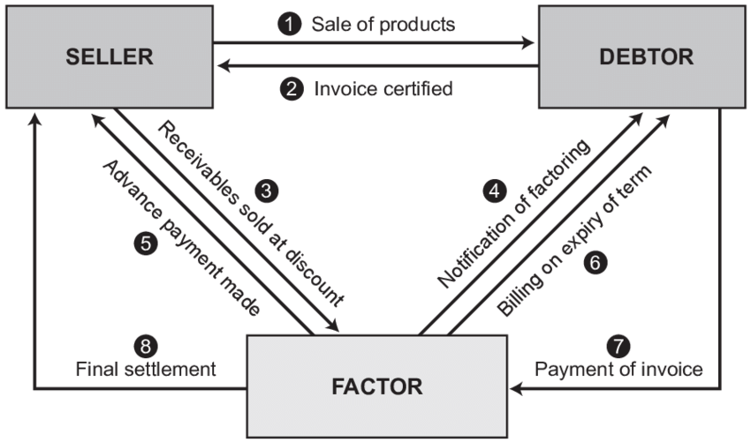

Figure 1.8 – Factoring schema

1. **Adopted Framework**

Choosing a Framework before embarking on project development is a crucial decision that can either streamline or complicate the process. The selection process should be undertaken with care. For our specific project, we have decided to utilize the SCRUM agile Framework.

1. Why SCRUM

We have chosen Scrum for this project because it offers several key benefits that align well with our project goals and needs [Web 6] . Here's a breakdown of the advantages Scrum provides:

* **Adaptability and Flexibility:** Scrum lets us adjust to changing needs as we learn more, ensuring the final product stays relevant.
* **Focus on Delivering Value Early and Often:** By delivering working features in short sprints, we get user feedback early to build the most valuable product.
* **Improved Transparency and Communication:** Daily meetings, sprint reviews, and retrospectives keep everyone informed and aligned.
* **Increased Efficiency and Productivity:** Focused sprints with prioritized tasks keep the team on track and productive.
* **Enhanced Team Morale and Ownership:** Scrum gives ownership to the development team, boosting morale and engagement.

### Scrum Presentation

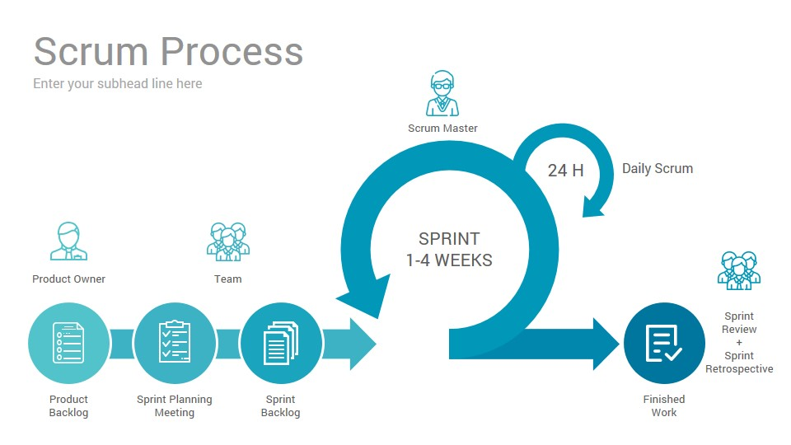

Figure 1.9– SCRUM cycle

SCRUM helps us to concentrate on a defined set of project objectives through an iterative approach. This approach involves breaking down the project into smaller cycles, called Sprints, which typically last between two to four weeks. At the end of each Sprint, an increment is delivered, representing a tangible and expandable version of the project.

### 1.6.3 SCRUM Team

In the SCRUM cycle, each scrum team member has a defined responsibility, and we have:

* **The Product Owner:** is the project owner responsible for managing the product backlog. They own the project’s objectives and reasons behind them, ensuring clear communication and prioritization of tasks for the development team.
* **The Scrum Master:** is the technical team’s facilitator and leader. Their major role is to apply the Scrum process and guarantee that its goals are met. During several sprints, they play a critical role in removing any hurdles and impediments that may hamper the team’s work and the overall growth of the project.
* **Development team:** in charge of the project’s delivery strategy. They are a self-organized team with the authority to choose how the project is carried out and concluded.

## 1.6.4Gantt Chart

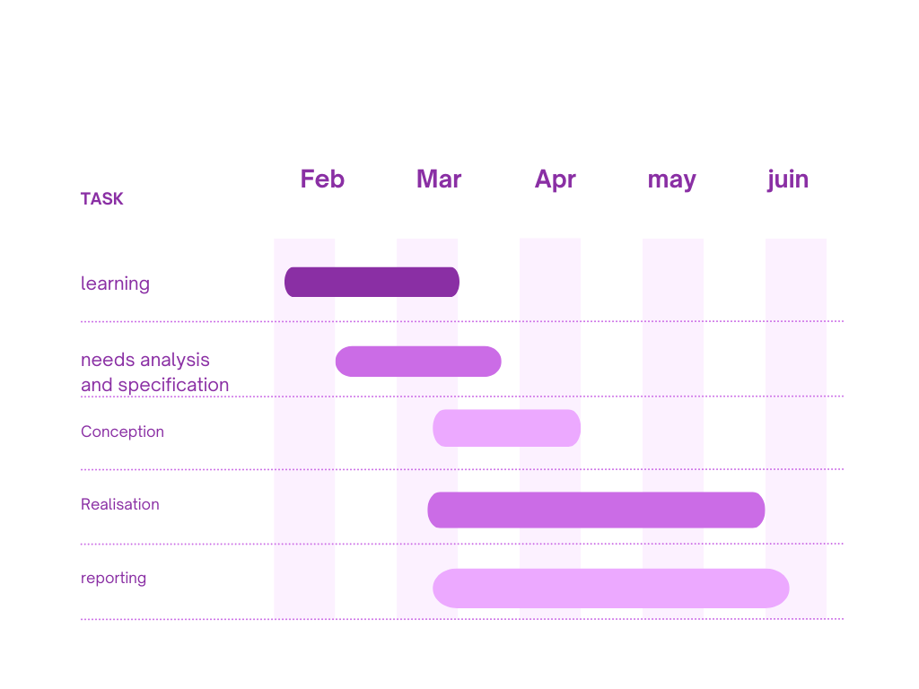Figure 1.10 - Gantt chart

## Conclusion

We have described the broad setting of the project and current solutions in this chapter. Wethen defended our process of development Framework selection. The following chapter will be devoted to requirement analysis and specific

# Chapter 2: Planification and architecture

## 2.1 Introduction

This chapter will cover the planning and the architecture utilized in our project. Initially, we will identify the actors involved in our application, followed by a detailed analysis of the functional and non-functional requirements using the Framework chosen in the preceding chapter. Lastly, we will provide a succinct overview of technologies and programming languages applied to implement our solution.

## 2.2 Analysis of Needs

The requirements specification phase consists of understanding and determining the various functionalities and needs of the system. In this phase, we will present the functional and non-functional requirements of our project.

### 2.2.1 Actor identification

Our project involves <three main actors:

* + **Agent** : The primary user of the XPERT-FACTOR platform, capable of performing all creation and modification tasks on the platform.
  + **Administrator**: The platform administrator who has the rights to register or delete agents and validators, view their information, manage their own profile, and access other relevant functionalities.
  + **Validator**: An application user who performs all validation and consultation tasks.

**Agent :**

The agent has the ability to perform the following tasks

- Authentification

- Organize and store digital files in a convenient and secure manner, with easy access, sharing, searching, and tracking of modifications.--

- Manage receipts.

- Manage credits and debits.

- Manage financing.

- Manage contracts.

- Manage disputes and extensions.

- Manage recoveries.

- Manage limits.

- Authenticate according to a defined role to access these features and other services offered by the company.

**Administrator:**

The administrator has the ability to perform the following tasks:

-Authentification

- Create roles and permissions, and assign these permissions to a role.

- Manage users (agents and Validators).

- Manage the application's settings.

- Generate intelligent reports.

**Validator:**

The validator has the ability to perform the following tasks :

- Authentification

-Validate invoice

-Validate disputes and propogation

-Validate contrats

-Validate Limites

* + Our application also offers its **members** the following features:
    - Consult the available member
    - View outstanding invoices
    - View Limit Status
    - View status of late invoices
    - Consult the status of unpaid invoices
    - View Cash Status
    - View commission status

### 2.2.2 Requirements identification

#### 2.2.2.1 Functional requirements

Functional requirements of a product refer to the essential features or use cases that allow application users to accomplish their tasks effectively. It is crucial for developers to understand these requirements to create a useful and operational system. Generally, functional requirements describe how a system will behave in specific scenarios. Our application offers the following functionalities to its users:

- User Authentication and Authorization: The web application allows users to log in, granting them access to various features of the web application.

- Management of Individuals: (legal or natural persons) Offering the ability to add, modify, and view individuals.

- Management of Member Accounts.

- User Management: Providing the ability to add, modify, display, block, and assign access rights to user groups.

- Contract Management: Offering the ability to add and view contracts.

- Scanning and Document Management.

Our application also offers the following functionalities to its members:

- View Available Members.

- Display Unpaid Invoices.

- Display Credit Limit Status.

- Display Overdue Invoices Status.

- Check Unpaid Invoices Status.

- Display Cash Flow Status.

- Display Commissions Status.

#### 2.2.2.2 Non-functional requirements

These are the requirements that ensure the delivery of a reliable product that meets user requirements and can handle risks of failure or malfunction. The non-functional requirements of our application will be:

- **Security**: The platform must respect the confidentiality of data and ensure their integrity by providing a login interface (access), using a civil ID in case of an individual and with an identifier and a password in case of a manager, all validated by the factoring company's database and with the manipulation of a token which represents the access token.

- **Performance**: Our application must be performant, meaning it must meet the needs of its users optimally and in a reduced time.

- **Response Tim**e: Following user actions, the application must react within a reasonable time.

- **Extensibility**: The code must be clear to allow for future evolutions or improvements.

- **Availability**: The system must always be accessible.

- **Ergonomics**: The application offers a user-friendly and easy-to-use interface.

**2.3 Project Management with SCRUM**

In the following sections, we introduce the various individuals involved in the different stages of our project, including the Scrum team, Product Owner, and Scrum Master. We will outline the roles, responsibilities, and objectives associated with each member.

|  |  |  |
| --- | --- | --- |
| Role | Mission | Actor |
| Product Owner | Vision and product Backlog  Stakeholders' management  Prioritization and Refinement | Fodhiel Karkni |
| Scrum Master | Facilitation and Coaching  Scrum Expert  Product Backlog management  Communication and Transparency | Moataz Dakhlaoui |
| Scrum Team | Sprint Execution  Inspect And Adapt  Shared Responsibility | Anis Allagui  Amine Khadhraoui  Nour Lahbibi  Nermine Mouhajri |

Table 2.1 – Project management with scrum

### 2.3.1 Product Backlog

In Scrum Framework, the product backlog is considered the most significant artifact.

It contains a comprehensive list of all the required features and needs of the product.

The table below displays the Backlog of our application, with each user story assigned a rank based on its previously determined priority. We have opted to begin processing our user stories with the most important use cases. Additionally, we provide an explanation of the various terms used in the table.

• ID: represents the user story’s identifier.

• Name of the feature is used to better organize user stories, such as tool management.

• User Story: includes the description of the user story in the form of "As a... I want...".

• The priority: of the user stories according to their business value and the order of implementation.

|  |  |  |  |
| --- | --- | --- | --- |
| ID | Name of the feature | User Story | The priority |
| 1 | Add  Moral individual | As an Agent/Admin  I want to add a new moral individual to the system  So that I can efficiently manage their factoring needs  and creditworthiness. | 1 |
| Add Physical individual | As an Agent/Admin  I want to add a new physical individual to the system  So that I can process their factoring requests for  physical goods or invoices. |
| Listing individuals | As an Agent/Admin  I want to be able to view a list of all individuals (moral and physical) in the system  So that I can easily search, filter, and manage their factoring activities. |
| 2 | Create Contract | As a seller, I want to create a contract to sell my invoice to a factor so I can get immediate cash. | 2 |
| View Contracts | As a seller, I want to view all my contracts including their details. |
| Update Contract | As a seller, I want to update the details of an existing contract, such as the invoice amount or due date (before the factor purchases the invoice). |
| 3 | Adding Limits to Contracts | As an Agent/Admin, I want to be able to set limits for new contracts, so that I can establish boundaries and ensure compliance with company policies | 4 |
| Validating Contract Limits | As an Agent/Admin, I want the system to validate contract limits before finalization, so that I can ensure adherence to company policies and prevent potential risks. |
| 4 | Add Bordereau | As an Agent/Admin,  I want to add new bordereaux to the system.  So that I can efficiently record and manage details of invoices or receivables submitted for factoring. | 6 |
| Validate Bordereau | As a Validator,  I want to see a list of all bordereaux with search capabilities  So that I can efficiently review, validate, and reject bordereaux submitted for factoring. |
| 5 | Add financing | As an Agent/Admin, I want to be able to add new financing. | 3 |
| Validate financing | As a Validator, I want to be able to validate existing financing. |
| Refuse financing | As a Validator, I want to be able to decline existing financing. |
| Financing details | As an Agent/Admin, I want to be able to see the details of a financing |
| 6 | Add unpaid invoice | As a factoring account manager,I want to add new unpaid invice to the system . So that I can efficiently record and manage details of invoices or receivables submitted for factoring. | 5 |
| Consult unpaid | As an Agent/Admin , I want to see a list of all unpaid with search capabilities .So that I can efficiently review, validate, and reject unpaid invoices submitted for factoring |
| Reconcile an invoice | As an Agent/Admin i need to mark an invoice as paid or adjusted. |
| Mark an instrument as unpaid | As an Agent/Admin , i need to mark an instrument (contract/agreement) as unpaid. |
| Reschedule payment date | As an Agent/Admin, i need to reschedule the payment date for an instrument |
| 7 | Login form | As an Agent/Admin/Validator , I want to enter my login credentials | 7 |
|  | Login Submission | As Agent/Admin/Validator, I want to submit my login credentials |  |
|  | Manage roles | As an admin , I want to manage roles of users |  |
|  | Manage users | As an admin , I want to manage users by adding or deleting or editing them |  |
|  | Manage permissions | As an admin I want to manage permissions given to the users |  |

Table 2.2 – Product Backlog

### 2.3.2 Global Use Case Diagram

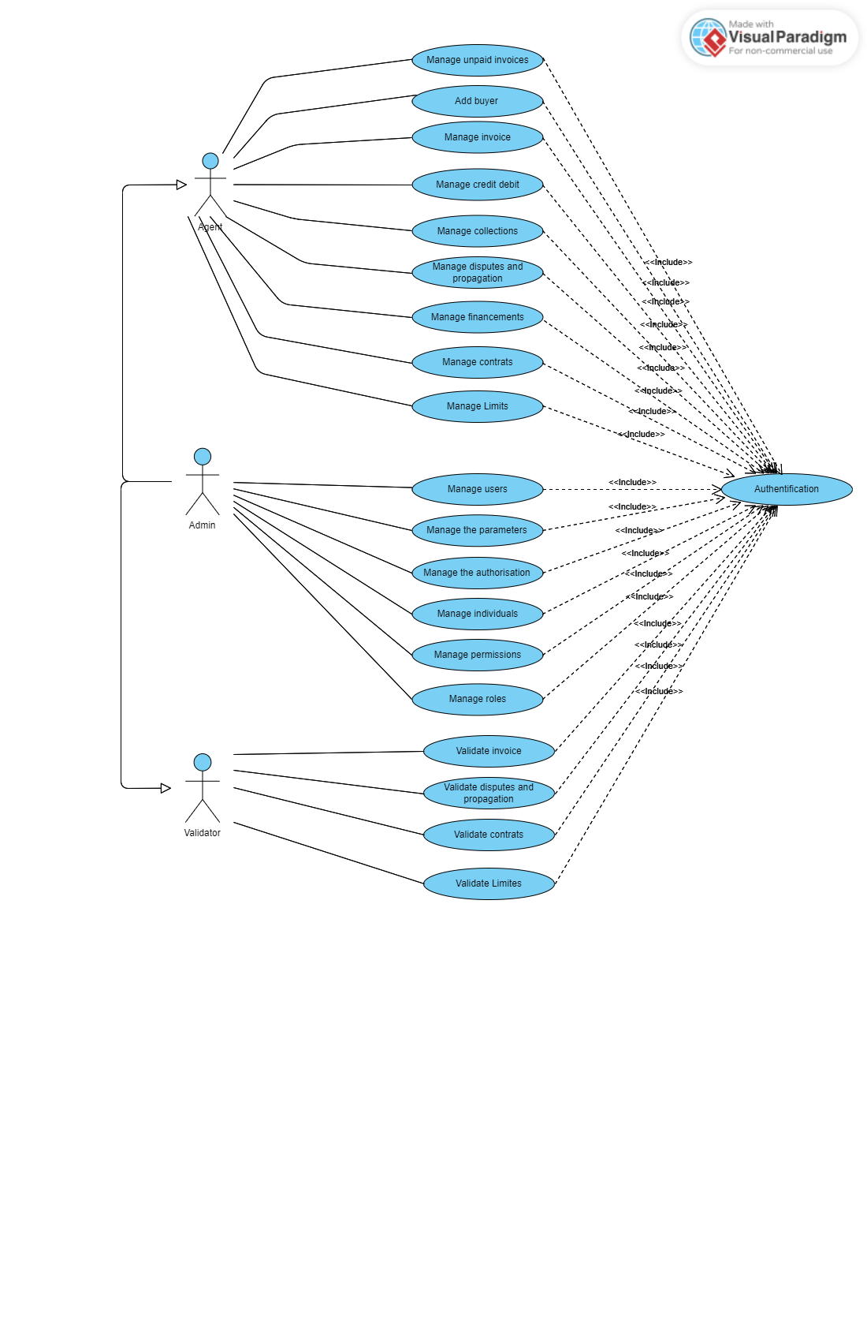

Figure 2.1 – Global Use Case Diagram

The diagram depicted above offers a comprehensive overview of how our application operates by showcasing the interactions among the system’s use cases.

### 2.3.3 Sprints Plan

Our project has been segmented into sprints, where each sprint comprises a set of functionalities with a specific objective. Following the conclusion of each sprint, we will have an increment or partial version of the product that can be delivered to the customer.

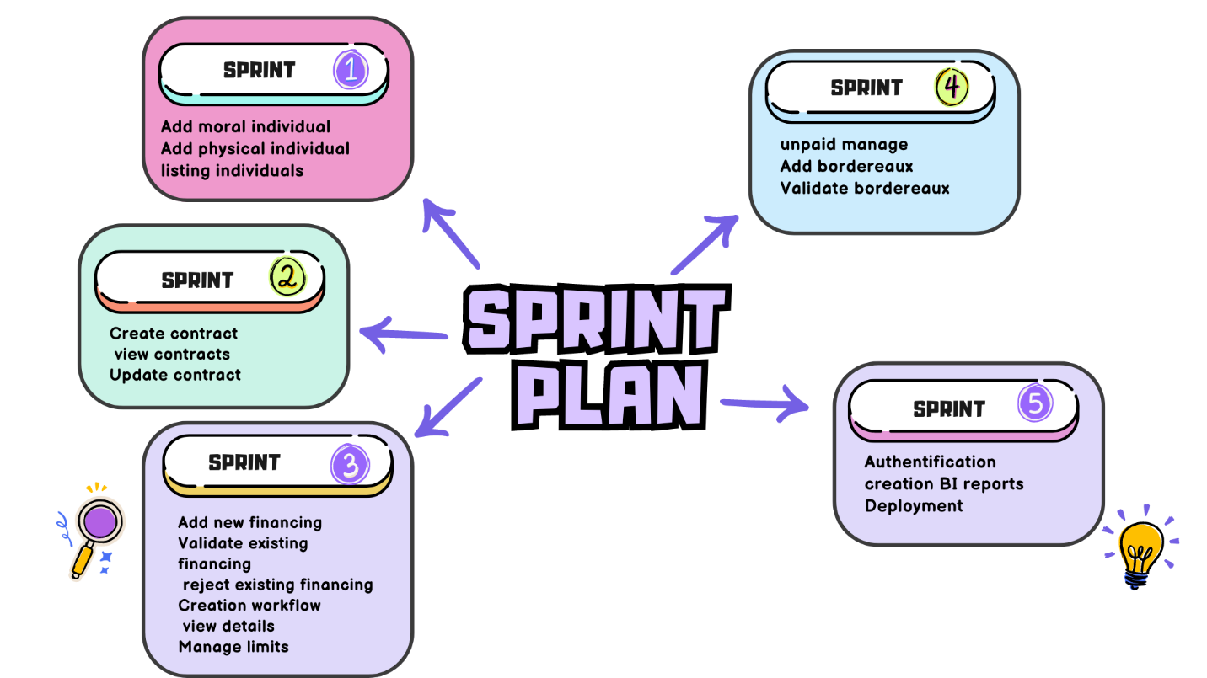

Figure 2.2 – Sprint Planning

## 2.4 Working Environment

### 2.4.1 Material environment

|  |
| --- |
| DELL G3 15 |
| Intel(R) Core (TM) i5-10300H CPU @ 2.50GHz 2.50 GHz |
| Nvidia GeForce GTX |
| Hard disc 1024 GO HDDR 256 GO SSD |
| Windows 10 Pro |

Table 2.3 – Nour’s Material environment

|  |
| --- |
| LENOVO IDEAPAD S145 |
| Intel(R) Core(TM) i3-1005G1 CPU @ 1.20GHz 1.19 GHz |
| Intel(R) Iris(R) Xe Graphics |
| Hard disc 1024 GO HDDR 512 GO SSD |
| Windows 10 |

Table 2.4 – Nermine’s Material environment

### 2.4.2 Development environment

#### 2.4.2.1 Next JS

Next.js is a React framework that facilitates server-side rendering and static site generation for React-based web apps. It streamlines React development with features like automatic code splitting, server-side rendering, and efficient client-side routing. Developed by Vercel, it simplifies building fast, SEO-friendly, and scalable web apps with React. [Web 7]



Figure 2.3 – Next JS logo

#### 2.4.2.2 .NET Framework

.NET 8.0 is a backend framework for web and mobile apps in the .NET

ecosystem. It simplifies server management and routing, offering tools for building single-page, multipage, and hybrid applications with scalability and performance in mind. [Web 8]



Figure 2.4 – .Net logo

#### 2.4.2.3 SQL Server

SQL Server is a robust relational database management system (RDBMS) developed by Microsoft. It efficiently organizes data into structured tables with rows and columns, enabling powerful storage and retrieval capabilities. With SQL Server, users can manage and query data using the SQL language, making it suitable for a wide range of applications requiring structured data storage and management. [Web 9]



Figure 2.5 – SQL Server logo

#### 2.4.2.4 Swagger UI

Swagger is an open-source framework for designing, building, and documenting RESTful APIs. It provides a user-friendly interface, Swagger UI, for interacting with API endpoints and automatically generating API documentation, making it easy to understand and test APIs from the browser. [Web 10]



Figure 2.6 – Swagger UI logo

#### 2.4.2.6 Visual Studio Code

Visual Studio Code is a free coding editor that helps you start coding quickly. Use it to code in any programming language, without switching editors. Visual Studio Code has support for many languages, including Python, Java, C++, JavaScript, and more.



Figure 2.7 – Visual Studio Code logo

#### 2.4.2.7 Online Visual Paradigm

Online Visual Paradigm (VP-UML) is a UML CASE Tool supporting UML 2, SysML and Business Process Modeling Notation (BPMN) from the Object Management Group (OMG). In addition to the modeling support, it provides report generation and code engineering capabilities including code generation. [Web 11]



Figure 2.8 – Visual paradigm logo

#### 2.4.2.8 JetBrains Rider

JetBrains Rider is a leading cross-platform IDE for .NET and game developers looking to boost productivity and streamline their development process. [Web 12]



Figure 2.9 – JetBrains Rider logo

#### 2.4.2.9 Docker

Docker simplifies the development and deployment process by providing a consistent environment for applications, reducing conflicts and errors caused by differences between development, testing, and production environments. It also enhances scalability and resource efficiency, as multiple containers can run on a single host without the overhead of traditional virtual machines. [Web 13]



Figure 2.10 – Docker logo

#### 2.4.10 Power BI

Power BI is a powerful tool for data analysis and interactive visualization, offering significant benefits in terms of accessibility, connectivity, customization, and security. It enables businesses to transform their data into actionable insights, facilitating informed decision-making and improving organizational performance. [Web 15]

Figure 2.11 – Power BI logo

## 2.5 Architecture of The Application

The concept of architecture is vast and includes logical, physical, and software architecture, among others.

In the context of application design, the architecture refers to the simplified representation of the components and their interrelationships. In our case we choose the clean architecture to work with.

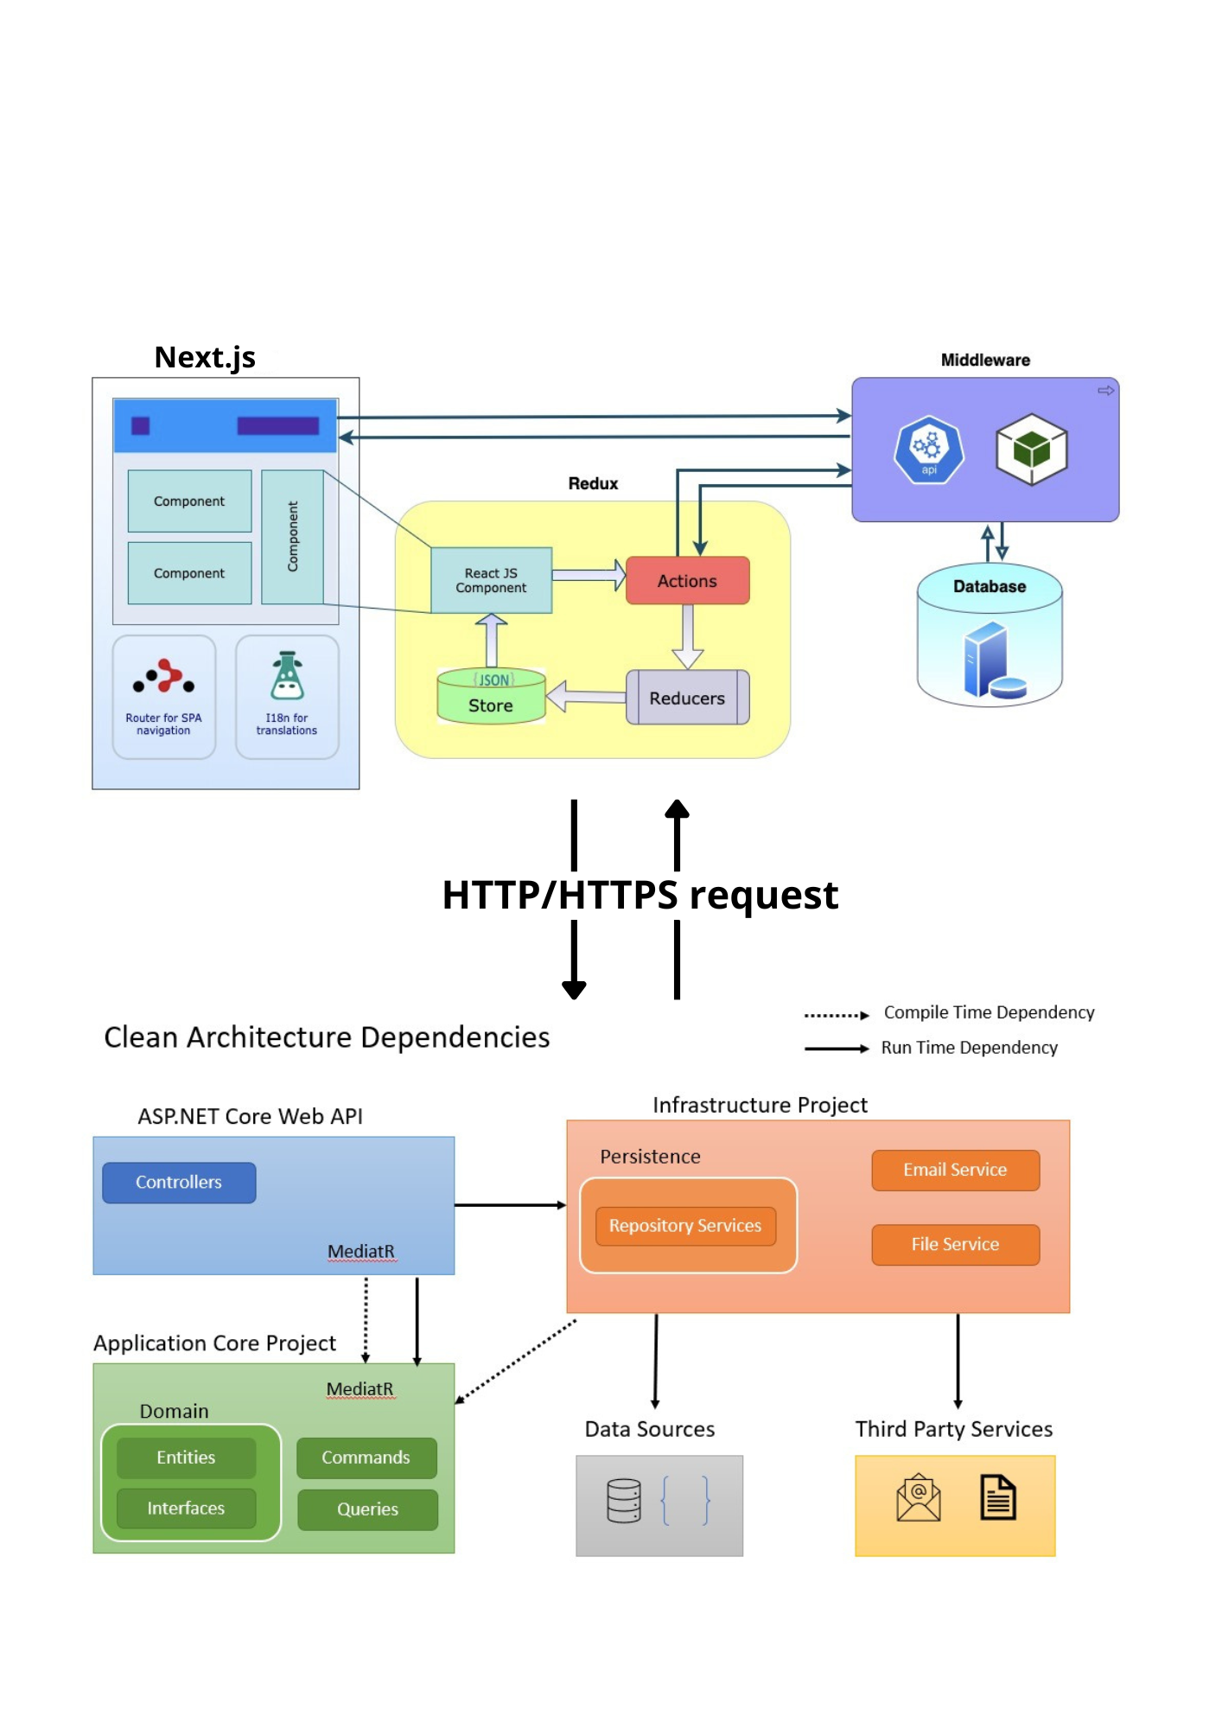

Figure 2.12 -Physic architecture

### 2.5.1 Back-end architecture

**Clean Architecture:** is a software design philosophy and methodology for structuring code in a way that makes it more maintainable, testable, and scalable. Our backend follows a clean architecture approach, ensuring separation of concerns and high testability. [Web 14]

* Presentation Layer: Handles HTTP requests and responses, and is responsible for user interface logic.
* Application Layer: Contains the application logic and orchestrates use cases.
* Domain Layer: Represents the core business logic and domain entities, ensuring high-level business rules.
* Infrastructure Layer: Handles data access, external API calls, and other infrastructure concerns.

#### 2.5.1.1 Why clean architecture:

It emphasizes separation of concerns, ensuring that the business logic is decoupled from the implementation details. Here are the core principles of Clean Architecture:

* Separation of Concerns: Different aspects of the application are separated into distinct layers, each with its own responsibility.
* Dependency Rule: The direction of dependencies should only point inward. Higher-level modules should not depend on lower-level modules, and outer layers should not depend on inner layers.
* Layered Architecture: Typically, Clean Architecture divides the system into layers such as:

**- Entities:** Represent the business objects and rules.

**- Use Cases:** Contain the application-specific business rules and interact with entities to perform actions.

**- Interface Adapters:** Convert data from the format most convenient for use cases and entities to the format most convenient for external agents like the web, database, etc.

**- Frameworks and Drivers:** Include UI, database, web frameworks, and external APIs.

* Independence: Each layer is independent, allowing changes in one layer without affecting others. This independence facilitates testing and development.
* Testability: The architecture promotes writing unit tests and integration tests, ensuring each part of the system works correctly in isolation and together.

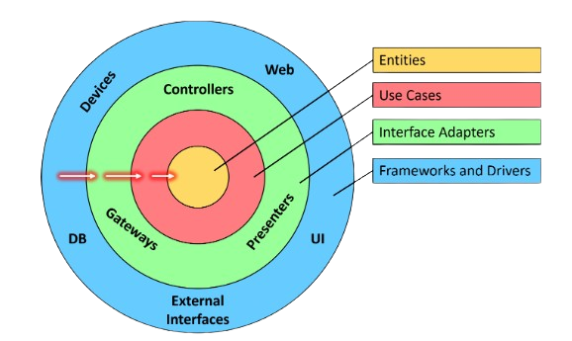

Figure 2.13- clean architecture schema

We all knew the MVC architecture , which stands for "Model," "View," "Controller," is implemented in most projects. It is not very complex and still allows for a good segmentation of the application layers. The "Controller" is the master and is responsible for capturing the request, processing it using the data provided by the model, and finally injecting the desired data into the view.

But as you know very well, as our application grows in complexity, many specific cases arise and force us to change this process. Consequently, the neat architecture we initially set up tends to lose its meaning. It is in these moments that we wish for a more segmented and abstract architecture.

## 2.5.2 Front-end architecture

For our application, the frontend is developed using a component-based architecture in React. This approach allows us to create modular and reusable user interfaces, simplifying development and maintenance.

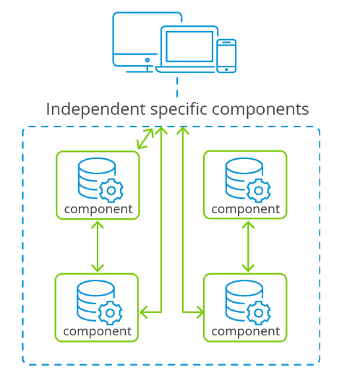By using React, each part of the user interface is encapsulated in independent components, each managing its own state and properties. This not only facilitates debugging and testing but also allows for the evolution of the application by adding or modifying features without affecting the rest of the system. This component-based architecture contributes to a consistent and efficient user experience, while improving developer productivity through a clear and organized code structure.

Figure 2.14 - Schema Component-Based Architecture

**2.5.2.1 Why Component-Based architecture**

**• Modularity and Reusability:**

The component-based architecture allows for the creation of autonomous code units that can be easily reused in different parts of the application. This reduces development time and improves the consistency of the user interface.

**• Ease of Maintenance:**

Components encapsulate their own state and logic, simplifying debugging and maintenance. Developers can work on individual components without risking affecting other parts of the application.

**• Simplified Evolution:**

This architecture allows for the addition or modification of features in isolation, minimizing the risk of introducing bugs in other parts of the system.

**• Better State Management:**

By using libraries like Redux Toolkit, the global state of the application is managed efficiently and predictably, improving the performance and stability of the application.

**• Consistent User Experience:**

By structuring the code clearly and organized, the component-based architecture contributes to providing a smooth and efficient user experience.

## Conclusion

This chapter outlined our application's requirements, defined actor roles, and described the initial framework stage, including team identification, product backlog creation, and sprint planning. We also reviewed the development environment and application architecture. The next chapter will cover the first sprint's development.

# Chapter 3: Sprint 1 Study and realization

## Individual Module

## 3.1 Introduction

In this section, we will start the implementation of the proposed solution by initiating the first sprint. The main objective of the sprint is to work on the individual module which contains tasks like adding moral or physical individual or listing all the individuals. These tasks build upon the groundwork conducted in the preceding chapter.

## 3.2 Sprint Backlog

Before starting the sprint, the Scrum team needs to meet and define a clear and understandable sprint goal in business terms. The primary question that needs to be addressed is why the team is undertaking the sprint.

For this sprint, the objective is to implement the Add individual for both moral and physical, and the listing of the individual. Next, the team must decide which stories from the backlog will be included in the sprint backlog, and these stories have been estimated in terms of days.

|  |  |  |  |  |  |
| --- | --- | --- | --- | --- | --- |
| Sprint Num | Name of feature | ID user story | User Story | Acceptance Criteria | Estimation |
| 1 | Add Moral individual | 1.1 | As Agent/Admin  I want to add a new moral individual to the system  So that I can efficiently manage their factoring needs and creditworthiness. | System adds moral individuals by capturing key details (name, contact, business, financials, optional credit history) and validates data for a manageable factoring profile. | 6d |
| 1 | Add  Physical individual | 1.2 | As an Agent/Admin  I want to add a new physical individual to the system  So that I can process their factoring requests for physical goods or invoices. | The system captures details for physical individuals and goods (type, value), links them to moral individuals, and validates data for a manageable factoring profile. (Similar to moral individual story) | 5d |
| 1 | Listing individuals | 1.3 | As an Agent/Admin  I want to be able to view a list of all individuals (moral and physical) in the system  So that I can easily search, filter, and manage their factoring activities. | The system displays a searchable and sortable list of all individuals (type, name, business type, status) with easy access to profiles for further actions. | 4d |

Table 3.1 – Sprint 1 Backlog

## 3.3 Functional Specifications

We will be creating a use case diagram for this sprint to answer the question "What does our system do?" In addition, we will also provide a textual description of the diagram to further explain the functionalities of the system.

### 3.3.1 Use Case Diagram

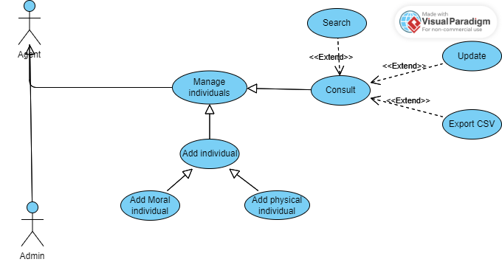

Figure 3.1– Individual Use Case

In this sprint and to ensure that the use case diagram is easily understood, UML provides the option of providing a textual description for each use case, which describes the behavior of the system.

This technique is used to provide additional information about a use case and can significantly contribute to its value. The description can be captured in the model as single or multiple comments, but for our report, we have presented it separately in tables to improve readability and clarity. In the following sections, we will provide tables that describe important or complex use cases of this sprint.

### 3.3.2 Add Moral individual scenario description

#### 3.3.2.1 Detailed use case

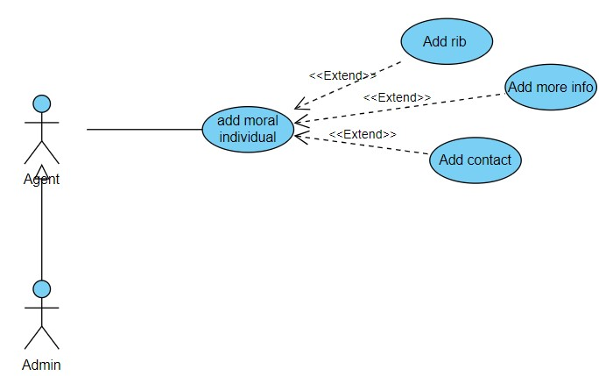

Figure 3.2– Add moral individual Use Case

#### 3.3.2.2 Use case description

In this section, our focus is on providing a comprehensive description of the "Add moral individual " use case.

The first table describes the textual description of the "Add Moral individual" use case and the second is “Add contact”.

|  |  |
| --- | --- |
| Title | Add Moral individual |
| Actor | Agent or Admin |
| Pre-condition | - Agent has access to the factoring system. |
| Post-condition | - New moral individual is added to the system.  - Individual profile is accessible for further management. |
| Normal scenario description | 1. Agent opens the "Moral individual" form.  2. Agent completes the form with all required information (Legal status, Denomination, etc.).  3. Agent clicks "Add Individual" button.  4. System validates the entered data.  5. Upon successful validation, a confirmation message is displayed, and the individual profile is accessible. |
| Exception scenario description | 1. Required information is missing (e.g., Denomination). -> System displays an error message indicating the missing fields.  2. Invalid data is entered (e.g., incorrect format for RIB). -> System displays an error message with details about the invalid data.  3. System encounters an error during data processing. -> Agent is notified of the error, and relevant IT support personnel are informed. |

Table 3.2 – Add Moral individual scenario description

|  |  |
| --- | --- |
| Title | Add Contact for Moral Individual |
| Actor | Agent or Admin |
| Pre-condition | - Agent is on the moral individual profile page. |
| Post-condition | - A new contact is added to the moral individual's profile. |
| Normal scenario description | 1. Agent clicks the "Add Contact" button.  2. A pop-up window with a contact form appears.  3. Agent fills out the contact information (First and last name, Position, phone number, etc.).  4. Agent clicks the "Save" button.  5. System validates the entered data.  6. Upon successful validation, the contact is added to the individual's profile, and the pop-up window closes. |
| Exception scenario description | 1. Required information is missing (e.g., First and last name). -> System displays an error message indicating the missing fields within the pop-up window.  2. Invalid data is entered (e.g., incorrect email format). -> System displays an error message with details about the invalid data within the pop-up window. |

Table 3.3 – Add Contact for Moral Individual scenario description

### 3.3.3 Add physical individual scenario description

#### 3.3.3.1 Detailed use case

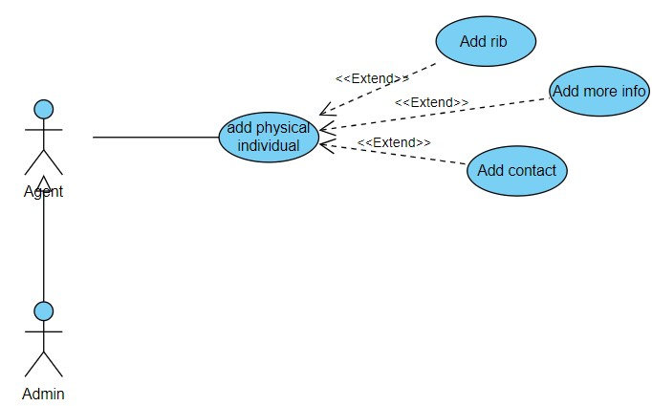

Figure 3.3– Add physical individual Use Case

#### 3.3.3.2 Use case description

In this section, our focus is on providing a comprehensive description of the "Add moral individual " use case.

The first table describes the textual description of the "Add physical individual" use case and the second is “Add contact”.

|  |  |
| --- | --- |
| Title | Add physical individual |
| Actor | Agent or Admin |
| Pre-condition | - Agent has access to the factoring system. |
| Post-condition | - New physical individual is added to the system.  - Individual profile is accessible for further management. |
| Normal scenario description | 1. Agent opens the " physical individual " form.  2. Agent completes the form with all required information (Nationality, Language, Name, etc.).  3. Agent clicks "Add Individual" button.  4. System validates the entered data.  5. Upon successful validation, a confirmation message is displayed, and the individual profile is accessible. |
| Exception scenario description | 1. Required information is missing (e.g., Denomination). -> System displays an error message indicating the missing fields.  2. Invalid data is entered (e.g., incorrect format for RIB). -> System displays an error message with details about the invalid data.  3. System encounters an error during data processing. -> Agent is notified of the error, and relevant IT support personnel are informed. |

Table 3.4 – Add physical individual scenario description

|  |  |
| --- | --- |
| Title | Add Contact for Moral Individual |
| Actor | Agent or Admin |
| Pre-condition | - Agent is on the moral individual profile page. |
| Post-condition | - A new contact is added to the moral individual's profile. |
| Normal scenario description | 1. Agent clicks the "Add Contact" button.  2. A pop-up window with a contact form appears.  3. Agent fills out the contact information (First and last name, Position, phone number, etc.).  4. Agent clicks the "Save" button.  5. System validates the entered data.  6. Upon successful validation, the contact is added to the individual's profile, and the pop-up window closes. |
| Exception scenario description | 1. Required information is missing (e.g., First and last name). -> System displays an error message indicating the missing fields within the pop-up window.  2. Invalid data is entered (e.g., incorrect email format). -> System displays an error message with details about the invalid data within the pop-up window. |

Table 3.5 – Add Contact for physical Individual scenario description

### 3.3.4 Consult individuals List scenario description

#### 3.3.4.1 Detailed use case

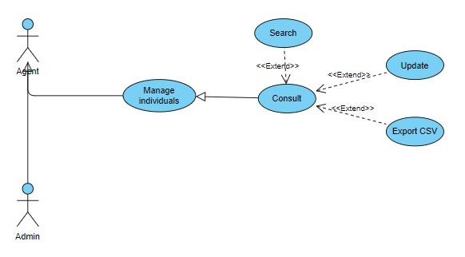

Figure 3.4– Consult individuals list Use Case

#### 3.3.4.2 Use case description

The table below describes the textual description of the " Consult individuals list " use case.

|  |  |
| --- | --- |
| Title | Consult individuals list |
| Actor | Agent or Admin |
| Pre-condition | - Agent has access to the factoring system. |
| Post-condition | - Agent can view and manage a list of all individuals (moral and physical). |
| Normal scenario description | 1. Agent accesses the "Individuals List" page.  2. The page displays a searchable table with information about all individuals, including: * Individual type (moral/physical) * Name * Additional relevant details (configurable)  3. Agent can search the list using various criteria (e.g., name, type, business type, status).  4. Agent clicks on a specific individual from the list.  5. The individual's detailed profile is displayed.  6. Agent edits the desired information within the individual's profile.  7. Agent clicks the "Save" button.  8. System validates the updated data.  9. Upon successful validation, the changes are saved, and the updated profile is displayed. |
| Exception scenario description | 1. System encounters an error while retrieving the list of individuals. -> Agent is notified, and relevant IT support personnel are informed.  2. Required information is missing after editing (e.g., Denomination for moral individual). -> System displays an error message indicating the missing fields.  3. Invalid data is entered (e.g., incorrect format for RIB). -> System displays an error message with details about the invalid data.  4. System encounters an error during data processing. -> Agent is notified of the error, and the update is not saved. |

Table 3.6 – Consult individuals list scenario description

## 3.4 Modeling

After defining the requirements, modeling is a crucial stage in the sprint process.

Our team has employed UML to create models of our scenarios. Included below are the

sequence diagrams for important use cases and the corresponding class diagram.

### 3.4.1 Sequence diagram

UML Sequence Diagrams are interaction diagrams that detail how operations are carried out. They capture the interaction between objects in the context of a collaboration. Sequence Diagrams are time focus and they show the order of the interaction visually by using the vertical axis of the diagram to represent the time what messages are sent and when.

#### 3.4.1.1 Add moral individual sequence diagram

This sequence diagram illustrates the interaction between a user (either an agent or administrator) and the factoring software for adding a new moral individual. The user encounters a form requesting various details about the individual, including legal form, business information, contact details (with the ability to add multiple contacts), and VAT specifics. Upon entering and submitting the information, the system validates the data and saves the record, confirming the successful addition of the moral individual. The following diagram will visually depict this interaction flow.

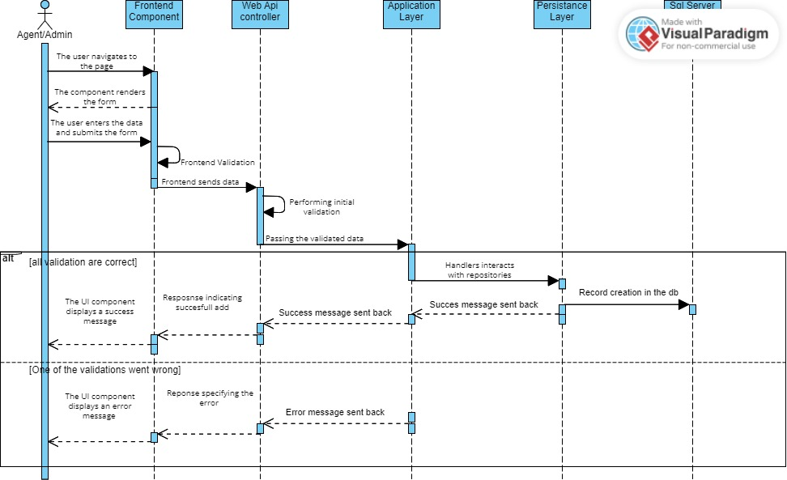

Figure 3.5– Add moral individual sequence diagram

#### 3.4.1.2 Consult Individual List sequence diagram

This sequence diagram illustrates the interactions between the Agent/Admin user, the front-end components, and the back-end layers within the .NET Clean Architecture application when consulting the list of individuals. The scenario details the steps involved in retrieving the list, displaying it with the specific criteria, accessing an individual's details, and optionally editing and saving changes.

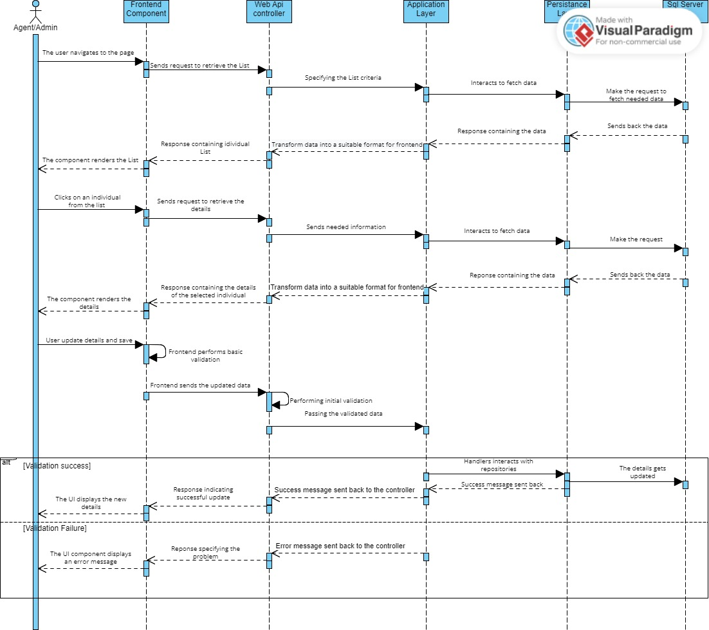

Figure 3.6– Consult individual List sequence diagram

### 3.4.2 Class Diagram

In software engineering, a class diagram in the Unified Modeling Language (UML) is a type of static structure diagram that describes the structure of a system by showing the system’s classes, their attributes, operations (or methods), and the relationships among objects.

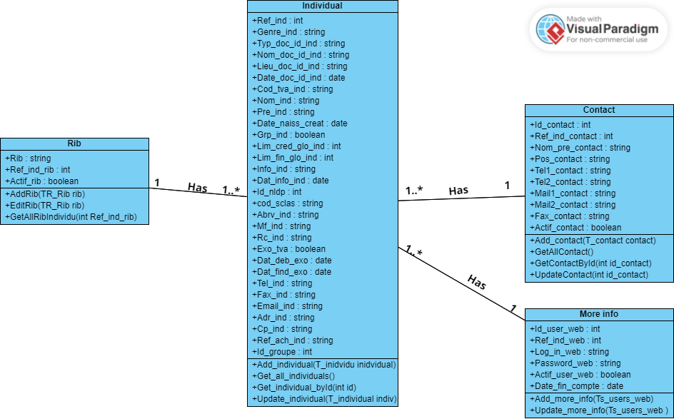

Figure 3.7– Sprint 1 class diagram

## 3.5 Realization

In this section, we will showcase a collection of screenshots featuring the user interfaces that have been implemented during the current sprint.

### 3.5.1 Add moral individual interface

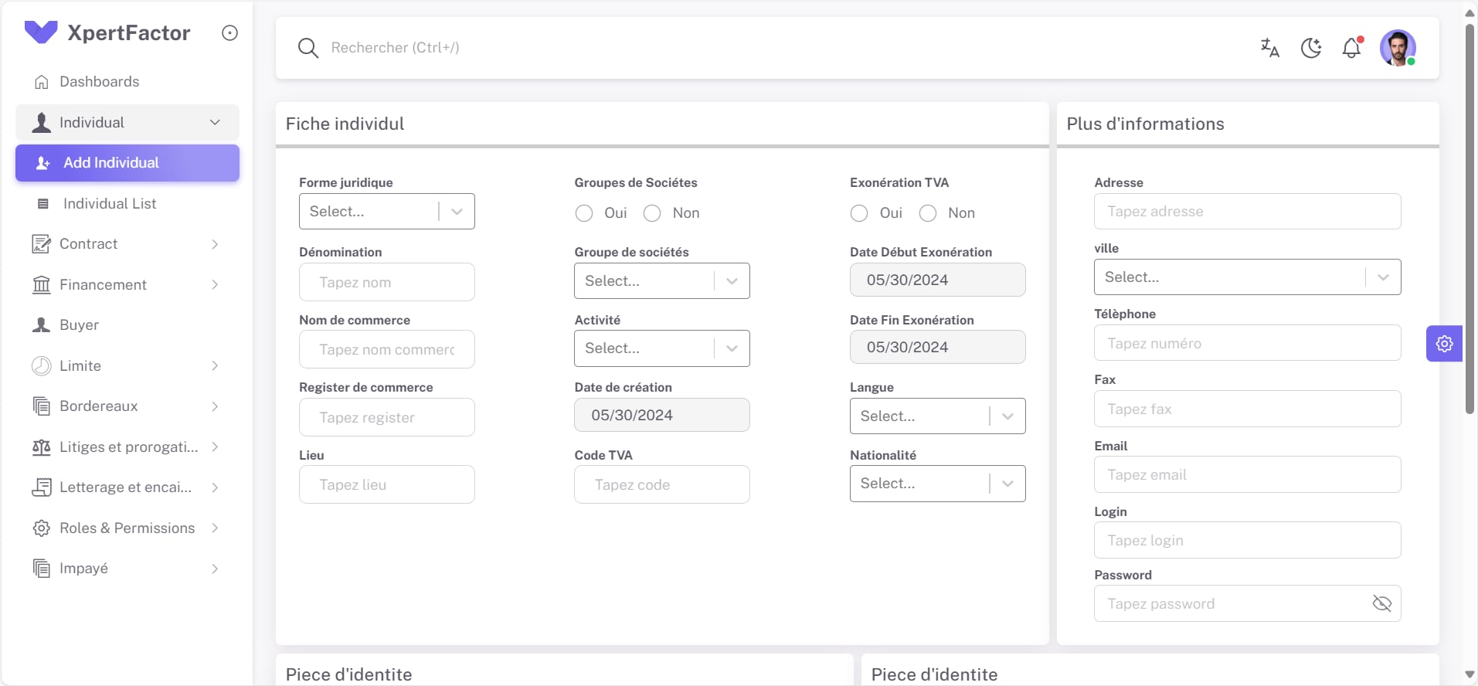

Figure 3.8 – add individual interface

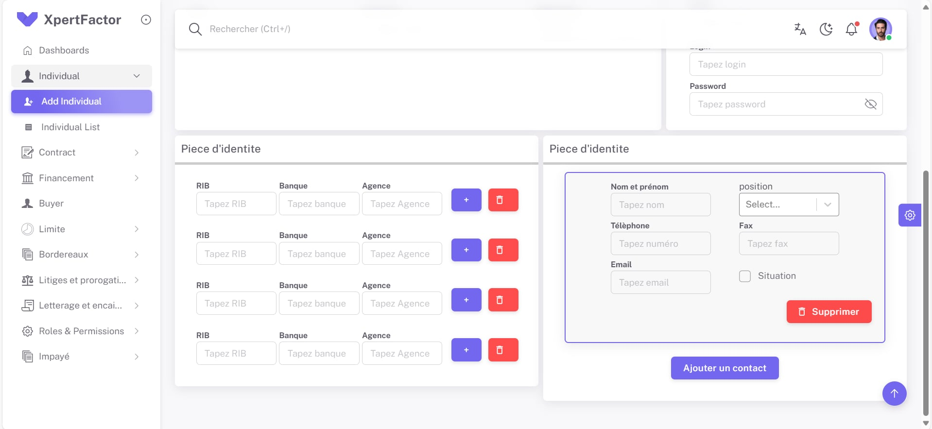

Figure 3.9 – add individual rest interface

## 3.6 Tests

To guarantee a high-quality product, our development process prioritizes rigorous testing. Functionality is thoroughly evaluated at the end of each sprint, followed by comprehensive validation with the Product Owner. This ensures bugs are caught early, features meet expectations, and the software remains well-maintained throughout its lifecycle.

In this sprint we have used **Swagger** to test the individual creation, the getting by Id and the get all.

Next, we will present a collection of screenshots illustrating a selection of the tests we have conducted.

### 3.6.1 Individual creation

In Swagger, test individual creation by selecting the POST method for the "Create New Individual" endpoint at http://localhost:8746/api/v1/Individu/CreateNewIndividu, define the new individual's data in the request body, execute the request, and verify a successful response (200 OK) with potential details about the created individual.

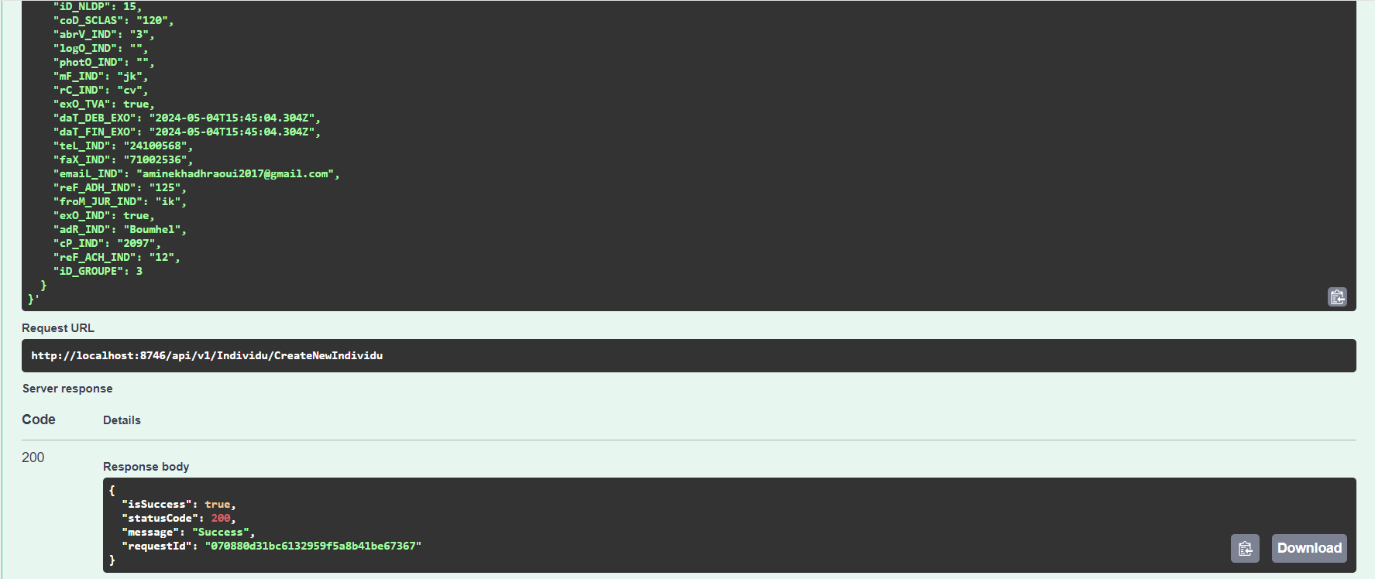

Figure 3.10– Test case individual creation

### 3.6.2 Get individual By Id

Next and as a part of testing the retrieve of an individual by ID, We selected the GET method for the "Get Individual by Id" endpoint using the URL http://localhost:8746/api/v1/Individu/GetIndividuById/5, replacing "5" with the actual ID of the desired individual. After executing the request, we verified a successful response (200 OK) containing the details of the retrieved individual.

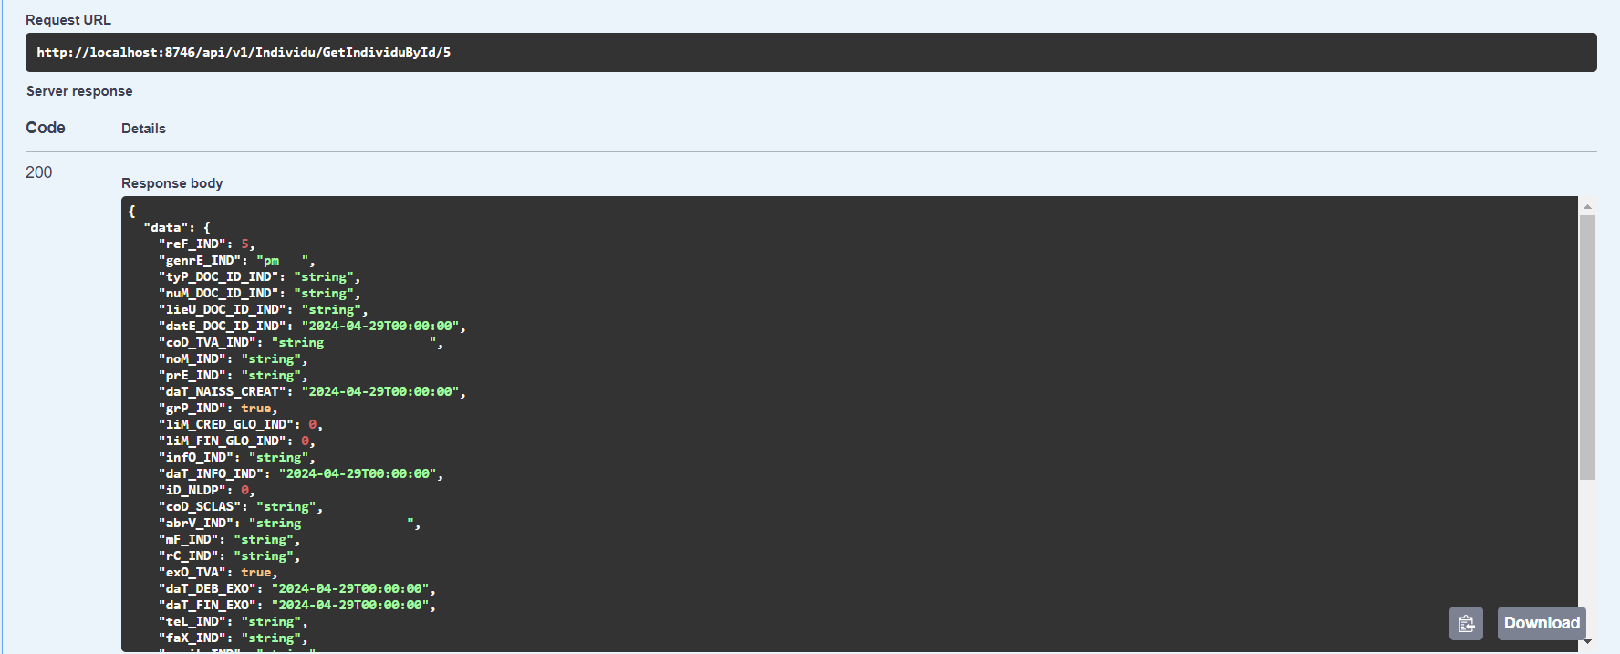

Figure 3.11– Test case of getting individual by id

### 3.6.3 Get All individuals

As part of testing, we tested fetching all individual entries. We selected the GET method for the "Get All Individuals " endpoint at the URL http://localhost:8746/api/v1/Individu/GetAllIndividus. Upon executing the request, we aimed to retrieve a successful response (200 OK) containing a list of all individuals stored within the system.

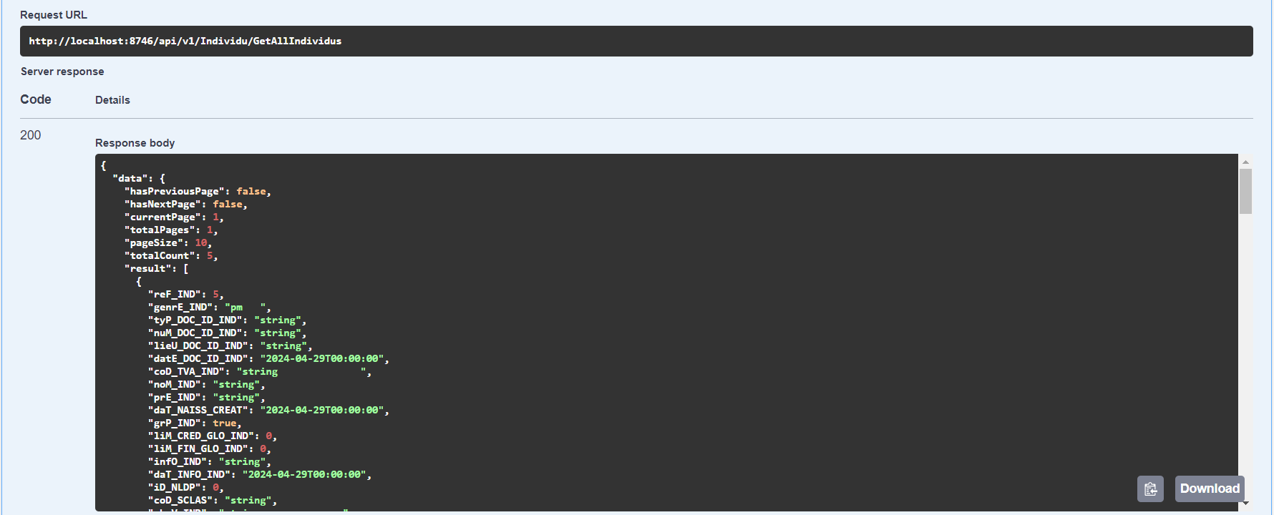

Figure 3.12– Test case of getting all individuals

## 3.7 Sprint 1 Retrospective

This section is designed to be a continuous improvement meeting for the Scrum Team. It's a time for the team to reflect on the just-completed sprint and identify areas where they can improve their processes, tools, and ways of working.

* We successfully implemented the creation of both the moral and physical individual.
* We finished implementing also the getting individual by id.
* We implemented the functionality of getting all individuals.
* We implemented the authentification .

A complex technical issue this sprint delayed other stories. We’ll try to figure out ways to spot these earlier, like code reviews or tech huddles. We can also adjust how we estimate to account for unforeseen complexities, improving our future sprint efficiency.

## 3.8 Conclusion

This chapter covered the first sprint, including analysis, design, development, and testing. The next chapter explores the functionalities of the second sprin

# Chapter 4: Sprint 2 Study and realization

## 4.1 Introduction

Like the previous chapter, in this section, we will delve into the details of our second sprint. We will present our backlog and use cases, followed by a thorough examination of each use case.

## 4.2 Sprint Backlog

Following the same approach as the previous sprint, we will now establish our second sprint backlog.

|  |  |  |  |  |  |
| --- | --- | --- | --- | --- | --- |
| Sprint Num | Name of feature | ID user story | User Story | Acceptance Criteria | Estimation |
| 2 | Create Contract | 2.1 | As an Agent/Admin, I want to create a contract to sell my invoice to a factor so I can get immediate cash. | *User can upload a copy of the invoice  * System validates invoice details and calculates factoring fee  * User can review contract details before submitting  * System saves contract information and generates a unique contract ID | 3 |
| 2 | View Contracts | 2.2 | As an Agent/Admin, I want to view all my contracts including their details. | * User can access a list of all their contracts  * Each contract displays details like contract ID, invoice amount, due date, factoring fee, and status  * User can search and filter contracts by various criteria (e.g., date range, status) | 2 |
| 2 | Update Contract | 2.3 | As an Agent/Admin, I want to update the details of an existing contract, such as the invoice amount or due date (before the factor purchases the invoice). | * User can search for a specific contract by ID * User can edit specific contract details (e.g., invoice amount, due date)  * System validates updated information  * User can review changes before submitting update  * System reflects the updated information on the contract details and list | 1 |

Table 4.1 – Sprint 2 Backlog

## 4.3 Functional Specifications

### 4.3.1 Use case diagram

The picture down below represents the use case for our second sprint

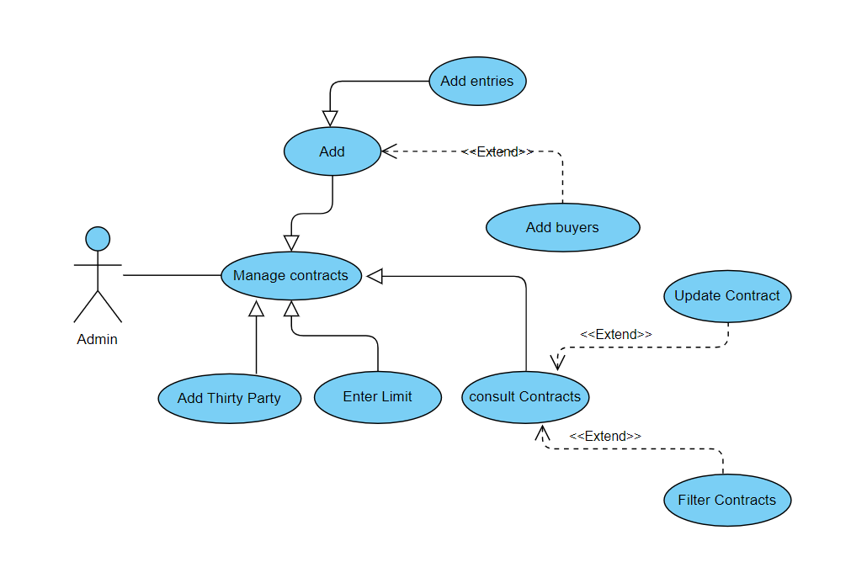

Figure 4.1– Contract Use Case

### 4.3.2 Use case description

In this section, our focus is on providing a comprehensive description of the "Create Contract" use case.

Now, we will delve into the details of each use case by providing a textual description for each one.

#### 4.3.2.1 Use Case: Create Contract

The table below describes the textual description of the " Consult individuals list " use case.

|  |  |
| --- | --- |
| Title | Add Contract |
| Actor | Admin |
| Pre-condition | - Admin has access to the factoring system. |
| Post-condition | - A new contract is created.  - Contract details are saved. |
| Normal scenario description | 1. User selects "Add Contract" from the menu.  2. User selects an existing buyer from the system or creates a new buyer.  3. User enters contract details (contract type, value, terms).  4. User reviews and submits the contract.  5. System confirms contract creation and displays a contract ID. |
| Exception scenario description | - Required contract details are missing.  - System displays an error message explaining the issue ("Missing contract value"). |

Table 4.2 – Create a contract scenario description

#### 4.3.2.2 Use Case: Consult Contracts

The table below describes the textual description of the " Consult Contracts list " use case.

|  |  |
| --- | --- |
| Title | Consult Contracts list |
| Actor | Agent/Admin |
| Pre-condition | Agent /Admin has access to view contracts. |
| Post-condition | Contract information is displayed. |
| Normal scenario description | 1. Agent /Admin selects "Consult Contracts" from the menu.  2. Agent /Admin searches for a contract by ID, buyer name, or other criteria.  3. System displays a list of matching contracts.  4. User selects a contract to view details.  5. System displays contract details (e.g., parties involved, contract type, value, terms). |
| Exception scenario description | - User does not have access to view contracts.  - Contract cannot be found based on search criteria.  - System displays a message indicating insufficient permissions. - System refines the search results based on additional criteria provided by the user. |

Table 4.3 – Consult Contracts list scenario description

#### 4.3.2.2 Use Case: Update Contracts

The table below describes the textual description of the " Consult Contracts list " use case.

|  |  |
| --- | --- |
| Title | Consult Contracts list |
| Actor | Admin |
| Pre-condition | Admin has access to view contracts. |
| Post-condition | Contract information is displayed. |
| Normal scenario description | 1. Admin selects "Consult Contracts" from the menu.  2. Admin searches for a contract by ID, buyer name, or other criteria.  3. System displays a list of matching contracts.  4. Admin selects a contract to view details.  5. System displays contract details (e.g., parties involved, contract type, value, terms). |
| Exception scenario description | - Admin does not have access to view contracts.  - Contract cannot be found based on search criteria.  - System displays a message indicating insufficient permissions. - System refines the search results based on additional criteria provided by the user. |

Table 4.4 – Consult Contracts list scenario description

### 4.3.3 Add Contract scenario description

#### 4.3.3.1 Detailed use case “create Contract”

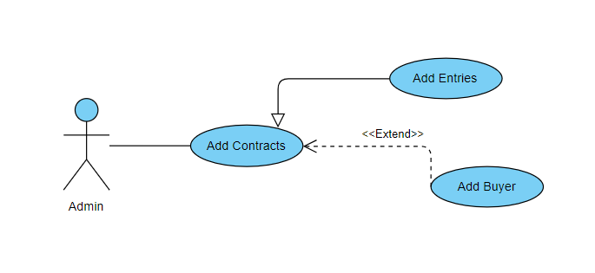

Figure 4.2– Create Contract Use Case

#### 4.3.3.2 Use case description

In this section, our objective is to present a detailed description of the "Add Contract" use case.

The following table outlines the textual description of the "Add Contract" use case:

|  |  |
| --- | --- |
| Title | Add instruments |
| Actor | Agent /Admin |
| Pre-condition | - Agent /Admin has access to the factoring system. |
| Post-condition | - New instrument is added to the system. |
| Normal scenario description | 1. Agent /Admin navigates to the "Add Contract" section.  2. Agent /Admin provides the necessary details for the new instrument (e.g., type Contract, cheque, Comm Factoring).  3. Agent /Admin submits the form.  4. System validates the input data.  5. System adds the new contract to the system.  6. System displays a success message to the user. |
| Exception scenario description | 1. Required information is missing (e.g., Type, adherent name).  System displays an error message indicating the missing fields.  2. Invalid data is entered (e.g., missing information's). System displays an error message with details about the invalid data.  3. System encounters an error during data processing.  Agent /Admin is notified of the error, and relevant IT support personnel are informed. |

Table 4.5 – Add contract scenario description

### 4.3.4 Update Contract scenario description

#### 4.3.4.1 Detailed use case

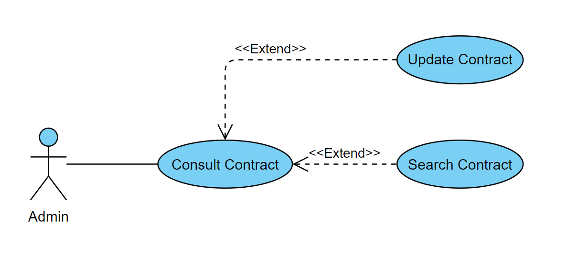

Figure 4.3– Update contracts use case

#### 4.3.4.2 Use case description

In this section, we aim to provide a detailed description of the "update contracts" use case.

The following table outlines the textual description of the " update contracts" use case:

|  |  |
| --- | --- |
| Title | Update Contract |
| Actor | Admin |
| Pre-condition | - Admin has access to the factoring system. |
| Post-condition | - The contract form is Ensuring that the instruments match the values expected in the invoice. |
| Normal scenario description | 1- Admin selects a contract to update.  2- Admin views the current contract details.  3- Admin edits the contract details.  4- Admin initiates the update process.  5- System validates the updated contract details.  6- System updates the contract.  7- System updates related records.  8- System logs the update action.  9- System displays a success message to the admin. |
| Exception scenario description | 1. Admin selects a contract to update.  2. Invalid data is entered  3. System encounters an error during data processing. |

Table 4.6– Update contract scenario description

### 4.3.5 Consult Contract scenario description

#### 4.3.5.1 Detailed use case



Figure 4.4– Consult Contract use case

4.3.5.2 Use case description

In this section, we aim to provide a detailed description of the "Consult Contract" use case.

The Following table outlines the textual description of the "Consult Contract" use case:

|  |  |
| --- | --- |
| Title | Consult Contract |
| Actor | Admin |
| Pre-condition | - Admin has access to the factoring system. |
| Post-condition | -The contract details are successfully viewed. |
| Normal scenario description | 1 - Admin navigates to the contract management section.  2- Admin searches for a specific contract.  3- Admin selects the contract to consult.  4- System retrieves the contract details.  5- System displays the contract details.  6- Admin reviews the contract details. |
| Exception scenario description | 1. Required information is missing.  2. Invalid data is entered  3. System encounters an error during data processing.  4- Admin lacks the necessary permissions. |

Table 4.7 – Consult contract scenario description

## 4.4 Modeling

Requirements locked in, we've dived into modeling, a critical step in this sprint. We've leveraged UML to craft sequence diagrams for essential use cases, along with a class diagram, to clearly illustrate our system's behavior.

### 4.4.1 Sequence diagram

UML Sequence Diagram as a step-by-step picture show. It reveals how different parts of a system talk to each other, like characters in a play. Each message or "conversation" is shown happening in order, from top to bottom, making it easy to see what happens first, second, and so on. This helps us understand how the system works.

### 4.4.1.1 Add Contract Sequence diagram

This sequence diagram illustrates the interactions between the User/Admin, the front-end components, and the back-end layers within the contract management system when adding a new contract. The scenario details the steps involved in initiating the add contract process, entering contract details, validating the information, saving the new contract to the database, and confirming the successful addition of the contract.

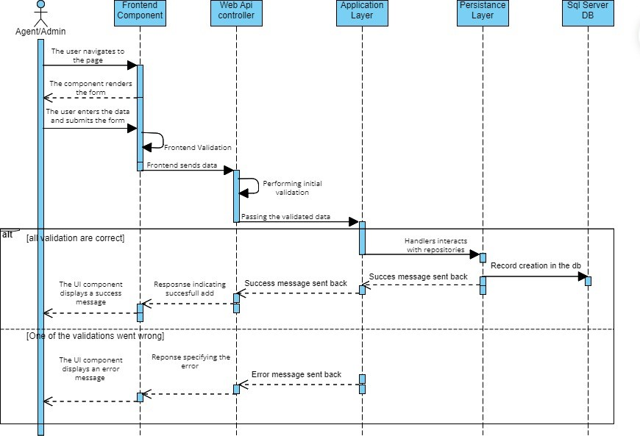

Figure 4.5– Add Contract sequence diagram

### 4.4.1.2 Update Contract Sequence diagram

This sequence diagram illustrates the interactions between the User/Admin, the front-end components, and the back-end layers within the contract management system when updating an existing contract. The scenario details the steps involved in initiating the contract update process, retrieving the current contract details, editing the information, validating the updates, saving the changes to the database, and confirming the successful update of the contract.

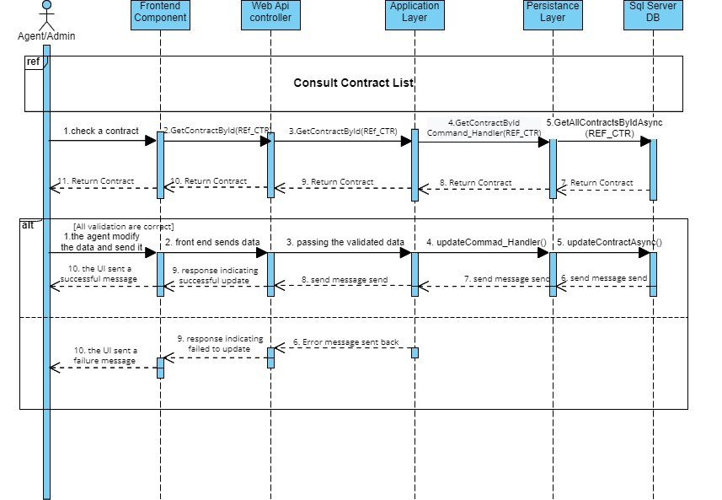

Figure 4.6– Update Contract sequence diagram

### 4.4.1.3 Consult Contract Sequence diagram

This sequence diagram illustrates the interactions between the User/Admin, the front-end components, and the back-end layers within the contract management system when consulting a contract.

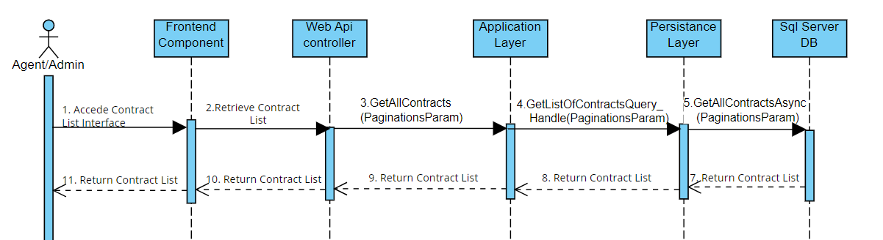

Figure 4.7– Add Contract sequence diagram

### 4.4.2 Contract Class diagram

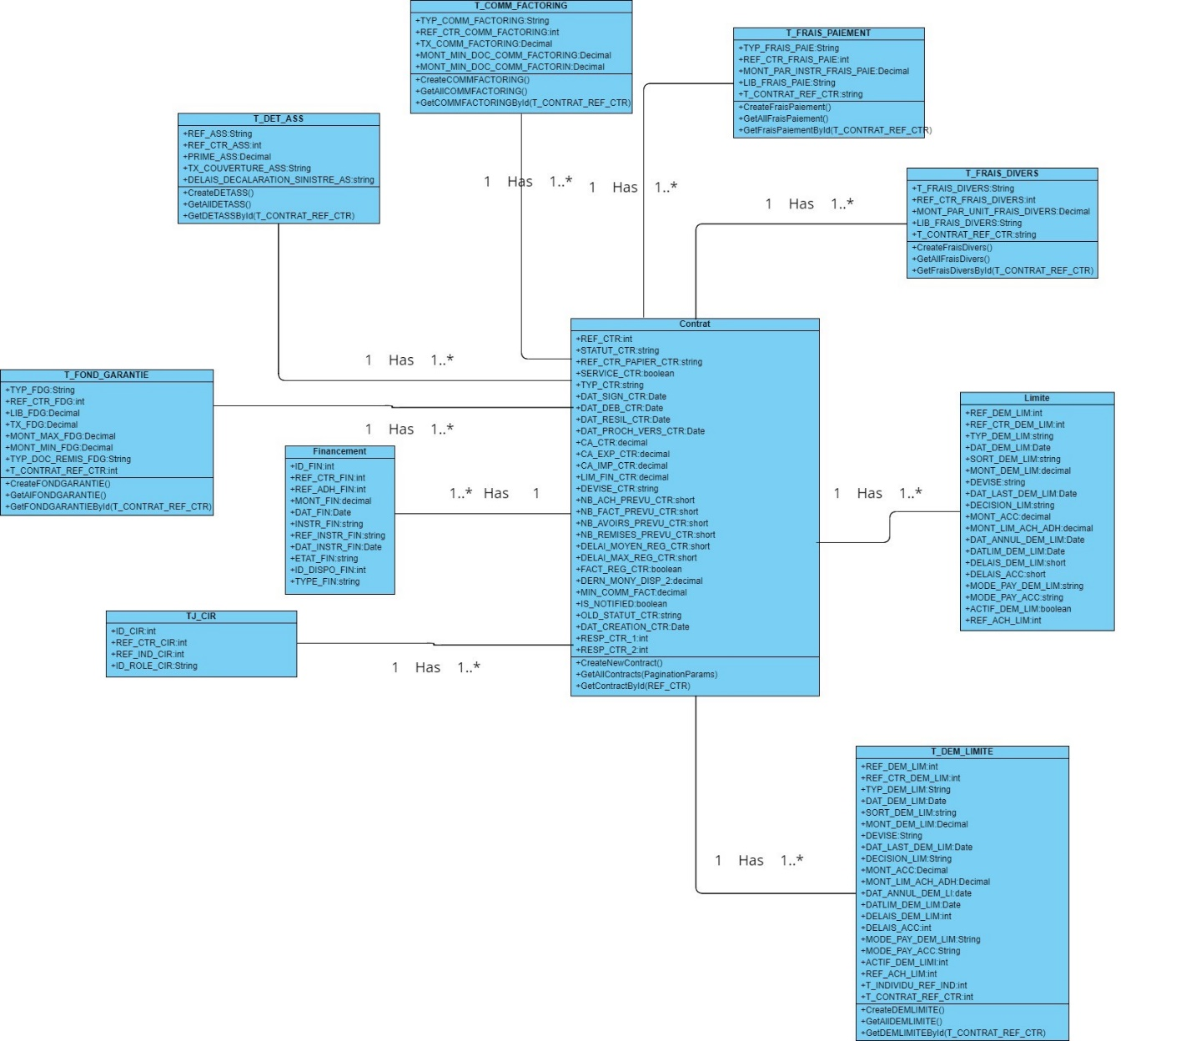This class diagram provides a structural representation of the Contract entity within the contract management system. It illustrates the attributes and methods associated with the Contract class, including properties such as REF_CTR, parties involved, terms, conditions, and status. Additionally, it outlines the relationships between the Contract class and other relevant classes

Figure 4.8– Sprint 2 class diagram

## 4.5 Realization

In this section, we will showcase a collection of screenshots featuring the user interfaces that have been implemented during the current sprint.

### 4.5.1 Add Contract Interface

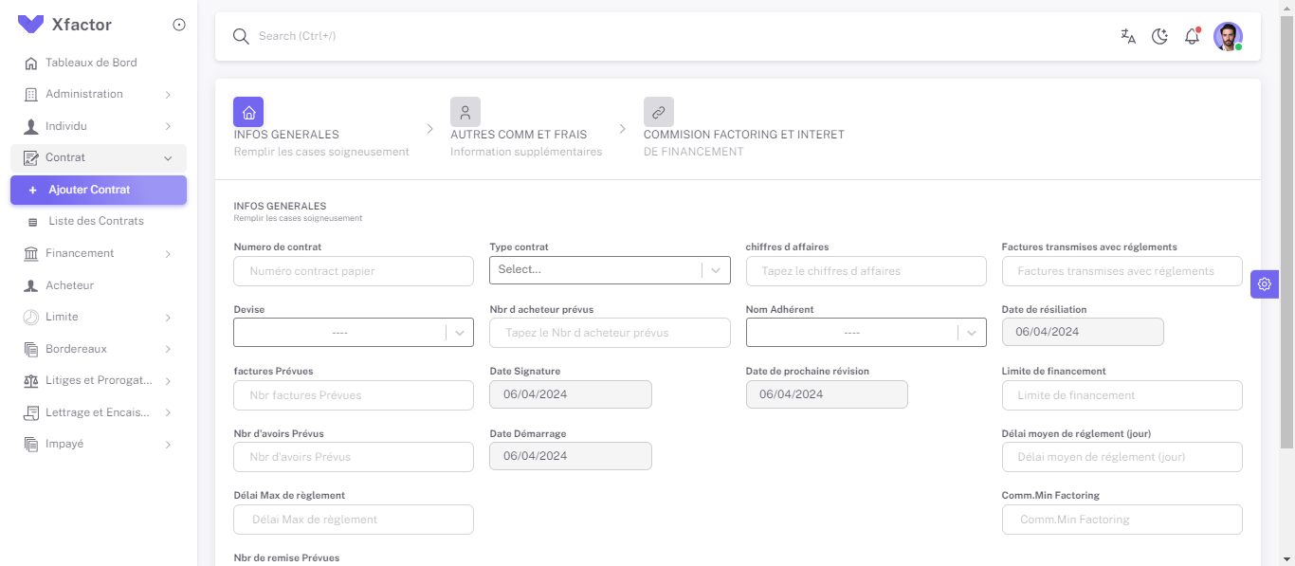Adding a new contract involves three steps:

Figure 4.9–Step 1 of Creation Contract 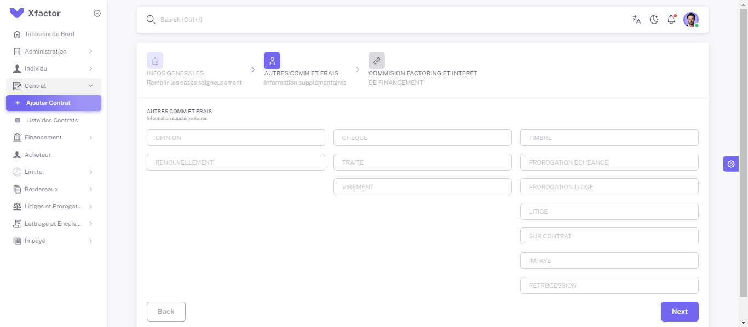

Figure 4.10–Step 2 of Creation Contract

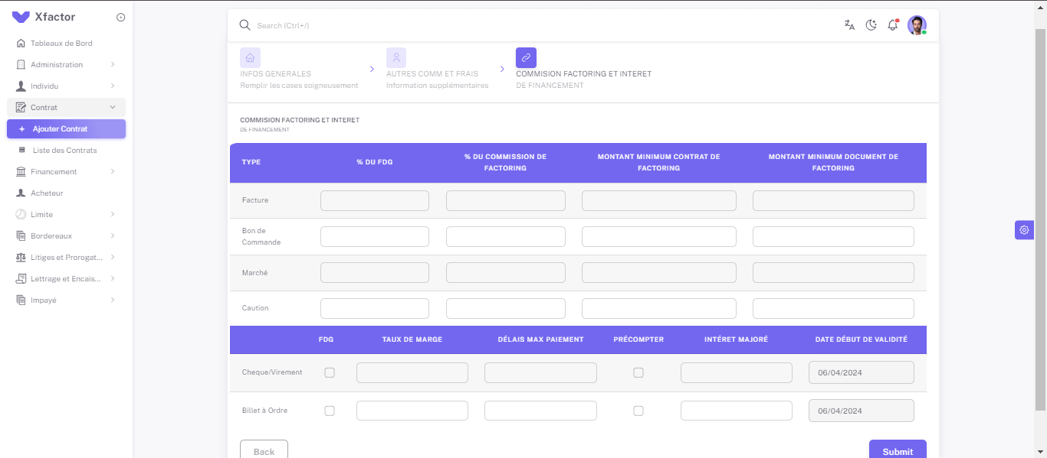Figure 4.11–Step 3 of Creation Contract

### 4.5.2 List Contract’s Interface

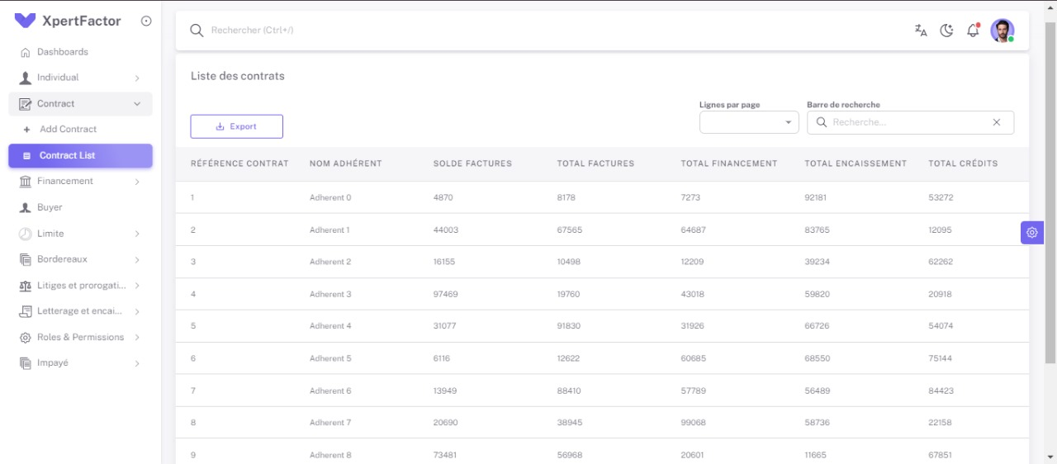

Figure 4.12– List Contract Interface

## 4.6 Tests

To guarantee a high-quality product, our development process prioritizes rigorous testing. Functionality is thoroughly evaluated at the end of each sprint, followed by comprehensive validation with the Product Owner. This ensures bugs are caught early, features meet expectations, and the software remains well-maintained throughout its lifecycle.

In this sprint we have used **Swagger** to test the individual creation, the getting by Id and the get all.

Next, we will present a collection of screenshots illustrating a selection of the tests we have conducted.

### 4.6.1 Contract creation

In Swagger, test individual creation by selecting the POST method for the "Create New Contract" endpoint at http://localhost:8746/api/v1/Contract/CreateNewContract, define the new Contract data in the request body, execute the request, and verify a successful response (200 OK) with potential details about the created contract.

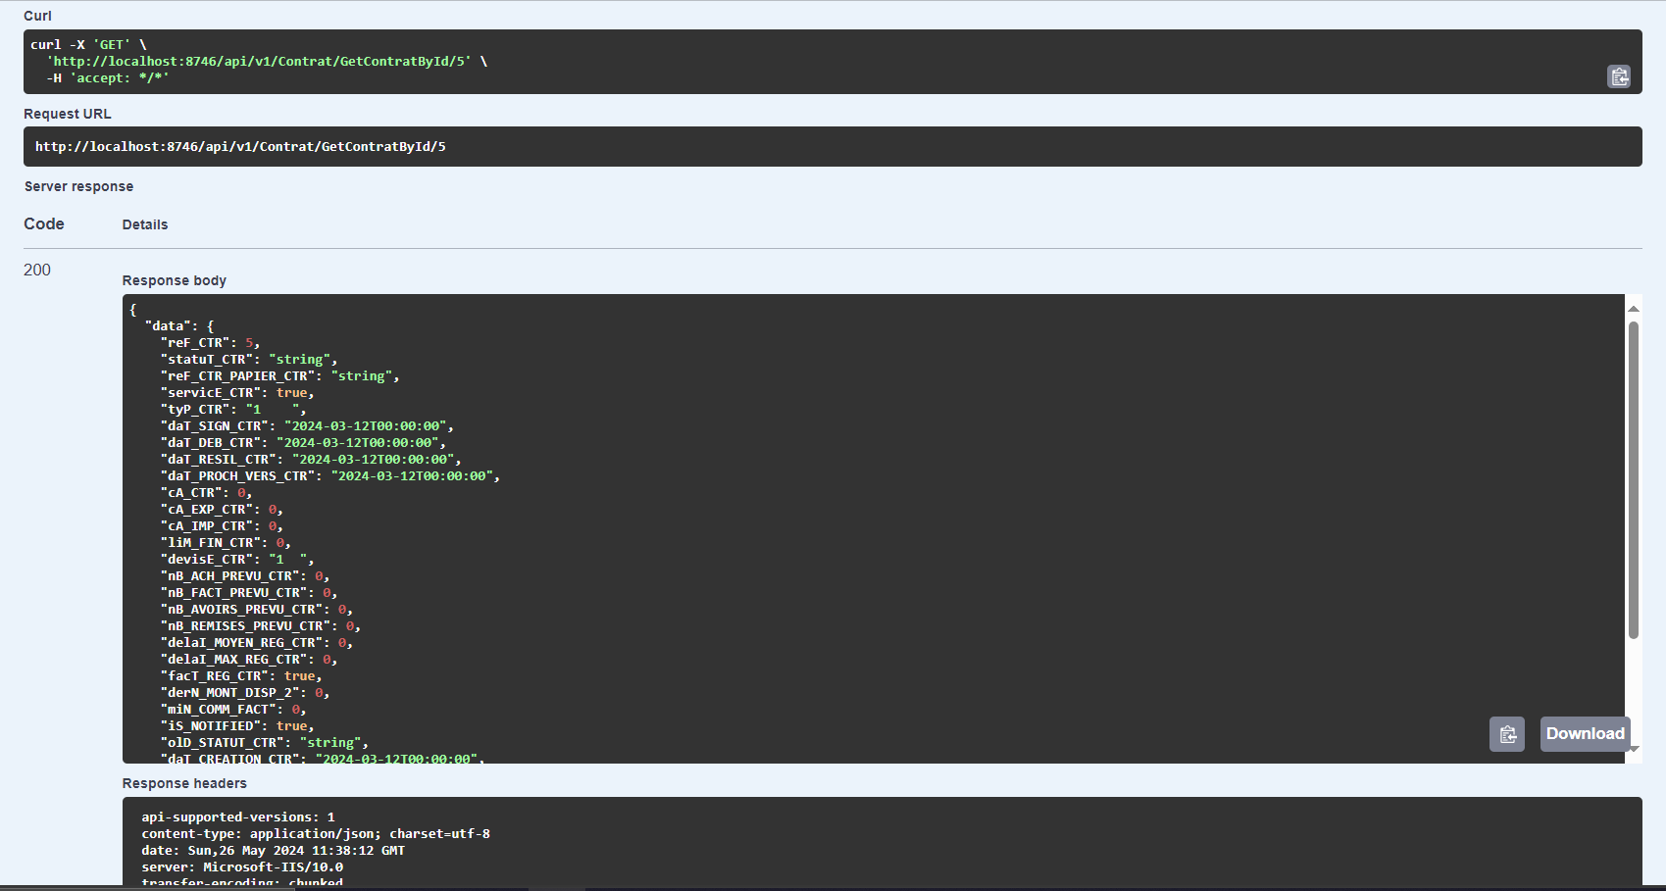

Figure 4.13– Test case of getting all individuals

### 4.6.2 Get contract By Id

Next and as a part of testing the retrieve of an individual by ID, We selected the GET method for the "Get contract by Id" endpoint using the URL http://localhost:8746/api/v1/ contract/GetContractById/5, replacing "5" with the actual ID of the desired Contract. After executing the request, we verified a successful response (200 OK) containing the details of the retrieved contract.



Figure 4.14– Test case of getting Contracts by ID

## 4.7 Sprint 2 Retrospective

This section is dedicated to incorporating the retrospectives provided by the product owner following the conclusion of our fourth sprint.

* + We successfully implemented the creation of the instrument
  + We implemented the addition of new Contract.
  + We successfully implemented the ability to List Contracts.
  + We implemented the functionalities of creation, deletion, updation and validation

contracts.

* + We also implemented the functionalities of get all bordereaux, get bordereau by id and get contract by reference (Ref_Ctr).

## 4.8 Conclusion

Having traversed the analysis, design, development, and testing phases of Sprint 2, this chapter has laid out the groundwork for a successful project. We now turn our attention to Sprint 3 in the next chapter, where we'll delve into the exciting features planned for implementatio

# Chapter 5: Sprint 3 Study and realization

## 5.1 Introduction

As in the previous chapter, in this section, we will delve into the details of our fourth sprint. We will present our backlog and use cases, then review each use case in depth.

## 5.2 Sprint Backlog

Following the same approach as the previous sprint, we will now establish our third backlog for the sprints.

|  |  |  |  |  |
| --- | --- | --- | --- | --- |
| ID | Name of feature | ID user story | User Story | Estimation |
| 3 | Manage Financing | 3.1 | As an Agent, I want to be able to add new financing. | 9d |
| 3.2 | As an Agent , I want to be able to validate existing financing. |
| 3.3 | As an Agent, I want to be able to reject existing financing. |
| 3.4 | As an Agent, I want to be able to view the details of a financing. |
|  |  | 3.5 | Creation workflow financement |  |
| 4 | Manage Limites | 4.1 | As a validator, I want to be able to add a new financing | 9d |
| 4.2 | As a validator, I want to be able to validate a existing funding . |
| 4.3 | As an Agent, I want to be able to refuse a existing funding. |
|  |  | 4.4 | As an Agent  , I want to see the financing details. |  |

Table 5.1 – Sprint 3 Backlog

## 5.3 Functional Specifications

We will create a use case diagram for this sprint to answer the question "What does our system do?" Additionally, we will prov–ide a textual description of the diagram to further explain the system's functionalities.

### 5.3.1 General Use Case Diagram

The image below represents the use case for our fourth sprint.

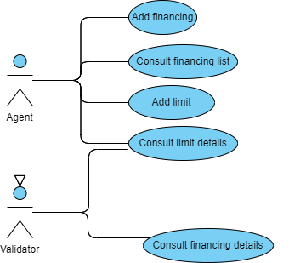

Figure 5.1 – Use Case Diagram "Manage Financing and Manage Limits"

To ensure that the use case diagram is easy to understand, UML provides the option to include a textual description of each use case, which describes the system's behavior.

### **5.3.2 Manage Financing** scenario **description**

#### 5.3.2.1 Detailed Use Case

The refinement of the use case "Manage Financing" is illustrated by the figure below.

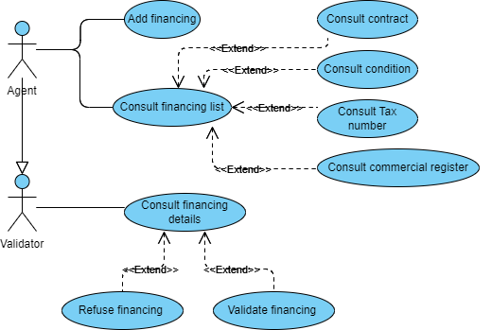

Figure 5.2 – Detailed Use Case Diagram "Manage Financing"

#### 5.3.2.2 Use Case Description

In this section, we aim to provide a comprehensive description of the use case "Manage Financing". The first table presents the textual description of the "Add Financing" use case, while the second describes the textual description of the "View Trade Registry" use case.

* Use Case "Add Financing" Description Table

|  |  |
| --- | --- |
| Title | Add Financing |
| Actor | Agent |
| Pre-condition | The agent has successfully authenticated to the application. |
| Post-condition | The financings are created. |
| Normal scenario description | 1. The agent selects a contract for a member.  2. The system displays all the information of the member per  contract.  3. The system displays the form for creating a new financing.  4. The agent enters the necessary information and validates the input.  5. The system checks for empty fields.  6. The system saves the new financing in the database.  7. The system displays a success message. |
| Exception scenario description | 2. a. The agent consults the member's contract by contract.  2. b. The agent consults the member's share condition by contract.  2. c. The agent consults the member's trade registry by contract.  2. d. The agent consults the member's tax ID by contract.  4. a. Empty or incorrect fields.  - The system displays an alert message.  - The scenario returns to step 2. |

Table 5.2 – Description of the Use Case "Add Financing"

* Use Case "Consult Trade Registry" Description Table

|  |  |
| --- | --- |
| Title | Consult Trade Registry |
| Actor | Agent |
| Pre-condition | The agent has successfully authenticated the application. |
| Post-condition | The member's trade registry is displayed to the agent. |
| Normal scenario description | 1. The agent selects the option to consult the trade registry.  2. The system displays a search form to specify the identifier of the  member or the contract.  3. The agent enters the identifier of the member or the contract.  4. The system searches for and retrieves the corresponding trade registry information.  5. The system displays the member's trade registry to the agent. |
| Exception scenario description | 2. a. The agent cancels the consultation of the trade registry.  - The system cancels the operation and returns to the previous  screen.  4. a. No trade registry found.  - The system displays a message indicating that no trade registry has been found for the specified identifier.  - The scenario returns to step 2. |

Table 5.3 – Description of the Use Case " Consult Trade Registry "

### 5.3.3 Manage Limits scenario description

#### 5.3.3.1 Detailed Use Case

The refinement of the use case "Manage Limits" is illustrated by the figure below.

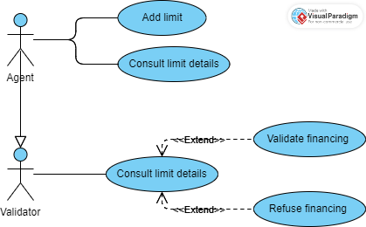

Figure 5.3 - Detailed Use Case Diagram "Manage Limits"

#### 5.3.2.2 Use Case Description

In this section, we aim to provide a comprehensive description of the use case "Manage Limits". The first table presents the textual description of the "Create Limit" use case, while the second describes the textual description of the "Validate Limit" use case.

* + Use Case "Consult Trade Registry" Description Table

|  |  |
| --- | --- |
| Title | Manage Limits |
| Actor | Agent |
| Pre-condition | The agent has successfully authenticated to the application. |
| Post-condition | The limits are created. |
| Normal scenario description | 1. The system displays the form for creating a new limit.  2. The agent selects a member.3. The agent selects a buyer.  4. The agent enters the necessary information and validates the  input.  5. The system checks for empty fields.  6. The system saves the new limit in the database.  7. The system displays a success message. |
| Exception scenario description | 5. a. If the system detects a format error in a field:  5. a1. The system displays an error message indicating the incorrect fields.  5. a2. The agent corrects the incorrect fields and validates again.  5. a3. The system checks the fields again.  5. a4. The system saves the new limit in the database.  5. a5. The system displays a success message. |

Table 5.4 – Description of the Use Case " Manage Limits"

* Use Case "Validate Limite" Description Table

|  |  |
| --- | --- |
| Title | Validate Limits |
| Actor | Validator |
| Pre-condition | The Validator has successfully authenticated to the application. |
| Post-condition | The limits are validated. |
| Normal scenario description | 1. The validator checks the list of already created limits.  2. The validator selects the "Validate Limit" option.  3. The validator validates the selected limit.  4. The system displays a success or failure message for the validation.  5. The system returns to the list of limits. |
| Exception scenario description | 4. a. If an error occurs during validation:  4. a1. The system displays an error message describing the issue.  4. a2. The validator corrects the error or contacts the administrator if necessary.  4. a3. The validator attempts to validate the limit again.  5. The system returns to the list of limits. |

Table 5.5 – Description of the Use Case " Validate Limits"

## 5.4 Modeling

We have reached another crucial phase in our understanding of the requirements. In the following section, we will present the sequence diagrams that have been considered in this sprint, as well as the class diagram.

### 5.4.1 Sequence diagram

At this stage, we begin with the sequence diagram for some use cases already detailed in the previous section.

#### 5.4.1.1 Add Financing sequence diagram

After authentication, a manager can add financing. The figure below represents the sequence diagram "Add Financing".

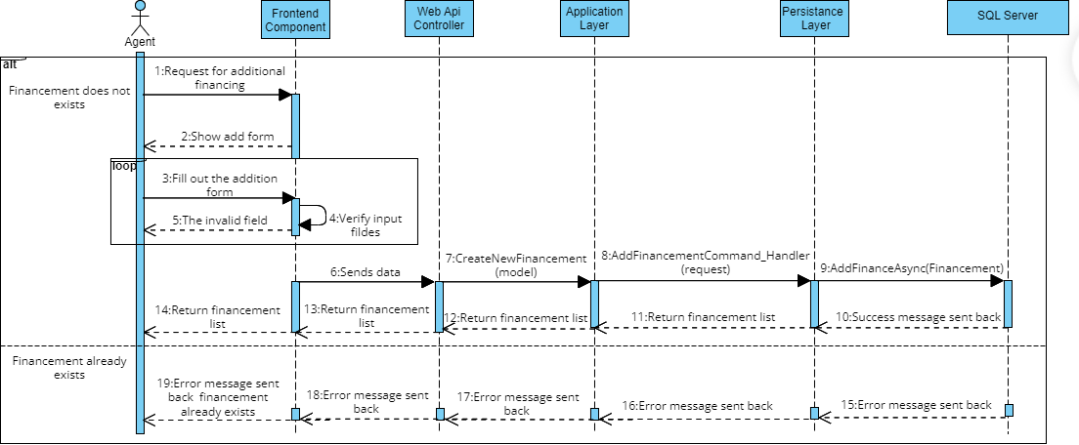

Figure 5.4 - Detailed Sequence Diagram "Add Financing"

5.4.1.2 View Financing Details **sequence diagram**

Authentication, a manager can consult the financing list to view the details of the financing. The following figure represents the sequence diagram "View Financing Details".

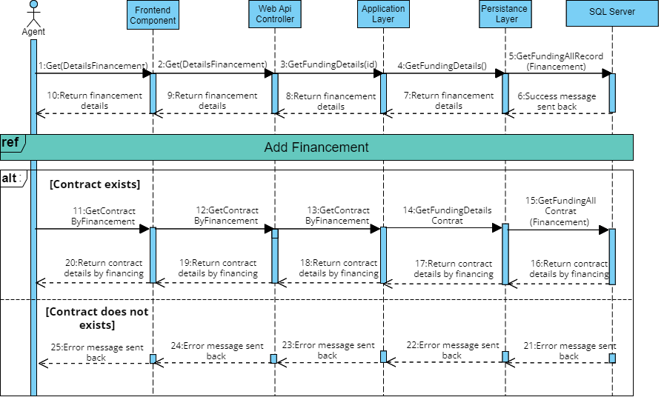

Figure 5.5 - Detailed Sequence Diagram "View Financing Details"

#### 5.4.1.3 Create Limit sequence diagram

Once authenticated, the manager can create a limit. The figure below illustrates the sequence diagram for "Create Limit".

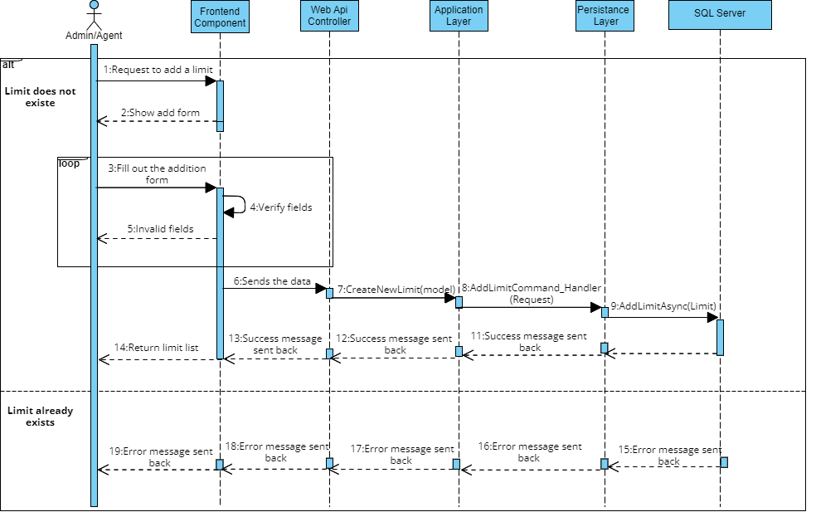

Figure 5.6 - Detailed Sequence Diagram "Create Limit"

#### 5.4.1.4 Validate Limit sequence diagram

Once authenticated, the validator can consult the list of created limits, choose a limit to validate. The figure below illustrates the sequence diagram for "Validate Limit".

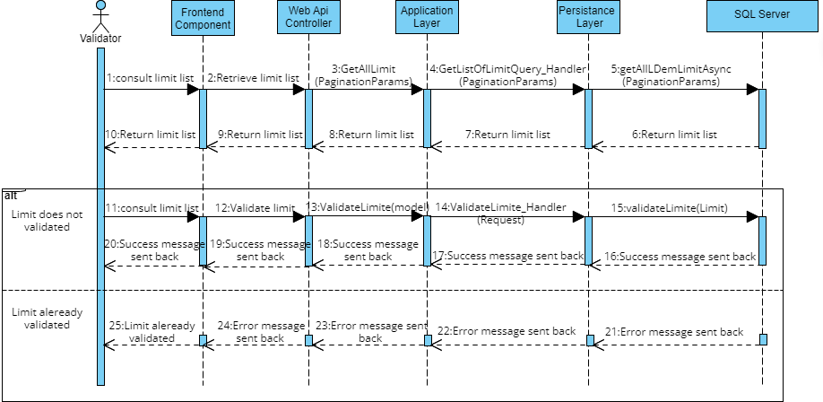

Figure 5.7 - Detailed Sequence Diagram "Validate Limit"

### 5.4.2 Class Diagram

In software engineering, a class diagram in the Unified Modeling Language (UML) is a type of static structure diagram that describes the structure of a system by showing the system's classes, their attributes, their operations (or methods), and the relationships between objects.

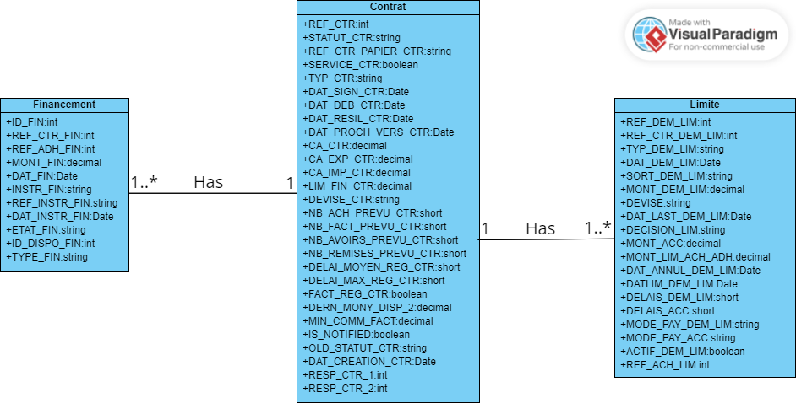

Figure 5.8 - Class Diagram of sprint 3

## 5.5 Realization

In this section, we will present a collection of screenshots showcasing the user interfaces that have been implemented during the current sprint.

### 5.5.1 "Add Financing" Interface

The "Add Financing" functionality allows users to add information about financing, such as the instrument number, financing type, and associated date, via a user-friendly form.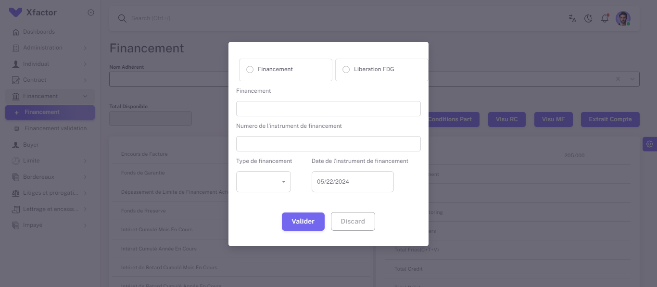

Figure 5.9 – "Add Financing" Interface

### 5.5.2 "View Financing Details" Interface

The "View Financing Details" functionality allows users to access detailed information about financing. This feature presents key attributes such as Total Invoices, Total Financing, Guarantee Fund, Invoice Outstanding, and Reserve Fund... Through a user-friendly interface, users can easily visualize and understand the financial aspects of each financing.

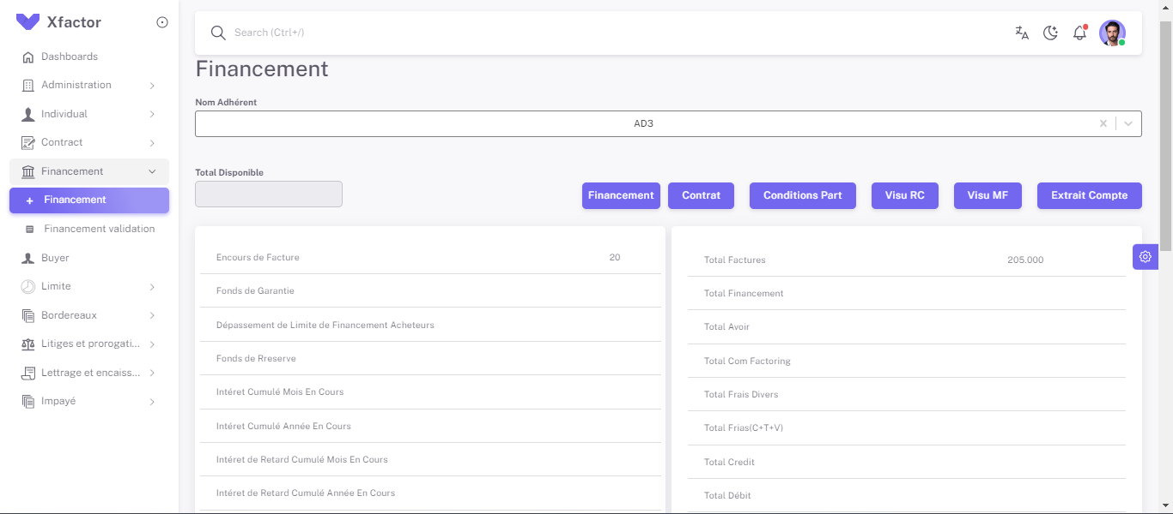

Figure 5.10 – "View Financing Details" Interface

### 5.5.3 Create Limit Interface

The "Create Limit" functionality allows users to add a new limit by entering specific information such as the name of the member, the name of the buyer, the amount... This functionality ensures precise and efficient limit management, providing an intuitive user interface for fast and error-free data entry.

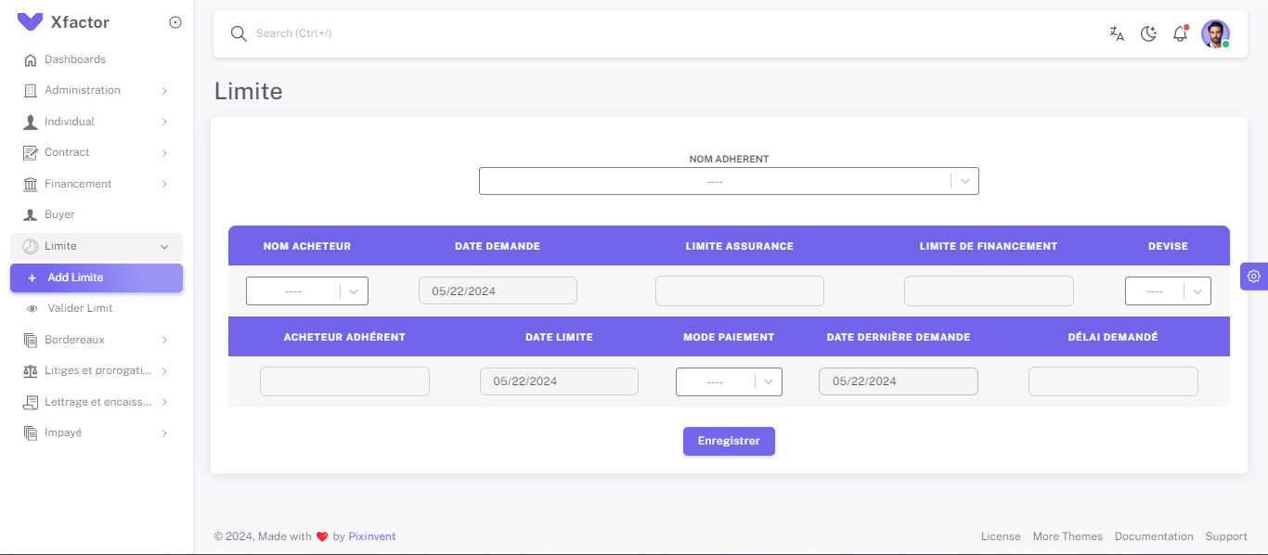

Figure 5.11 – "Create Limit" Interface

### 5.5.4 Validate Limit Interface

The "Validate Limit" functionality allows for modifying the state of a limit after consulting the list of limits. This task is essential to ensure that limits are properly approved or rejected based on predefined validation criteria. It provides a simple and efficient interface, allowing users to update the status of limits transparently and with complete traceability.

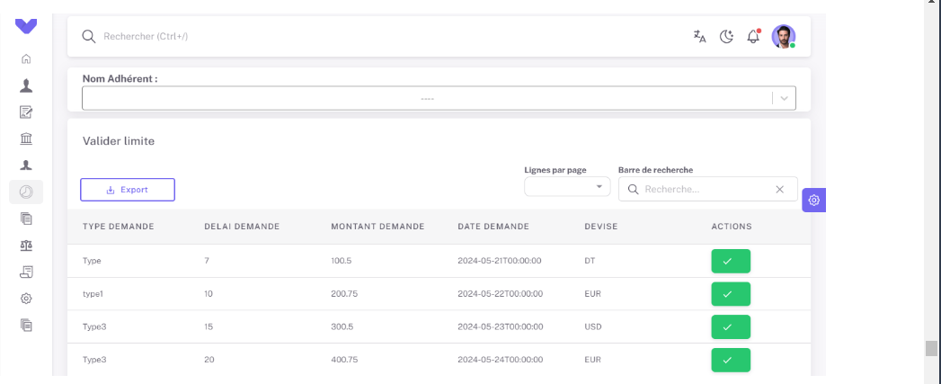

Figure 5.12 – "Validate Limit" Interface

## 5.6 Tests

Testing plays a crucial role in the software development lifecycle, constituting important steps. They allow developers to identify and rectify bugs while integrating new features, thus ensuring the continuous maintenance of the product even after its release. Therefore, before the end of each sprint, we tested the functionalities. Then, we validated all the functionalities with the Product Owner. As part of our process, we performed comprehensive functionality tests before concluding each sprint. We then validated each feature in collaboration with the Product Owner. In this sprint, we used Swagger to test the consultation of the list of inactive limits, Consultation of financing by contract reference, as well as Validate financing. We will then present a collection of screenshots illustrating a selection of tests that we have conducted.

### **5.6.1 Test Consultation of Financing by Contract Reference**

To test with Swagger, select the request type and use the GET method to consult the financing by contract reference. Enter the URL of the method and fill in the data in the Swagger body. Then click the "Send" button to execute the request. A success message will be displayed if the request is successful.

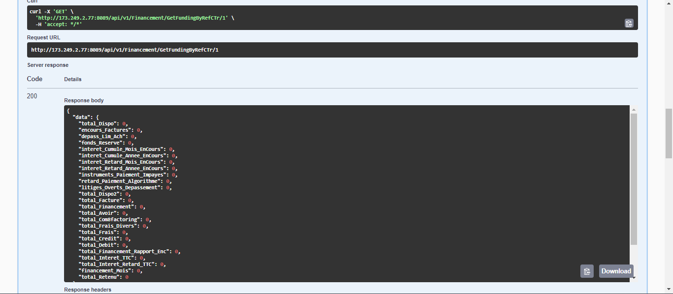

Figure 5.13 – "Consultation of Financing by Contract Reference" Test

### **5.6.2 Test Validate Financing**

To test the validation of financing with Swagger, select the PUT method to modify the financing status. Enter the URL of the method, fill in the necessary data in the Swagger body, then click the "Send" button to execute the request. A success message will be displayed if the request is successful.

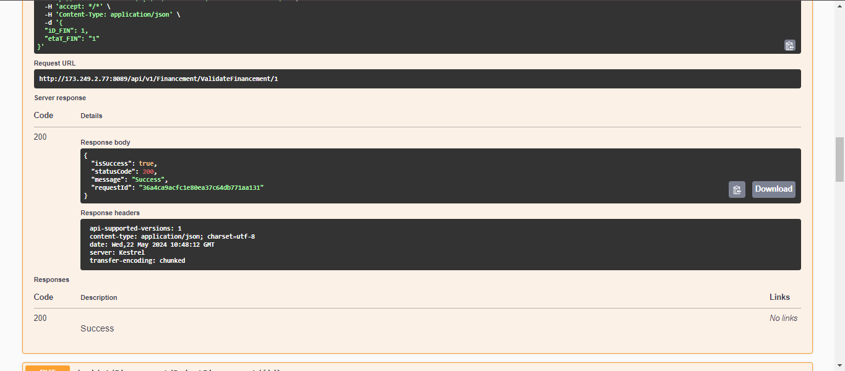

Figure 5.14 – "Validate Financing" Test

### 5.6.3 Test Consult Inactive Limits List

To test the consultation of the list of inactive limits with Swagger, select the GET method. Enter the URL of the appropriate method, then click the "Send" button to execute the request. The results will be displayed if the request is successful.

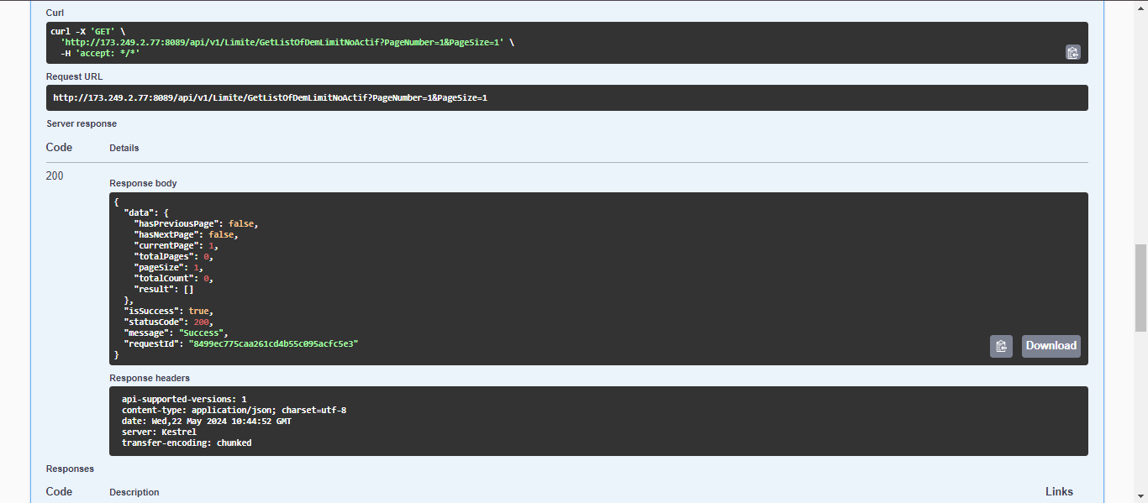

Figure 5.15 – "Consult Inactive Limits List" Test

## 5.7 PlannetPress connect module

PlanetPress Connect is a software solution developed by OL connect , designed for creating, managing, and distributing transactional and variable data documents. It is particularly useful for businesses that need to generate large volumes of personalized documents such as invoices, statements, and marketing materials.

* The DataMapper is a tool that converts and prepares data from multiple possible sources and formats. This course module covers the DataMapper from start to finish.
* The Data Designer in PlanetPress is used to create and design the layout of documents. It provides a visual interface to design various types of documents, such as invoices, statements, and marketing materials, ensuring they meet the specific needs of the organization.
* The workflow component in PlanetPress allows you to automate the entire document lifecycle, from data capture and document generation to distribution and archiving. Workflows help streamline processes, reduce manual intervention, and improve efficiency.

### 5.7.1 PlannetPress in Xpert factor

Shamsh IT now is the ambassador of PlanetPress in Tunisia and we use it in the workflow of Xpert Factor, we leverage PlanetPress to enhance and streamline our document-related tasks, particularly focusing on notifications and email communications.

It serves as a pivotal tool in automating and personalizing these processes, ensuring efficiency and accuracy in our operations.

Using PlanetPress in the Xpert Factor workflow significantly enhances our operational efficiency, reduces manual intervention, and improves the accuracy and personalization of our communications. The automation capabilities of PlanetPress ensure that our notifications and emails are timely and relevant, helping us maintain strong and effective communication with our clients. Additionally, the scalability of PlanetPress allows us to handle large volumes of documents and communications, supporting the growth and success of Xpert Factor.

By integrating PlanetPress into our workflow, we have transformed our document management processes, resulting in improved client satisfaction and streamlined operations.

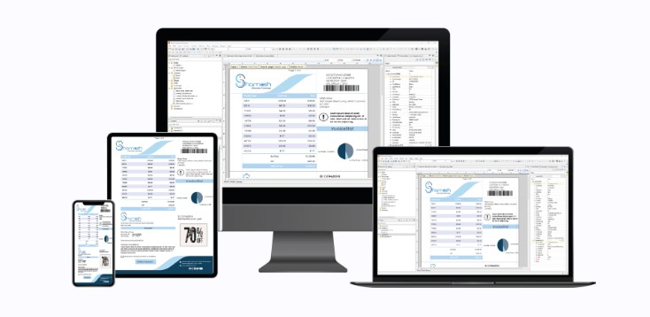

Figure 5.16 - exemple of PlanetPress work

This Qr code show us a youtube video of SHAMASH IT chanel were we are talking about PlanetPress connect and its services .

Figure 5.17 – Qr code

## 5.8 Sprint 4 Retrospective

This section is designed to include the retrospectives derived by the product owner after the completion of our first sprint.

✓ We have successfully implemented the financing management feature, allowing users to create and view financing details, as well as consult from contract, tax ID, trade registry.

✓ We have integrated the ability to validate financing, thus providing enhanced control and traceability of financing states.

✓ We have developed the necessary features to manage credit limits, including creation, consultation, and validation of limits.

We are ready to start the next sprint, provided, of course, that we have held a planning meeting beforehand.

## 5.9 Conclusion

In this chapter, we described the previous sprint, encompassing phases such as analysis, design, realization, and testing. Moving on to the next chapter, we will delve into the features associated with Sprint 4.

# Chapter 6: Sprint 4 Study and Realization

## Impayé module

## 6.1 Introduction

Building upon the progress of previous sprints, this section dives deep into Sprint 4, specifically the ‘impayé’ module. We'll be focusing on the backlog items and user stories critical for these functionalities. Get ready for a detailed breakdown of how we'll tackle tasks like creating lettering, managing collections, and ensuring smooth invoice reconciliation.

## 6.2 Sprint Backlog

|  |  |  |  |  |  |
| --- | --- | --- | --- | --- | --- |
| Sprint Num | Name of feature | ID user story | User Story | Acceptance Criteria | Estimation |
| 5 | Add invoice | 5.1 | As an agent,I want to add new unpaid invice to the system . So that I can efficiently record and manage details of invoices or receivables submitted for factoring. | Factoring account managers can add new unpaid invoice (date, number, amount, due date), optional services details and data | 10d |
| Consult unpaid | 5.2 | As an agent, I want to see a list of all unpaid with search capabilities .So that I can efficiently review, validate, and reject unpaid invoices submitted for factoring. | System displays a searchable list of all unpaid invoices with options for review, validation, and rejection. | 3d |

Table 6.1 – Sprint 4 Backlog (Unpaid)

## 6.3 functional specification

### 6.3.1 Use case diagram

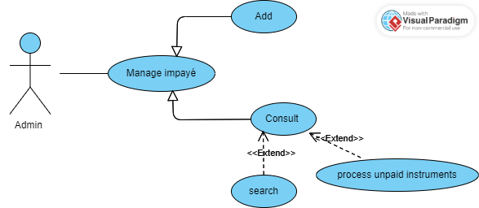

Figure 6.1 – Unpaid global use case

### 6.3.2 Add unpaid scenario description

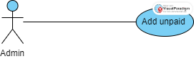

Figure 6.2 – Add unpaid use case

### 6.3.2.1 Use case description

|  |  |
| --- | --- |
| Title | Add unpaid |
| Actor | Agent or Admin |
| Pre-condition | The Agent or Admin must be logged into the system. |
| Post-condition | Unpaid items are create |
| Normal scenario description | 1. The system displays the form for creating a new unpaid instrument  2. The Agent or Admin enters the necessary information and validates its entry.  3. The system checks for empty fields.  4. The system records the new unpaid instrument in the database.  5. The system displays a success message. |
| Exception scenario description | 1.The admin may cancel adding a new user at any time.  2.The system may display an error message if the admin enters invalid information. |

Table 6.2 – use case description Add unpaid

### 6.3.3 Consult unpaid

### 6.3.3.1 Detailed use case

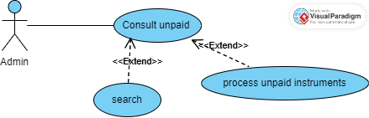

Figure 6.3 - Consult unpaid use case

### 6.3.3.2 Use case description

|  |  |
| --- | --- |
| Title | Add unpaid |
| Actor | Agent or Admin |
| Pre-condition | The Agent or Admin must be logged into the system. |
| Post-condition | Unpaid items are create |
| Normal scenario description | 1. Admin logs into the system.  2. Admin selects the option to consult unpaid invoices.  3. Admin can search for specific unpaid invoices.  4. Admin can process unpaid instruments if necessary. |
| Exception scenario description | 1. a Agent or Admin consults the list of outstanding instruments save  1. b Agent or Admin resolves unpaid instrument  3. a. Empty fields, not correct.  - The system displays an alert message.  - The scenario repeats 2. |

Table 6.3 - Consult unpaid description

## 6.4 Modeling

We have reached another crucial phase in our requirements understanding. In the upcoming section, we will present the sequence diagrams that have been considered in this sprint, along with the class diagram.

## 6.4.1 Sequence diagram

At this level, we begin with the sequence diagram of some use cases already detailed in the previous section.

### 6.4.1.1 Add unpaid sequence diagram

This sequence diagram shows the process of adding an unpaid invoice. An Admin or Agent navigates to the page, fills out, and submits the form. The frontend validates the data and sends it to the backend. The Web API controller performs further validation, and the application layer processes the data, creating a record in the SQL Server database. Success or error messages are then sent back to the user.

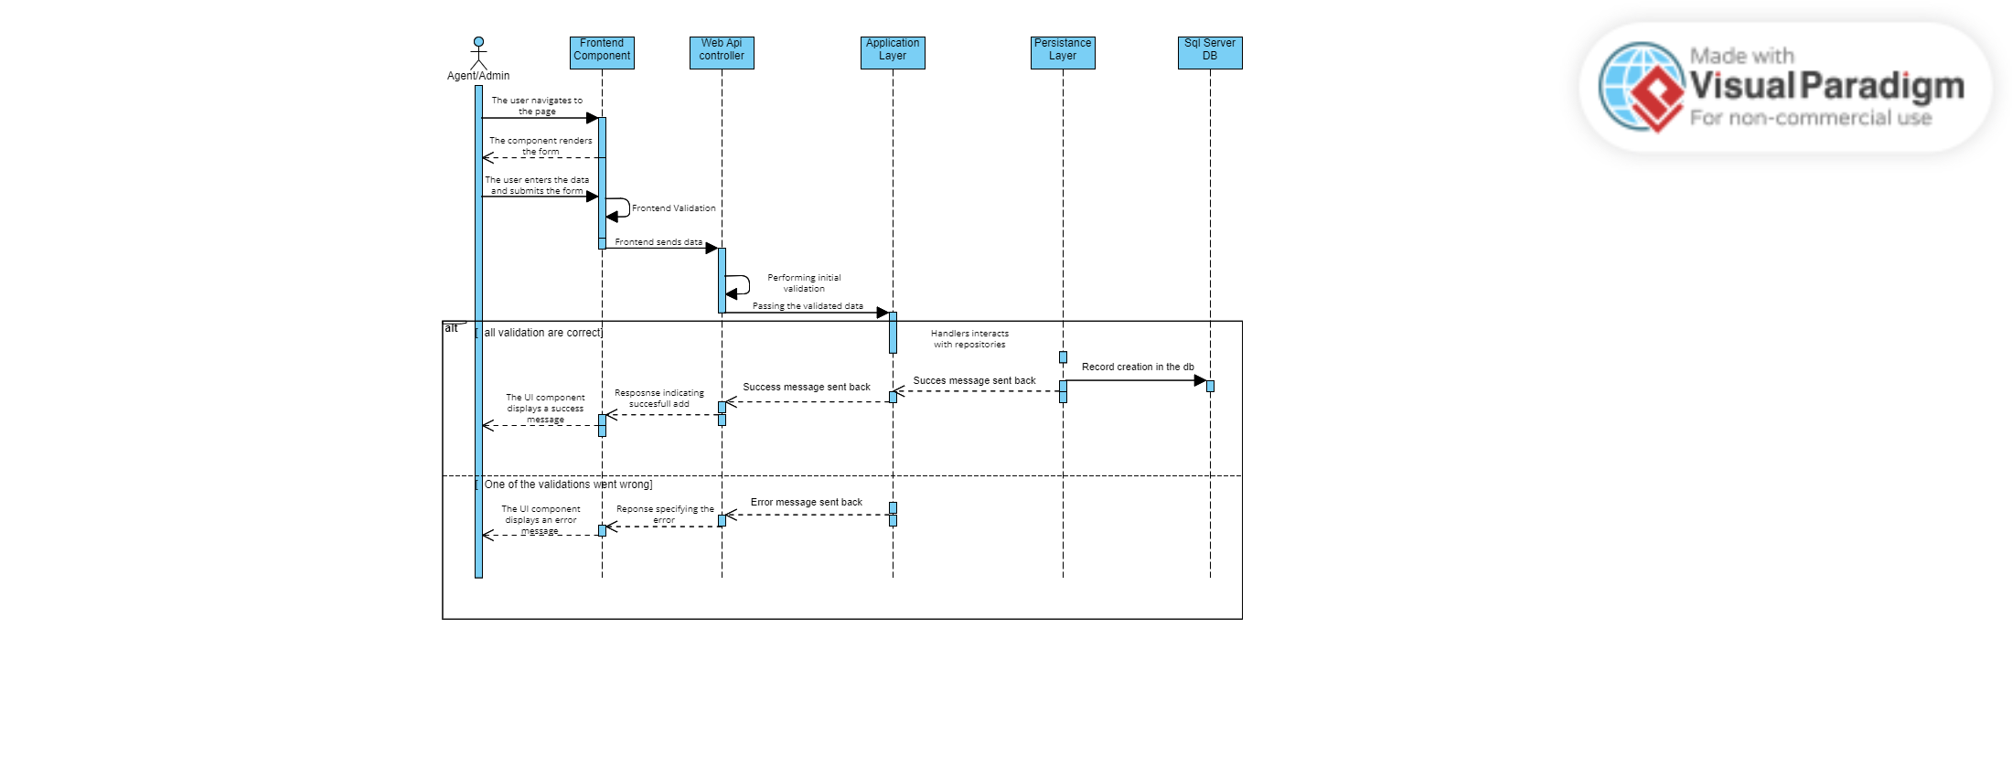

Figure 6.4 – add unpaid sequence diagram

### 6.4.1.2 Consult unpaid sequence diagram

This sequence diagram depicts the process of consulting an unpaid invoice. An Admin or Agent navigates to the page, fills out, and submits the form. The frontend component validates the data and sends it to the backend. The Web API controller performs additional validation, and the application layer processes the data, creating a record in the SQL Server database. Success or error messages are then returned to the user.

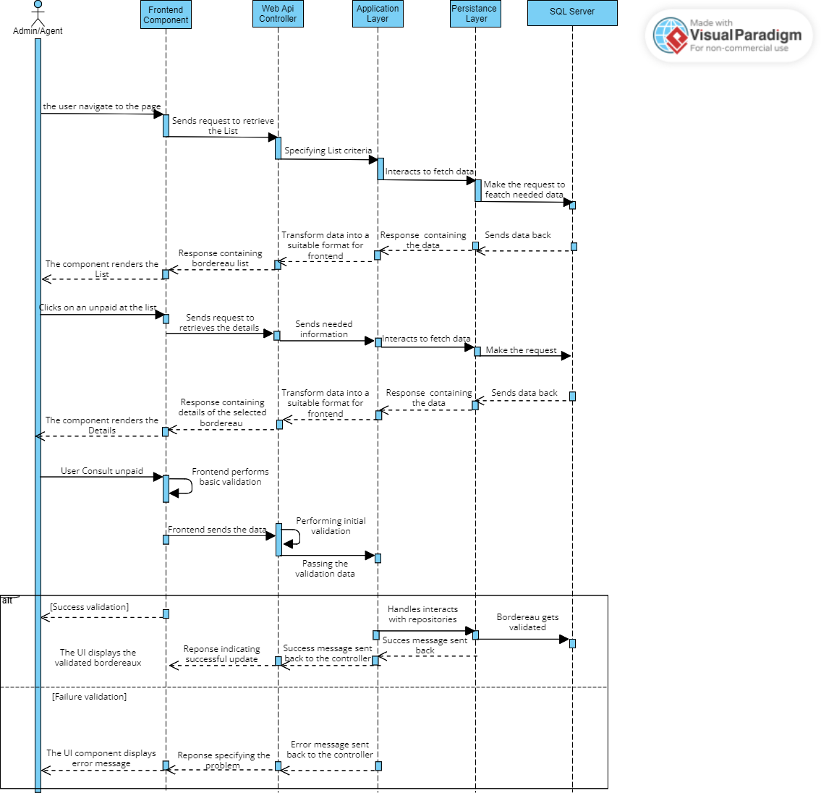

Figure 6.5 – consult unpaid sequnce diagram

### 6.4.2 Class diagram

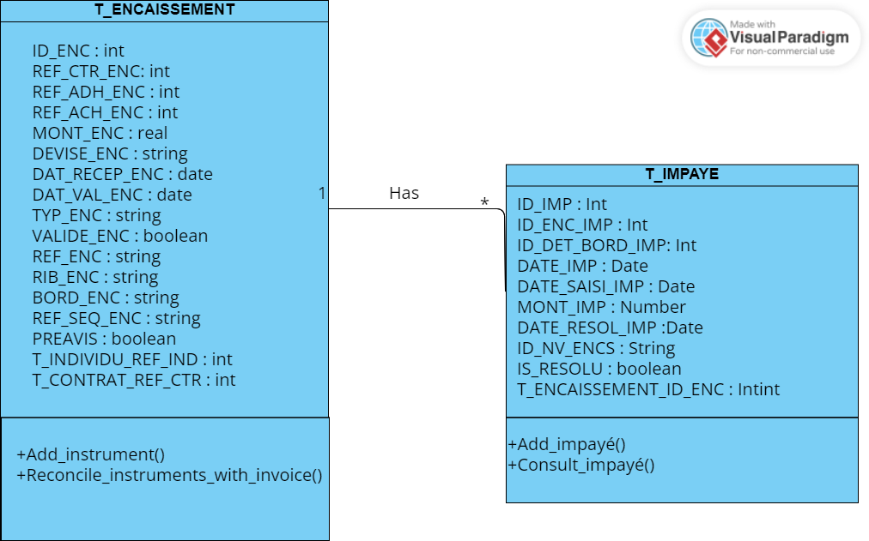

Figure 6.6 –Class diagram unpaid

## 6.5 Realization

### 6.5.1 Add unpaid interface

When the user selects the "Add unpaid" option in the Xfactor application, a form is displayed for adding new unpaid invoices.

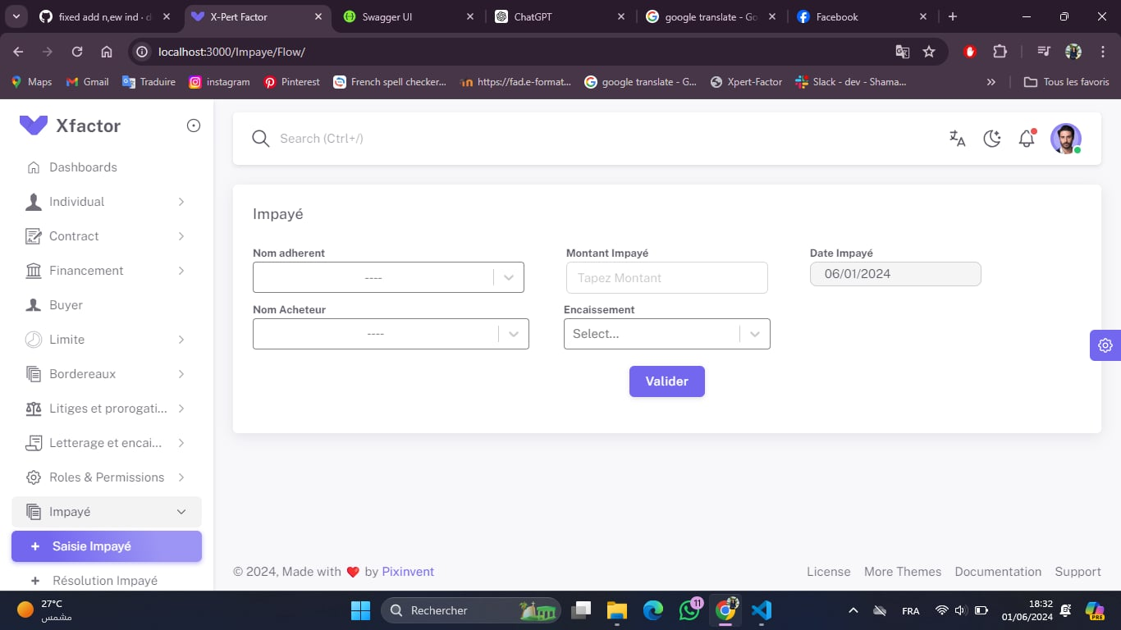

Figure 6.7 – add unpaid interface

### 6.5.2 Consult unpaid interface

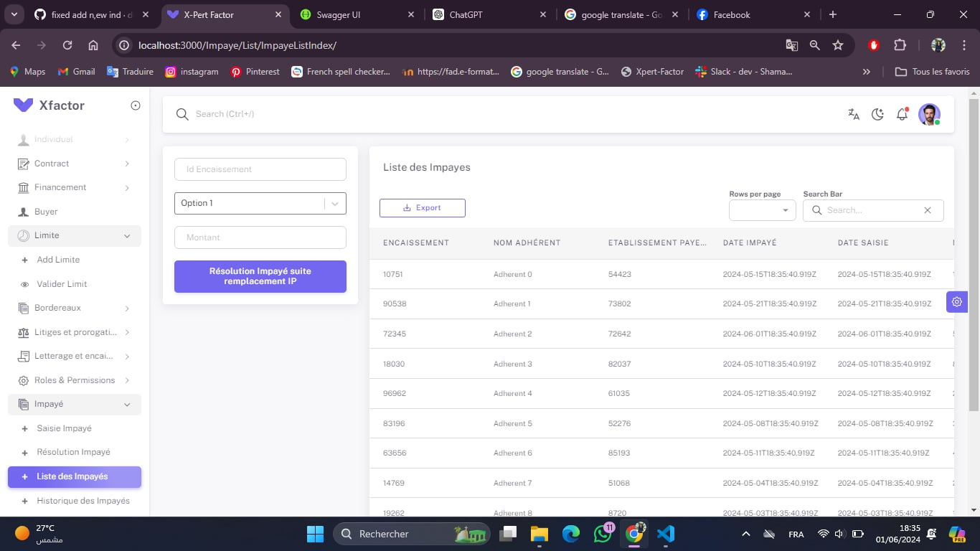

Figure 6.8 – Consult unpaid interface

### 6.5.3 resolution unpaid interface

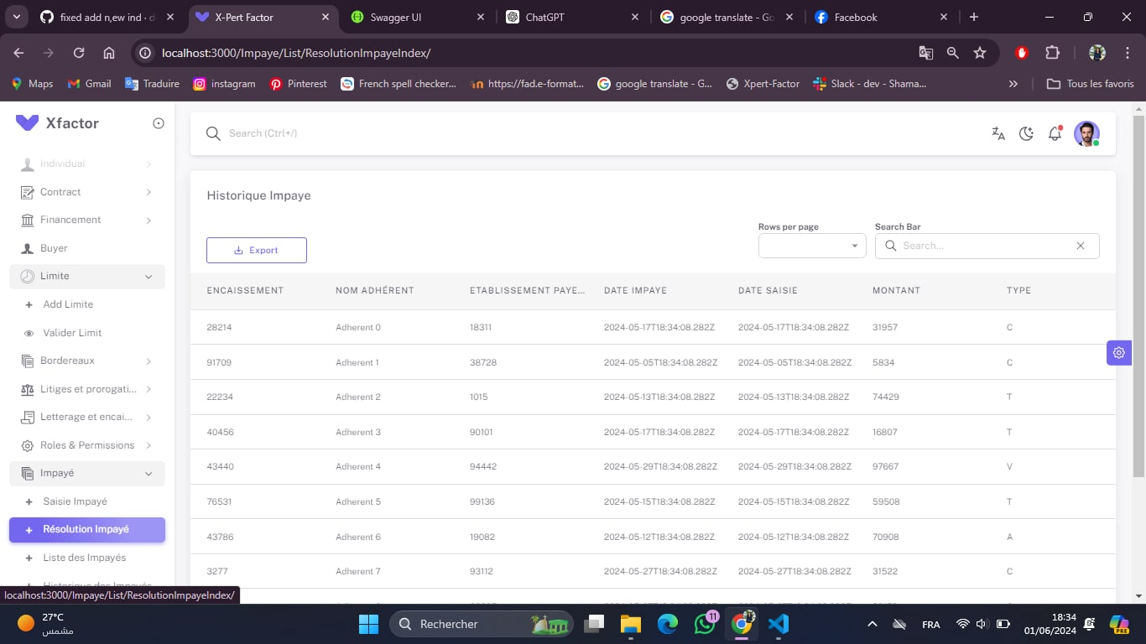

Figure 6.9 – resolution unpaid interface

## 6.6 Tests

When the user selects the "Add unpaid" option in the Xfactor application, a form is displayed for adding new unpaid invoices. Users can temporarily save the information or submit the form by clicking "Enregistrer." Additionally, there are options to restore an unpaid invoice and to cancel the operation.

### 6.6.1 Impayé (Unpaid) creation

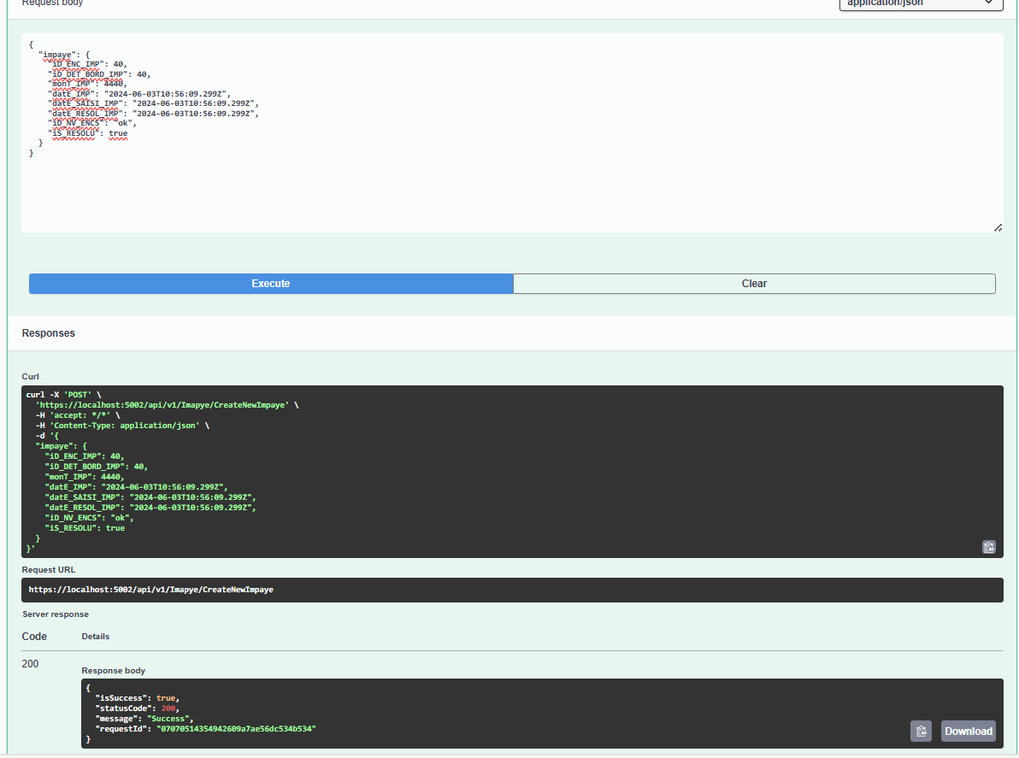Following up on our backend endpoint testing from the last sprint, this document details the process and results using Postman. A series of screenshots will showcase how we tested various endpoints and the responses we received. The first screenshot focuses on the response

Figure 6.10 - Impayé (Unpaid) creation

### 6.6.2 Impayé (unpaid) resolution

Figure 6.11 - Impayé (unpaid) resolution

### 6.6.3 Get List Of Impayé (unpaid)

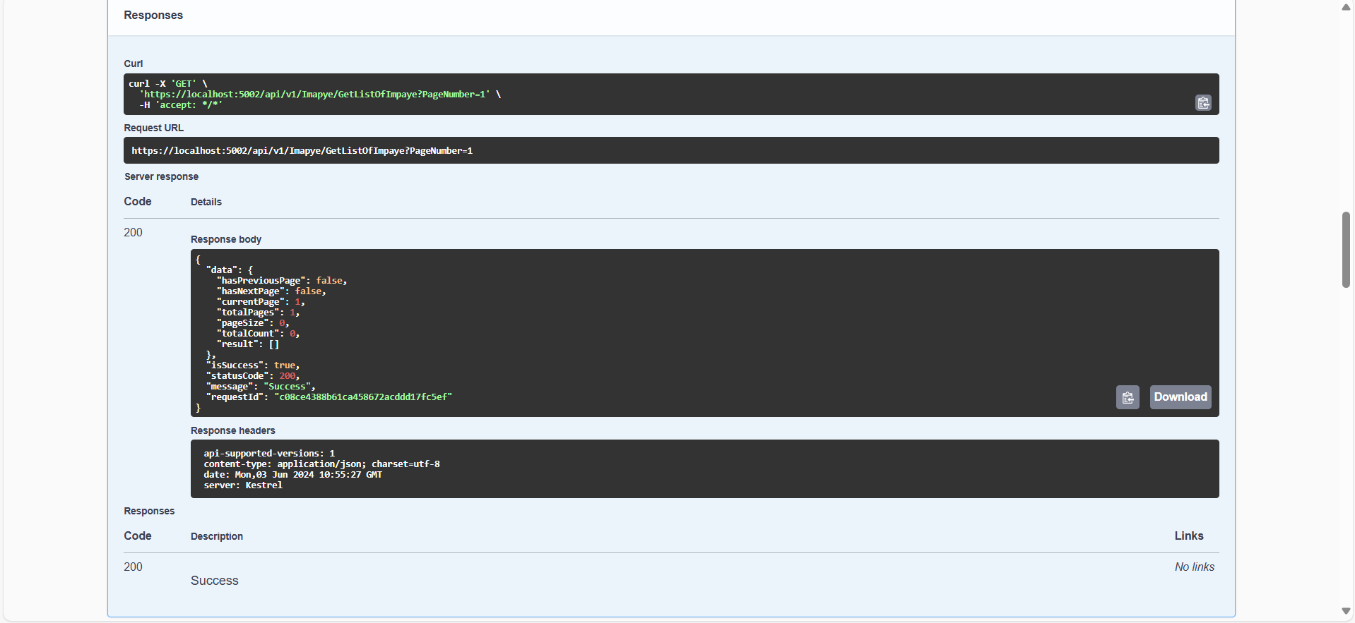

Figure 6.12 - Get List Of Impayé (unpaid)

### 6.6.4 Get List Of Historical Impayé(unpaid)

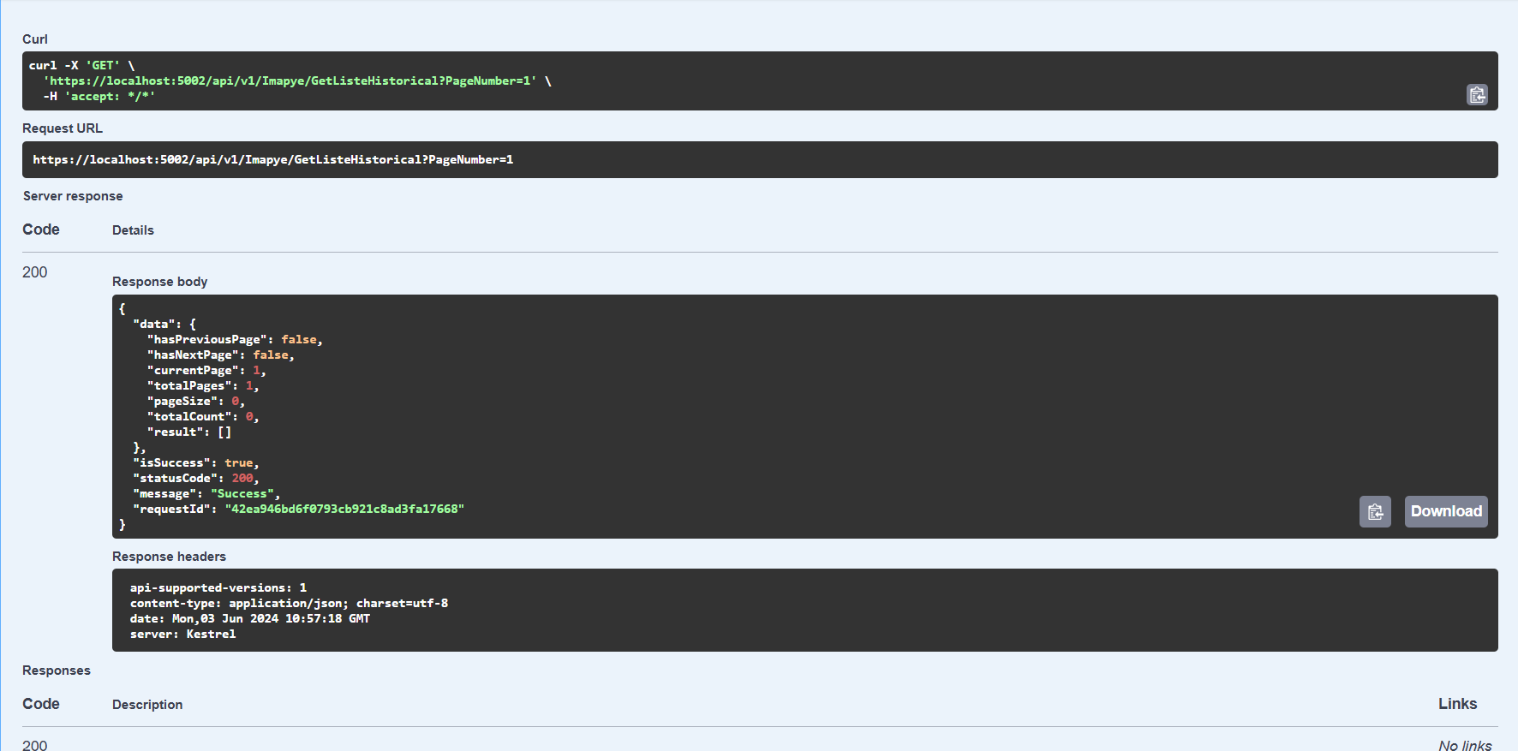

Figure 6.13 - Get List Of Historical Impayé(unpaid)

## Bordereaux module

## 6.7 Introduction

In the second part of the chapter, we will once again explore the intricacies of our fourth sprint but this time we will dive into the second module. So, we’ll begin by outlining our backlogs and use cases, and then proceed to thoroughly examine each use case.

## 6.8 Sprint Backlog

Continuing with the methodology from the previous sprints, we will now define our sprint backlog for the first module.

|  |  |  |  |  |  |
| --- | --- | --- | --- | --- | --- |
| Sprint Num | Name of feature | ID user story | User Story | Acceptance Criteria | Estimation |
| 6 | Add Bordereaux | 6.1 | As an agent ,I want to add new bordereaux to the system So that I can efficiently record and manage details of invoices or receivables submitted for factoring. | Agent can add new bordereaux with client, invoice (date, number, amount, due date), optional goods/services details and data validation for creation of a manageable record. | 10d |
| Validate Bordereaux | 6.2 | As a Validator,  I want to see a list of all bordereaux with search capabilities  So that I can efficiently review, validate, and reject bordereaux submitted for factoring. | System displays a searchable list of all bordereaux with options for review, validation, and rejection. | 3d |

Table 6.6 – Sprint Backlog (Bordereaux)

## **6.9 Functional Specifications**

### 6.9.1 Use Case Diagram

The picture down below represents the use case for our first module in this sprint

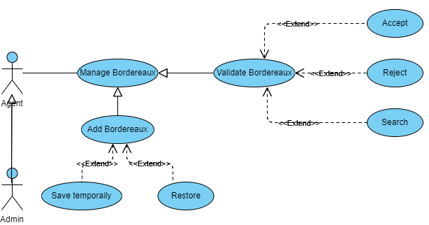

Figure 6.14–Bordereaux Use Case

In this sprint, our global use case diagram for the first module includes two use cases. To improve the clarity of the use case diagram, UML permits the addition of textual descriptions for each use case. The following sections will present tables with detailed descriptions of the important or complex use cases encountered during this sprint.

### 6.9.2 Add Bordereaux scenario description

#### 6.9.2.1 Detailed use case

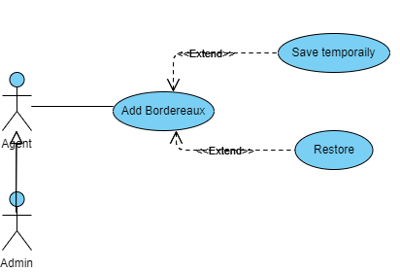

Figure 6.15– Add Bordereaux Use Case

#### 6.9.2.2 Use case description

The table below describes the textual description of the " Add Bordereaux " use case.

|  |  |
| --- | --- |
| Title | Add Bordereaux |
| Actor | Agent or Admin |
| Pre-condition | The Agent or Admin must be logged into the system. |
| Post-condition | The bordereaux are either added, saved temporarily,or restored based on the user's actions. |
| Normal scenario description | 1. The Agent or Admin initiates the "Add Bordereaux" process.  2. The system prompts the user to enter bordereaux details.  3. The user enters the required information and confirms the addition.  4. The system saves the bordereaux.  5. If needed, the user can choose to "Save temporarily" or "Restore" previously saved data.  6. The system performs the selected action and updates the  bordereaux accordingly. |
| Exception scenario description | 1. If the user does not have the necessary permissions, an  error message is displayed.  2. If required information is missing or incorrect, the system  prompts the user to correct it before proceeding.  3. If the system encounters an error while saving or restoring the  bordereaux, an appropriate error message is displayed, and the user can retry the action. |

Table 6.7 – Add Bordereaux scenario description

### 6.9.3 Validate Bordereaux scenario description

#### 6.9.3.1 Detailed use case

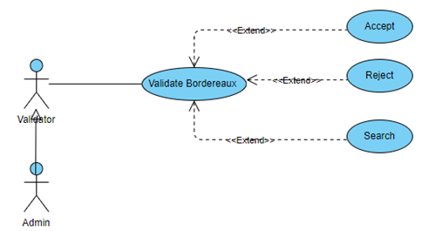

Figure 6.16– Validate Bordereaux Use Case

#### 6.9.3.2 Use case description

The table below describes the textual description of the " Validate Bordereaux " use case.

|  |  |
| --- | --- |
| Title | Validate Bordereaux |
| Actor | Validator |
| Pre-condition | The validator must be logged into the system. |
| Post-condition | The bordereaux are either accepted, rejected, or searched  based on the user's actions. |
| Normal scenario description | 1. The validator initiates the "Validate Bordereaux" process  2. The system presents the user with bordereaux awaiting Validation.  3. The validator reviews the bordereaux details  4. The validator chooses to "Accept," "Reject," or "Search" for specific bordereaux.  5. If "Accept" is chosen, the system marks the bordereaux as validated and updates the status.  6. If "Reject" is chosen, the system records the rejection and any  comments provided by the user.  7. If "Search" is chosen, the system allows the user to enter search criteria and displays matching bordereaux. |
| Exception scenario description | 1. If the user does not have the necessary permissions, an error message is displayed.  2. If there are no bordereaux to validate, the system informs the user and provides an option to search for bordereaux.  3. If the system encounters an error during validation (acceptance or rejection), an appropriate error message is displayed, and the user can retry the action.  4. If the search criteria yield no results, the system prompts the user to refine the search. |

Table 6.8 – Validate Bordereaux scenario description

## 6.10 Modeling

In this section, we will create the object class diagram for the first module of this sprint, along with the various detailed sequence diagram.

6.10.1 Sequence diagram

Sequence diagrams describe how the elements of the system interact with each other and with the actors. In the following, we present detailed sequence diagrams for the user stories of the first sprint.

#### 6.10.1.1 Add Bordereau Sequence diagram

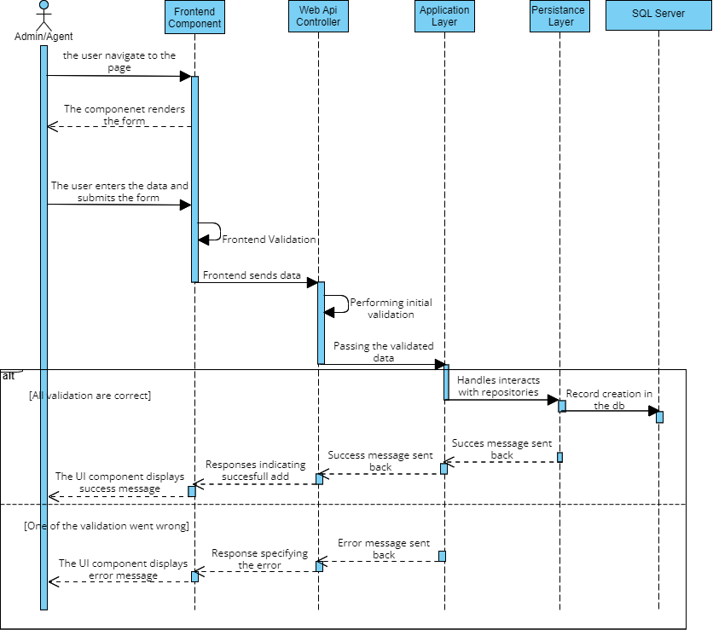

Figure 6.17– Add Bordereau Sequence diagram

#### 6.10.1.2 Validate Bordereau Sequence diagram

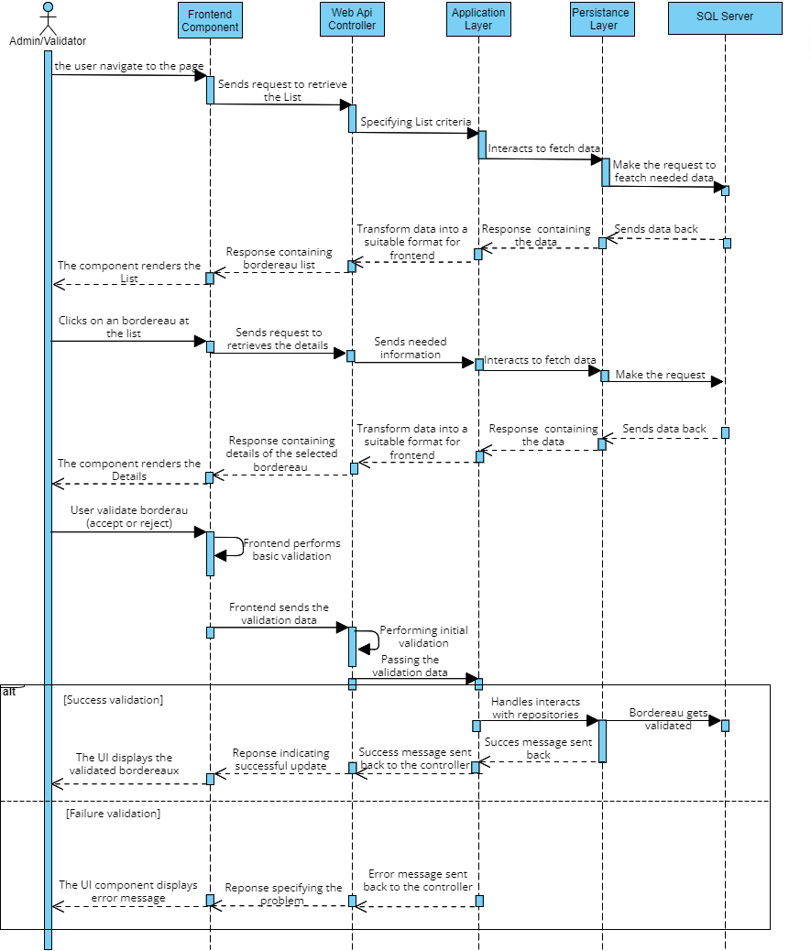

Figure 6.18– Validate Bordereaux Sequence diagram

### 6.10.2 Class Diagram

The updated diagram includes new classes from the current sprint, reflecting the incremental progress central to SCRUM. Each sprint builds on the last, creating a foundation for future developments and larger releases.

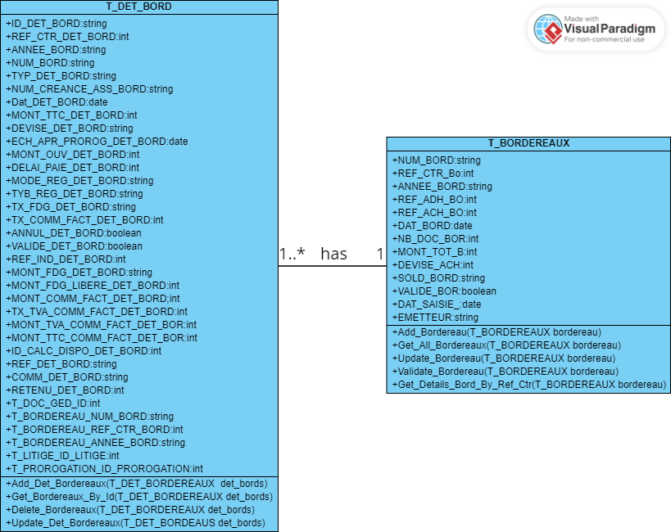

Figure 6.19–Bordereaux Class diagram

## 6.11 Realization

In this section, we will present a collection of screenshots showcasing the user interfaces implemented during the current sprint.

### 6.11.1 Add Bordereaux interface

When the user selects the "Add Bordereaux" option in the Xfactor application, a form is displayed for adding new bordereaux. The form includes fields for contract reference, bordereaux number, bordereaux year, number of documents, total amount, and bordereaux date. Users can save the information temporarily or submit the form by clicking "Enregistrer." Additionally, there is an option to restore a bordereau and to cancel the operation.

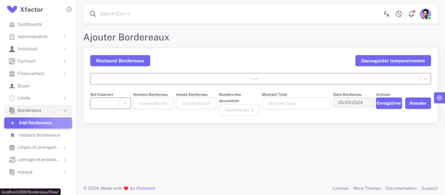

Figure 6.20– Add Bordereaux interface

### 6.11.2 Validate Bordereaux interface

When the user navigates to the "Validate Bordereaux" section in the Xfactor application, they see a list of bordereaux entries. Each entry displays the bordereaux number, contract reference, adherent name, number of documents, total amount, and entry date. Users can search and filter the entries, set the number of rows per page, and export the list. Actions for each entry include validating or rejecting the bordereaux using the corresponding green checkmark or red cross buttons.

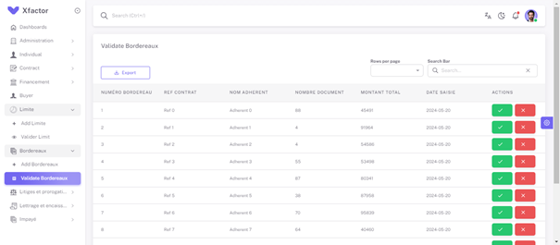

Figure 6.21– Validate Bordereaux interface

## 6.12 Tests

Similar to the previous sprint, we conducted testing of our backend endpoints using Swagger UI. In the following pages, we will present a series of screenshots showcasing the testing process and results of the Swagger UI endpoints.

### 6.12.1 Bordereaux creation

In Swagger, test bordereaux creation by selecting the POST method for the "Create New Bordereaux " endpoint at http://localhost:8746/api/v1/Bordereaux/CreateNewBordereaux, define the new bordereau’s data in the request body, execute the request, and verify a successful response (200 OK) with potential details about the created bordereau.

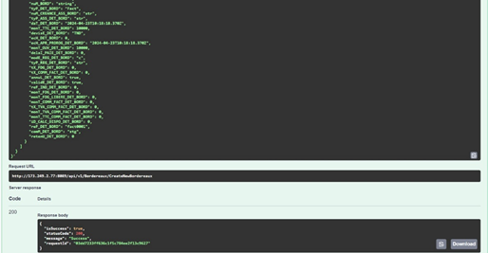

Figure 6.22– Test case create New Bordereaux

### 6.12.2 Get All Bordereaux

As part of our testing, we tested fetching all bordereaux entries. We used the GET method for the "Get All Bordereaux" endpoint at `http://localhost:8746/api/v1/Individu/GetAllBordereaux`.

After executing the request, we expected a successful response (200 OK) containing a list of all bordereaux stored in the system.

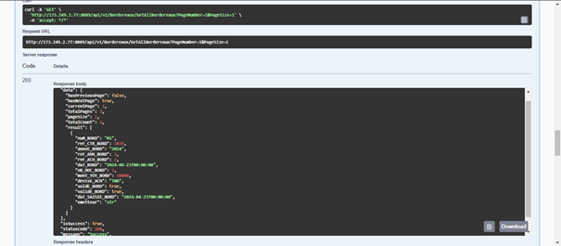

Figure 6.23– Test case Get All Bordereaux

### 6.12.4 Get Details Bordereaux By Ref_Ctr

As part of testing the retrieval of a bordereau by Ref_Ctr (contract reference), we selected the GET method for the "Get Details Bordereau by Ref_Ctr" endpoint using the URL ‘[http://localhost:8746/api/v1/Bordereaux/GetDetailsBordByRefCtr/{refCtr](http://localhost:8746/api/v1/Bordereaux/GetDetailsBordByRefCtr/%7brefCtr)}’,

replacing "{refCtr}" with the actual bordereau's contract reference. After executing the request, we verified a successful response (200 OK) containing the details of the retrieved bordereau.

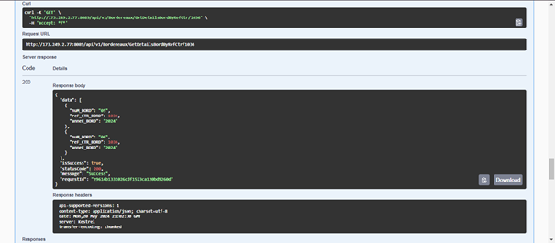

Figure 6.24– Test case Get Details Bordereaux By Ref_Ctr

### 6.12.5 Delete Bordereaux

To test the deletion of a bordereau, select the DELETE method for the "Delete Bordereau" endpoint at `http://localhost:8746/api/v1/Bordereaux/DeleteBordereau. Execute the request and verify a successful response (200 OK), confirming the bordereau has been deleted.

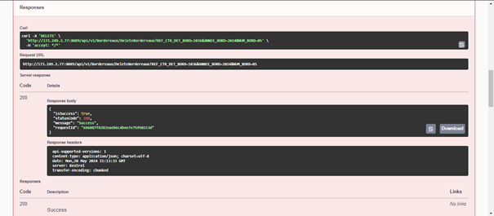

Figure 6.25– Test case Delete Bordereaux

### 6.12.7 Validate Bordereaux

Next, to test the validation of a bordereau, select the PUT method for the "Validate Bordereau" endpoint at `http://localhost:8746/api/v1/Bordereaux/ValidateBordereau`. Execute the request and verify a successful response (200 OK), confirming that the bordereau has been validated.

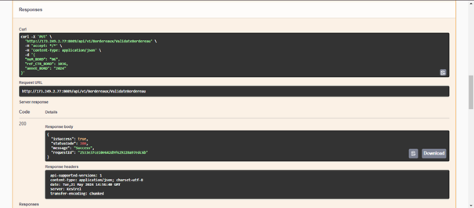

Figure 6.26– Test case Validate Bordereaux

## 6.13 Sprint 4 Retrospective

This section is dedicated to incorporating the retrospectives provided by the product owner following the conclusion of our fourth sprint.

* + We successfully implemented the creation of the instrument
  + We implemented the addition of new bordereau.
  + We successfully implemented the ability to validate bordereau.
  + We implemented the functionalities of creation, deletion, updation and validation

bordereaux.

* + We also implemented the functionalities of get all bordereaux, get bordereau by id and get bordereau by contract reference (Ref_Ctr).

## 6.14 Conclusion

In conclusion, this chapter was a period of significant progress and learning for the team. However, we also faced challenges, such as a complex technical issue that caused delays in other stories. In this chapter, we have covered 2 modules, which includes the phases of analysis, design, implementation, and testing. In the next chapter, we will explore the functionalities related to the fifth sprint

# Chapter 7: sprint 5 study and realization

## 7.1 Introduction

To securely access the web app, authorized users log in with a username/email and password. The system validates these credentials against a central database and grants access to the app's functionalities upon successful verification. If the credentials are invalid, an error message is displayed prompting the user to retry.

## 7.2 Sprint bakclog

|  |  |  |  |  |  |
| --- | --- | --- | --- | --- | --- |
| Sprint num | Name Of  feature | ID User story | User story | Acceptance Criteria | Estimation |
| 7 | To log in | 7.1 | As an agent/admin/ validator, I want to enter my username and password so that I can log in. | The login form accepts username and password input. | 3d |

Table 7.1 – Sprint 5 Backlog

## 7.3 Use case diagram

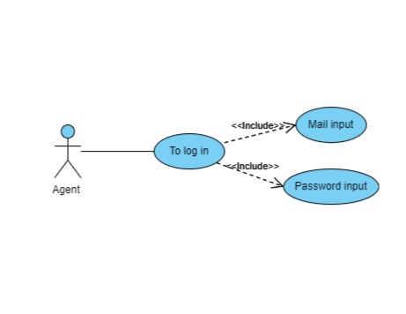

Figure 7.1 - Log in use case

## 7.3.1 Use case description

|  |  |
| --- | --- |
| Title | Authentification |
| Actor | Admin, Agent, validator |
| Pre-condition | The user (Agent or Admin or Validator) has valid log in credentials into the system. |
| Post-condition | User is successfully authenticated and gains access to the system's features. |
| Normal scenario description | 1. User navigates to the login page.  2. User enters their username and password.  3. User clicks the "Login" button.  4. System validates the credentials.  5. System grants access and redirects the user to the dashboard. |
| Exception scenario description | If the credentials are invalid, the system displays an error message and prompts the user to try again.  If the user account is locked, the system displays a message indicating that the account is locked and advises the user to contact support. |

Table 7.2 – use case description

## 7.4 Modeling

In this section, we will develop the object class diagram of this sprint, along with several detailed sequence diagrams.

### 7.4.1 Sequence diagram

A sequence diagram in a report is a visual timeline showing how objects in a system interact to achieve a specific task. Imagine a conversation, the objects are like participants, and the arrows represent messages they send back and forth. This clarifies complex interactions and helps identify potential issues.

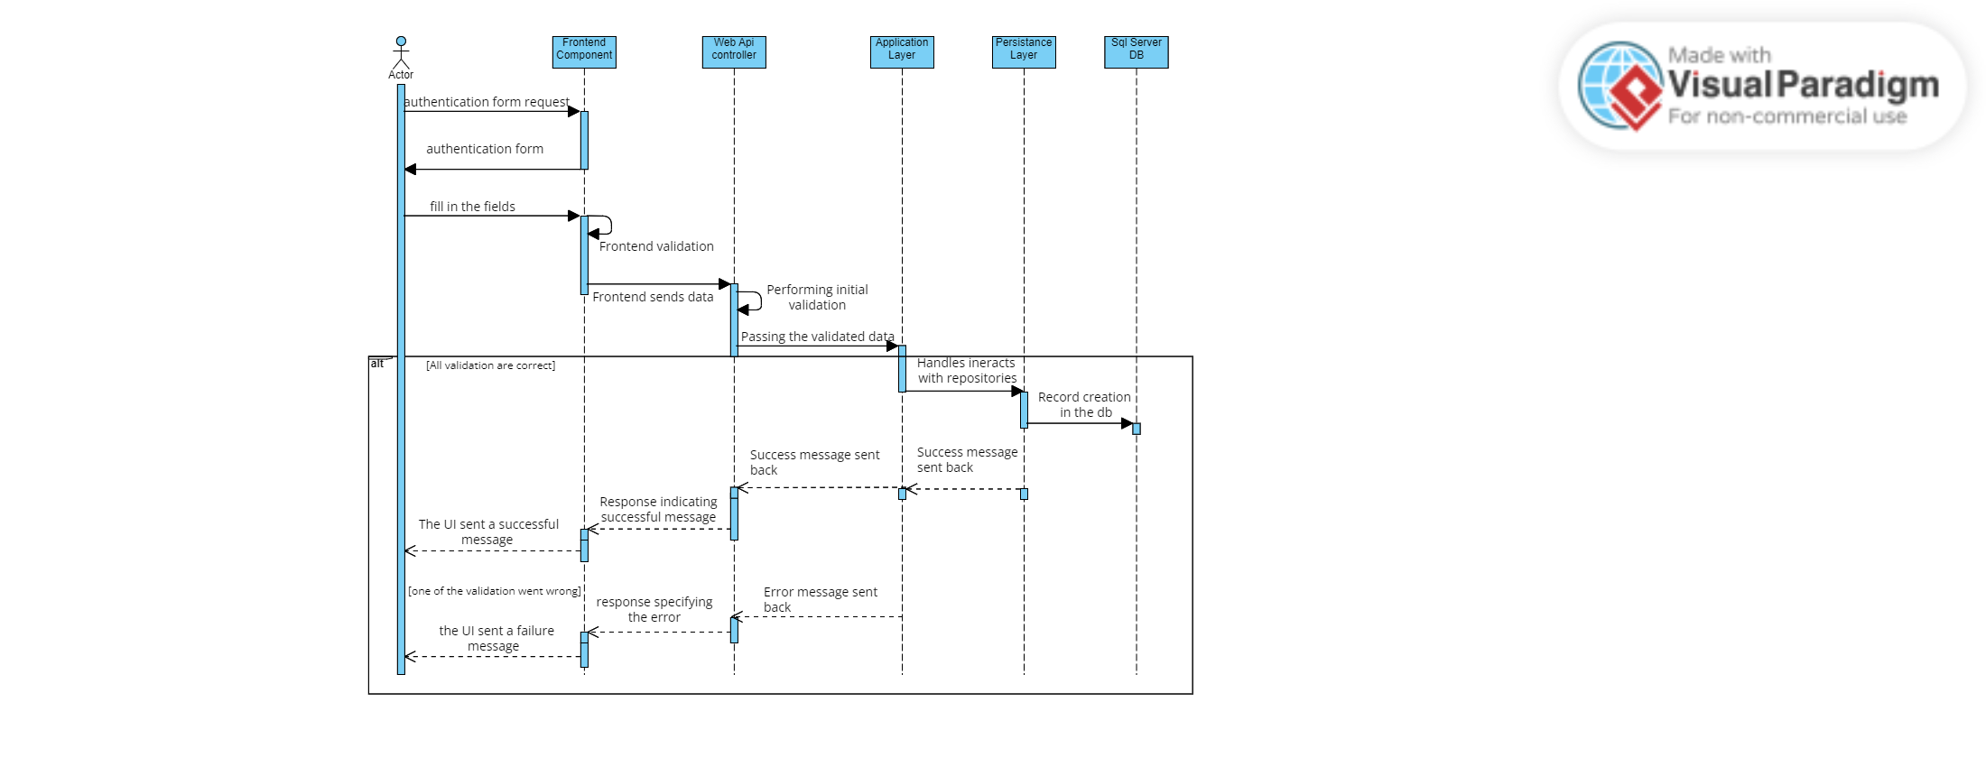

Figure 7.2 - login sequence diagram

## 7.5 Realization

In this section, we will present a series of screenshots that display the user interfaces developed during the current sprint.

### 7.5.1 Login interface

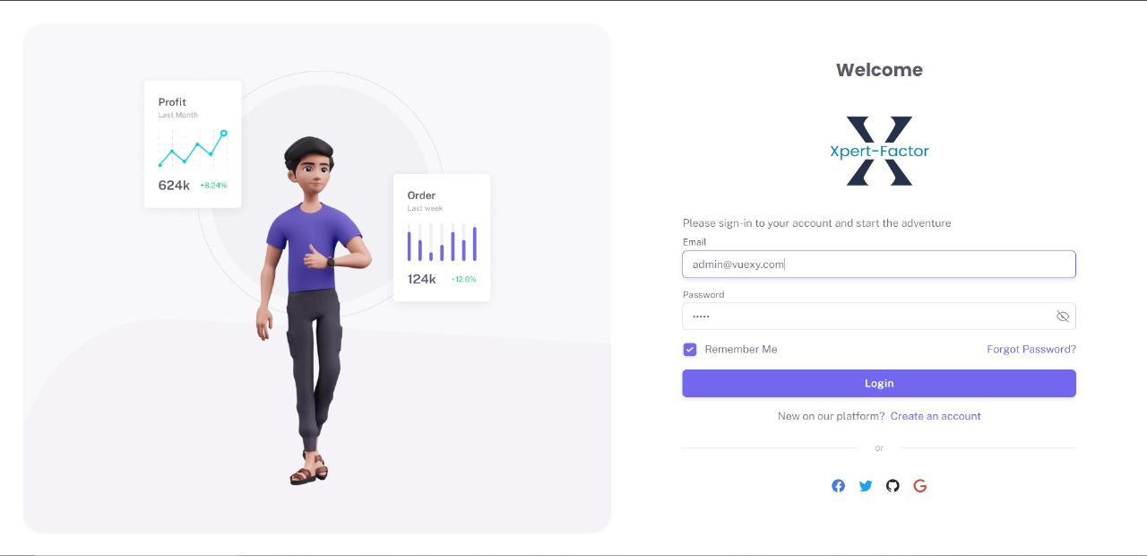

Figure 7.3 - Login interface

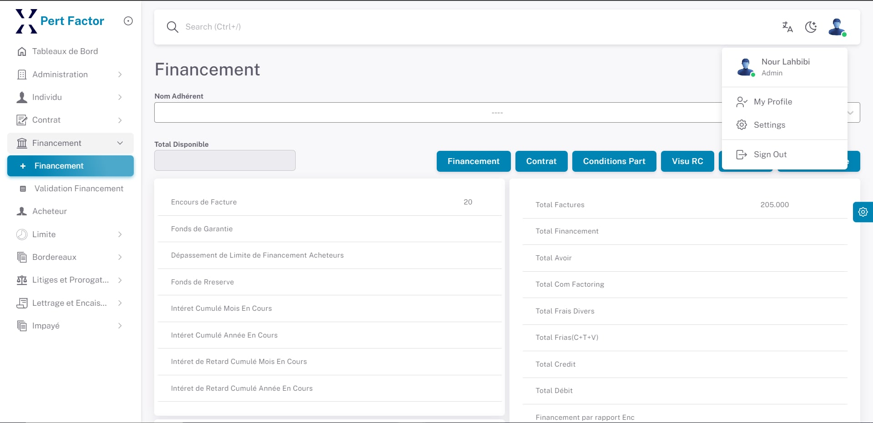

Figure 7.4 – login session

## Manage User, Roles, Permissions module

The Manage Users, Roles, and Permissions module enables administrators to efficiently control access, manage user profiles, roles, and permissions, ensuring security and operational efficiency.

## 7.6 Use case diagram

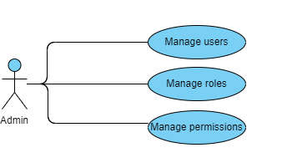

Figure 7.5 – Use case manage roles , permissions , users

### 7.6.1 Manage user scenario description

### 7.6.1.1 Detailed use case

|  |  |
| --- | --- |
| Title | Manage users |
| Actor | Admin |
| Pre-condition | - Admin is authenticated and logged into the system.  - Admin has the necessary permissions to manage users. |
| Post-condition | - Users are updated in the system as per the admin's actions.  - The system reflects the changes, and the updated configurations are accessible for further management. |
| Normal scenario description | 1. Admin selects the "Manage Users" option.  2. The system displays a list of existing users.  3. Admin chooses to add, edit, or delete a user.  - **For adding a user:**  1. Admin clicks "Add User" and fills in the required details (e.g., Name, Email, Role).  2. Admin clicks "Save".  3. System validates the input and adds the new user.  4. System displays a confirmation message  - **For editing a user:**  1. Admin selects a user to edit.  2. Admin updates the required details.  3. Admin clicks "Save".  4. System validates the input and updates the user details.  5. System displays a confirmation message.  - **For deleting a user:**  1. Admin selects a user to delete.  2. Admin confirms the deletion.  3. System validates the action and deletes the user.  4. System displays a confirmation message. |
| Exception scenario description | If the credentials are invalid, the system displays an error message and prompts the user to try again.  If the user account is locked, the system displays a message indicating that the account is locked and advises the user to contact support. |

Table 7.3 – Manage users description scenario

### 7.6.2 Manage roles scenario description

### 7.6.2.1 Detailed use case

Figure 7.6– Manage roles use case

|  |  |
| --- | --- |
| Title | Manage Roles |
| Actor | Admin |
| Pre-condition | - Admin is authenticated and logged into the system.  - Admin has the necessary permissions to manage roles. |
| Post-condition | - Users are updated in the system as per the admin's actions.  - The system reflects the changes, and the updated configurations are accessible for further management. |
| Normal scenario description | -Admin selects the "Manage Roles" option.  -Admin chooses to add, edit, or delete a role.  **For adding a role:**  1. Admin clicks "Add Role" and fills in the required details:  * Role Name  * Description (Optional)  * Permissions (Select from a list or assign specific permissions)  2. Admin clicks "Save".  * System validates the input and adds the new role.  * System displays a confirmation message.  **For editing a role:**  1. Admin selects a role to edit from the table.  2. Admin updates the details:  * Role Name (May or may not be editable)  * Description (Optional)  * Permissions (Modify associated permissions)  3. Admin clicks "Save".  * System validates the input and updates the role details.  * System displays a confirmation message.  **For deleting a role:**  1. Admin selects a role to delete from the table.  2. Admin confirms the deletion (e.g., pop-up confirmation).  * System validates the action and deletes the role, potentially reassigning users with that role to a default role (specify in post-condition if applicable).  * System displays a confirmation message. |
| Exception scenario description | If the credentials are invalid, the system displays an error message and prompts the user to try again.  If the user account is locked, the system displays a message indicating that the account is locked and advises the user to contact support. |

Table 7.4 – Manage roles scenario description

## 7.7 Manage permissions

### 7.7.1 Detailed use case

Figure 7.7 – Manage permissions use case

### 7.7.2 Manage permissions scenario description

|  |  |
| --- | --- |
| Title | Manage Permissions |
| Actor | Admin |
| Pre-condition | - Admin is authenticated and logged into the system.  - Admin has the necessary permissions to manage permissions. |
| Post-condition | - Permissions are updated in the system as per the admin's actions.  - The system reflects the changes, accessible for further management. |
| Normal scenario description | 1. Admin selects the "Manage Permissions" option.  2. The system displays a list of existing permissions.  3. Admin chooses to add, edit, or delete permissions for roles.      - **For adding permissions:**          1. Admin selects a role and adds the required permissions.           2. Admin clicks "Save".          3. System validates the input and updates the permissions.           4. System displays a confirmation message.   - **For editing permissions:**           1. Admin selects a role and updates the permissions.            2. Admin clicks "Save".        3. System validates the input and updates the permissions.            4. System displays a confirmation message.        - **For deleting permissions:**          1. Admin selects a role and removes the required permissions.        2. Admin clicks "Save".            3. System validates the action and updates the permissions.            4. System displays a confirmation message. |
| Exception scenario description | 1. **Missing Required Information:**   - If the Admin does not fill in all required fields when adding or editing permissions, the system displays an error message indicating the missing fields.  2. **Invalid Data Entry:**   - If the Admin enters invalid data (e.g., invalid format for permissions), the system displays an error message specifying the invalid data.  3. **Deletion Constraints:**   - If the Admin attempts to delete permissions that are critical, the system displays an error message indicating that the deletion cannot proceed.  4. **System Error:**   - If the system encounters an error during data processing, it notifies the Admin of the error and logs the issue for IT support to investigate. |

Table 7.5 – Manage permissions scenario description

## BI Module

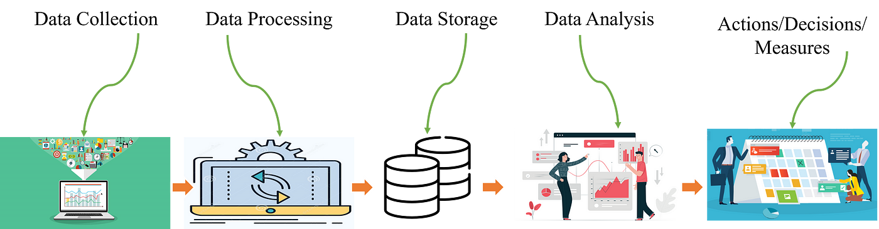Business Intelligence (BI) refers to the technologies, applications, and practices used to collect, integrate, analyze, and present business information. The primary purpose of BI is to support better business decision-making.

Figure 7.8– Conception BI Cycle

Here are some key aspects of Business Intelligence:

1. Data Collection:

Data collection involves gathering data from various sources like databases, spreadsheets, and other repositories. The ETL (Extract, Transform, Load) process is used to extract data, transform it into a consistent format, and load it into a data warehouse.

2. Data Processing:

Data processing includes cleaning, standardizing, and integrating collected data to ensure accuracy and consistency. This step prepares the data for analysis by creating a unified dataset from multiple sources.

3.Data Storage:

Processed data is stored in centralized repositories such as data warehouses, which organize data in a structured manner, or data lakes, which store raw data in its native format for flexible and scalable storage solutions.

4. Data Analysis:

Data analysis employs descriptive, predictive, and prescriptive analytics to generate insights. Descriptive analytics examines historical data, predictive analytics forecasts future outcomes, and prescriptive analytics recommends actions based on data insights.

5. Decision-Making:

Decision-making leverages insights from data analysis to inform business strategies and actions. BI systems provide accurate data insights, enabling organizations to improve efficiency, identify opportunities, and make informed decisions that drive success.These aspects of BI collectively enable organizations to leverage their data effectively for better decision-making, operational efficiency, and strategic advantage.

## Power BI Dashboard Analysis Module

#### 7.7Introduction

#### To enhance our understanding of the current project status and team performance, we have incorporated insights from Power BI dashboards. These dashboards provide real-time data visualizations that are crucial for effective decision-making and process improvements.

#### 7.7.1 Analysis and Implications

 The dashboards highlight critical financial metrics that impact our Scrum process.

By monitoring overdue invoices and financing limits, we can make informed decisions to ensure financial health and sustainability. This data allows us to:

* Use financial data to prioritize tasks that have direct financial implications, ensuring critical issues are addressed promptly.
* Assess how financial constraints or overdue payments might be impacting team performance and workload.
* Identify and mitigate risks related to financial delays or overextended credit limits.

### 7.7.2 ‘Buyer Dashboard’

            This dashboard below provides a comprehensive view of the buyer's situation, including total outstanding amounts, overdue invoices, and non-overdue invoices. It also visualizes the financing limits per buyer and the status of overdue and non-overdue invoices.

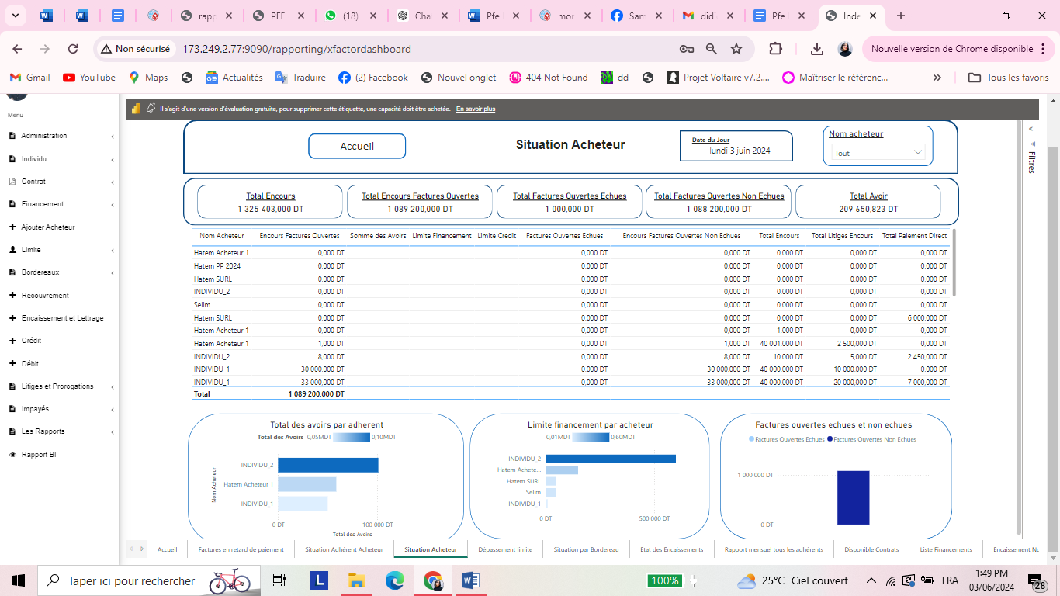

Figure 7.9 - Buyer Dashboard

This dashboard is designed to provide a comprehensive overview of financial metrics and performance indicators for all adherents, facilitating better decision-making and financial management in the context of factoring.

The Buyer Situation Dashboard offers a detailed view of buyer-related financial metrics. It is divided into several key sections :

* Top Summary Section :
  + Total Outstanding Amount: Displays the total outstanding balance, which is 1,325,403,000 DT.
  + Total Open Invoices: Shows the total amount of open invoices, which is 1,089,200,000 DT.
  + Total Overdue Invoices: Represents the total amount of overdue open invoices, totaling 1,000,000 DT.
  + Total Open Invoices Not Due: Indicates the total amount of open invoices that are not overdue, amounting to 1,088,200,000 DT.
  + Total Credits: Displays the total credits, which are 209,650,823 DT.
* Detailed Table Section: This section provides a breakdown of financial metrics by buyer name. Columns include:
  + - ‘Encours Factures Ouvertes’: Number of open invoices per buyer.
    - ‘Somme des Avoirs’: Sum of credits per buyer.
    - ‘Limite Financement’: Financing limit per buyer.
    - ‘Limite Credit’: Credit limit per buyer.
    - ‘Factures Ouvertes Echues’: Amount of overdue open invoices per buyer.
    - ‘Encours Factures Ouvertes Non Echues**’**: Amount of non-overdue open invoices per buyer.
    - ‘Total Encours’: Total outstanding amount per buyer.
    - ‘Total Litiges Encours’: Total outstanding disputes per buyer.
    - ‘Total Paiement Direct’ : Total direct payments per buyer.
* Bottom Visualization Section :
  + ‘Total des Avoirs par Adheren**t’**: A bar chart showing the total credits per member.
  + **‘**Limite Financement par Acheteur’: A bar chart displaying the financing limits per buyer.
  + **‘**Factures Ouvertes Echues et Non Echues’: A bar chart differentiating between overdue and non-overdue open invoices.

### 7.7.3 ‘Rapport mensuel tous les adherents’ dashboard

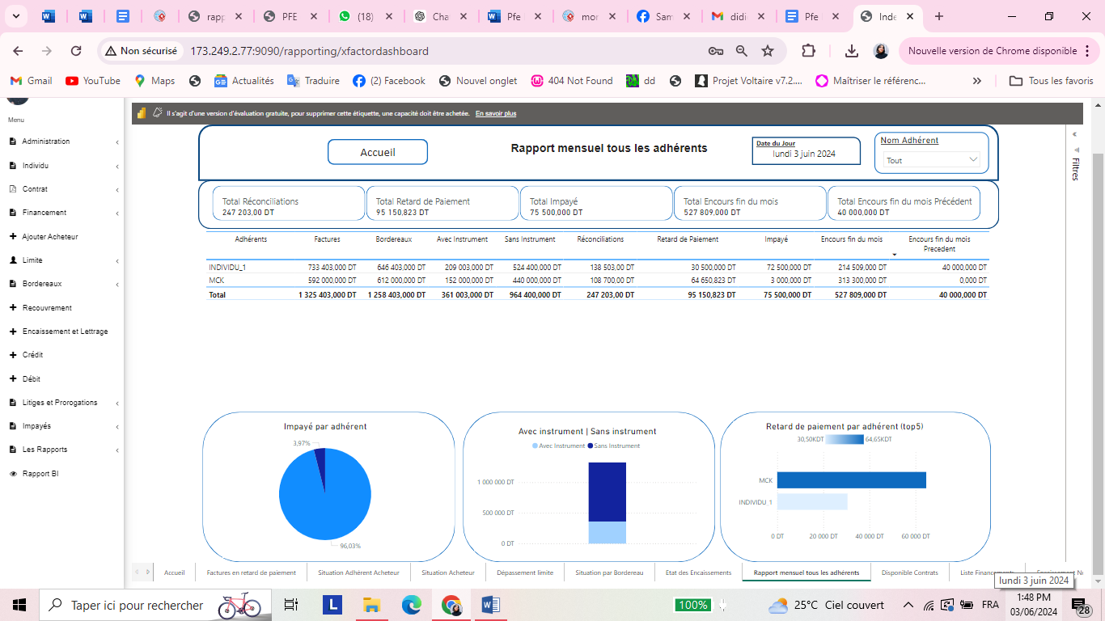

Figure 7. 10- Rapport mensuel tous les adherents dashboard

This ‘Rapport mensuel tous les adherents’ dashboard , specifically showing a monthly report for all adherents in a factoring context.

* Here’s a detailed description of the various sections and elements:

-Total Réconciliations: Shows a value of 247,203.00 DT.

- Total Retard de Paiement: Indicates a payment delay of 95,150,823 DT.

- Total Impayé: Displays unpaid amounts totaling 75,500,000 DT.

- Total Encours fin du mois: Total outstanding at the end of the month is 527,809,000 DT.

- Total Encours fin du mois Précédent: Total outstanding at the end of the previous month is 40,000,000 DT.

* The table provides detailed financial data for different adherents:

- Adhérents: The name of the adherent.

- Factures: Invoice amounts.

- Bordereaux: Bill of exchange amounts.

- Avec Instrument: Amounts with financial instruments.

- Sans Instrument: Amounts without financial instruments.

- Réconciliations: Reconciled amounts.

- Retard de Paiement: Payment delays.

- Impayé: Unpaid amounts.

- Encours fin du mois: Outstanding amounts at the end of the month.

- Encours fin du mois Précédent: Outstanding amounts at the end of the previous month.

- Totals for each category are summed at the bottom of the table.

* Graphs and Visualizations:

- Impayé par adhérent: A pie chart showing the percentage of unpaid amounts by adherent. INDIVIDU_1 has a significant portion (96.03%) compared to MCK (3.97%).

- Avec instrument | Sans instrument: A bar chart comparing amounts with and without financial instruments.

- Retard de paiement par adhérent (top 5): A bar chart highlighting the top 5 adherents with payment delays, showing that MCK has a larger delay (64,650 DT) compared to INDIVIDU_1 (30,500 DT).

#### 7.7.4 Conclusion

The integration of Power BI dashboards into our Scrum report provides a data-driven foundation for our decision-making processes. These insights enable us to maintain financial control, optimize team performance, and ensure the successful completion of our project goals.

## Deployment module

Deployment is the process of making a web application or website available for use on the internet. This involves preparing the application by writing code, compiling and optimizing files, and performing various tests to ensure functionality.

Once ready, the application is moved to a live server or cloud platform, where it involves uploading files, configuring servers, updating databases, and setting environment variables. Deployment can be automated using tools like CI/CD pipelines, containerization, and cloud services, which streamline the process and ensure consistent, reliable releases.

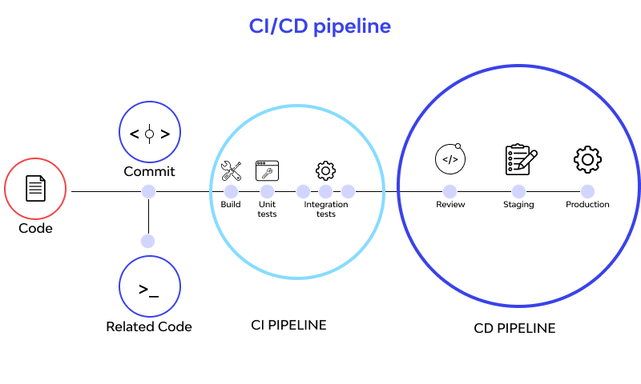Continuous monitoring and maintenance follow to keep the application running smoothly.

Figure 7.11– CI/CD pipeline schema

* 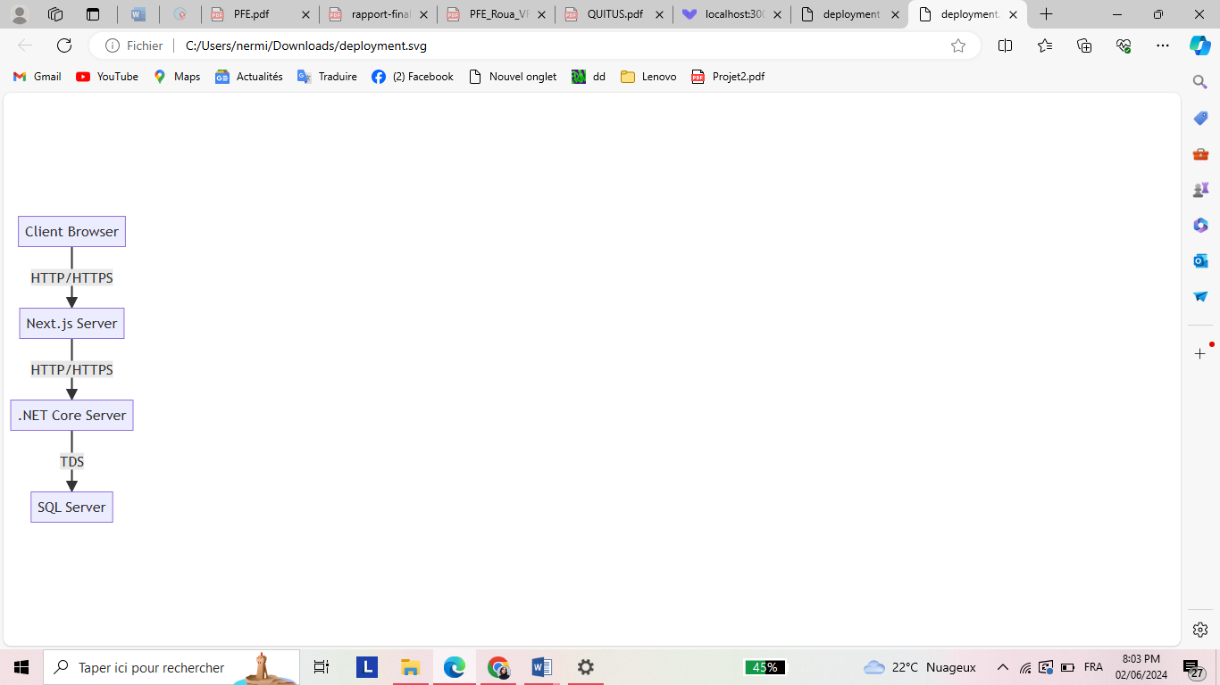**Client Browser:**The entry point for users interacting with the application. The browser sends HTTP/HTTPS requests to the Next.js frontend server.
* **Next.js Server:**The frontend of the application is built using Next.js. It is deployed on a dedicated Ubuntu server, packaged into a Docker container (NextjsDocker).
* **Next.js Components**:The frontend is structured using a component-based architecture. Each component handles a specific part of the UI.
* **Component 1, .., Component N:** These are examples of various reusable UI components within the Next.js application. Each component manages its own state and logic.
* **.NET Core Server :** The backend of the application is built using .NET Core. It is deployed on a dedicated Ubuntu server, packaged into a Docker container (DotnetCoreDocker).
* **SQL Server:** The database is implemented using SQL Server, deployed directly on a dedicated Windows server

Figure 7.12-deployment

* SQL Server Instance: The actual running instance of SQL Server**Summary:**

Client Browser: The entry point for users interacting with the application.

Next.js Server: Utilizes a component-based architecture to build a modular and reusable frontend.

.NET Core Server: Implements a clean architecture to ensure organized, maintainable, and testable code.

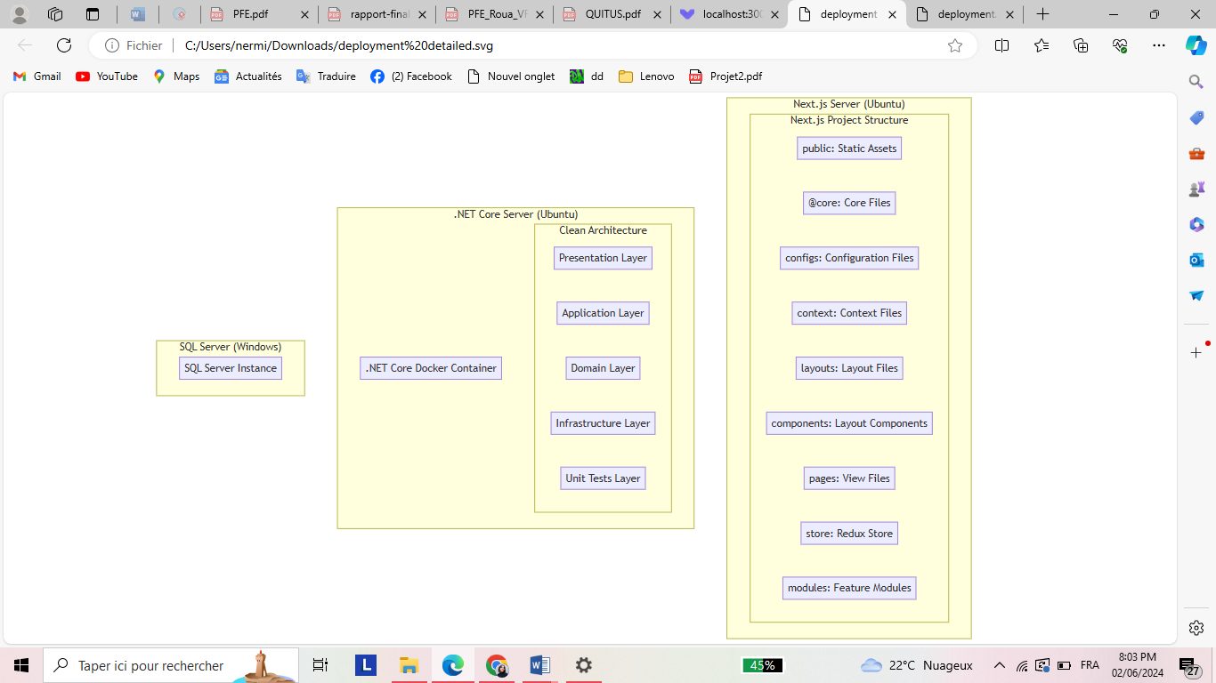

Figure 7.13– deployment schema

# General conclusion and perspectives

This report serves as a comprehensive summary of our end-of-study project marks a significant milestone in our academic and professional journey. The project, carried out at Shamash-IT, aimed to automate the factoring process, addressing the limitations of existing solutions and making factoring more accessible to businesses. Through thorough analysis, planning, and implementation, we have developed a comprehensive web application that streamlines factoring operations and improves efficiency.

During our internship at Shamash-IT, we had the opportunity to apply our theoretical knowledge in a practical setting, gaining valuable insights into the industry. We worked alongside experienced professionals, contributing to real-world projects and expanding our skills in software development, project management, and teamwork.

This experience has not only enhanced our technical abilities but has also provided us with a deeper understanding of the importance of innovation and continuous learning in the field of information technology. We are grateful for the support and guidance we received throughout our internship and project, and we look forward to applying the knowledge and skills we have gained in our future endeavors

## Webography

[Web 1] <https://www.shamash-it.com/> visited on March 5, 2024

[Web 2] <https://fundbox.com/> visited on March 5, 2024

[Web 3] <https://www.bluevine.com/> visited on March 5, 2024

[Web 4] <https://www.kservicing.com/> visited on March 5, 2024

[Web 5] <https://www.researchgate.net/figure/> visited on March 5, 2024.

[Web 6] <https://www.simplilearn.com/scrum-project-management-article> visited on April 24, 2024.

[Web 7] <https://nextjs.org/> visited on February 9, 2024.

[Web 8] <https://dotnet.microsoft.com/en-us/> visited on February 9, 2024.

[Web 9] <https://www.microsoft.com/en-us/sql-server/> visited on February 9, 2024.

[Web 10] <https://swagger.io/tools/swagger-ui/> visited on April 10, 2024.

[Web 11] <https://www.visual-paradigm.com/> visited on April 10, 2024.

[Web 12] <https://www.jetbrains.com/rider/> visited on March 5, 2024.

[Web 13] <https://www.docker.com/> visited on March 5, 2024.

[Web 14] <https://www.microsoft.com/en-us/power-platform/> visited on April 30, 2024.

[Web 15] <https://learn.microsoft.com/en-us/shows/dotnetconf-2022/clean-architecture>

visited on February 8, 2024

## Summary

This report has been prepared as part of my final project to obtain a national license diploma in Information Technology. This internship is carried out within the company Shamash it, and its goal is to develop a web app factoring platform. To accomplish this task, we utilized the .NET Framework as the backend framework, Next JS as the frontend framework, and SQL Server for database management. We also followed the SCRUM framework for the development process.

Key words: Next JS, .NET Framework, Scrum.

**Résumé**

Ce rapport a été préparé dans le cadre de notre projet final d’obtention d’une licence nationale en technologie de l’informatique. Ce stage est réalisé au sein de la société Shamash it, et son objectif est de développer une plateforme d’affacturage d’applications web. Pour accomplir cette tâche, nous avons utilisé le . NET Framework en tant que framework backend, Next JS en tant que framework frontend et SQL Server pour la gestion de base de données. Nous avons également suivi le cadre SCRUM pour le processus de développement.

Mots clés : Next JS, . NET Framework, Scrum.